Delaware Public Media

To protect marine environment, some Delaware businesses ditch plastic straws
By KATIE PEIKES

May 24, 2018 WDDE

http://delawarepublic.org/post/protect-marine-environment-some-delaware-businesses-ditch-plastic-straws

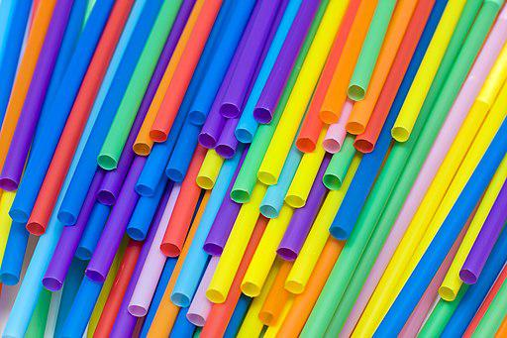
Some dining establishments across Delaware have stopped distributing plastic straws and are instead giving customers biodegradable paper straws in an effort to help protect the environment.
On World Turtle Day, May 23, The Greene Turtle Sports Bar and Grille went plastic straw-free and started distributing biodegradable paper straws by request.
Big Chill Beach Club in Bethany Beach decided to say goodbye to plastic straws when they opened for the season about five weeks ago.
“We thought it would be more environmentally conscious, especially in the ecosystem that we operate in, to do the paper straws,” said Big Chill Beach Club General Manager Jason Bradley.
The seasonal business could go through more than two bulk cases of straws just weeks into opening, he said. Since Big Chill Beach Club went plastic straw-free, they've seen a positive response "for the most part."
Once they’re thrown out, plastic straws can end up in the ocean. University of Delaware Marine Science Professor Danielle Dixson said marine life, like sea turtles, may mistake that plastic for food.
“That plastic itself can act as a magnet for different harmful chemicals. If animals eat that, whether it’s on accident or on purpose – both will happen – they’re actually ingesting this chemically toxic thing, that those chemicals will then break off into their body,” Dixson said.
That’s why Dixson says she’s happy restaurants are thinking about their impact.
“I mean they must give out hundreds and hundreds and hundreds a day,” she said.
Dixson herself uses metal straws.
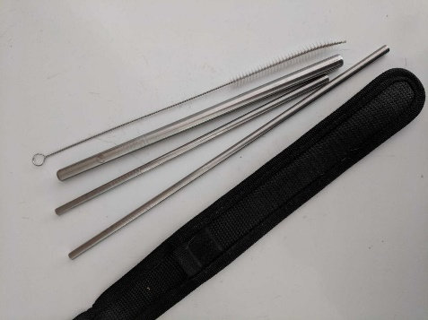
Metal straws and their casing.
CREDIT COURTESY OF DANIELLE DIXSON / UNIVERSITY OF DELAWARE
The grassroots group Plastic Free Delaware has been working for the last six to eight months on getting more establishments on board with eliminating plastic straws from their stock.
Dee Durham, the group’s co-chair, said the initiative has been growing faster than she ever thought it would.
“I think the more restaurants that do it, it’s going to become even more widespread and it’s just fabulous,” Durham said.
She says she hopes it will make straw numbers for Delaware’s annual Coastal Cleanup decrease.
According to data from Delaware's Department of Natural Resources and Environmental Control, over the last 10 years of Coastal Cleanup, volunteers have found more than 23,500 straws on Delaware beaches.

