Area 46 December Assembly
December 4th and 5th
Hosted by District 6
Location: Raton Convention Center 901 South 3rd Street Raton, NM 87740
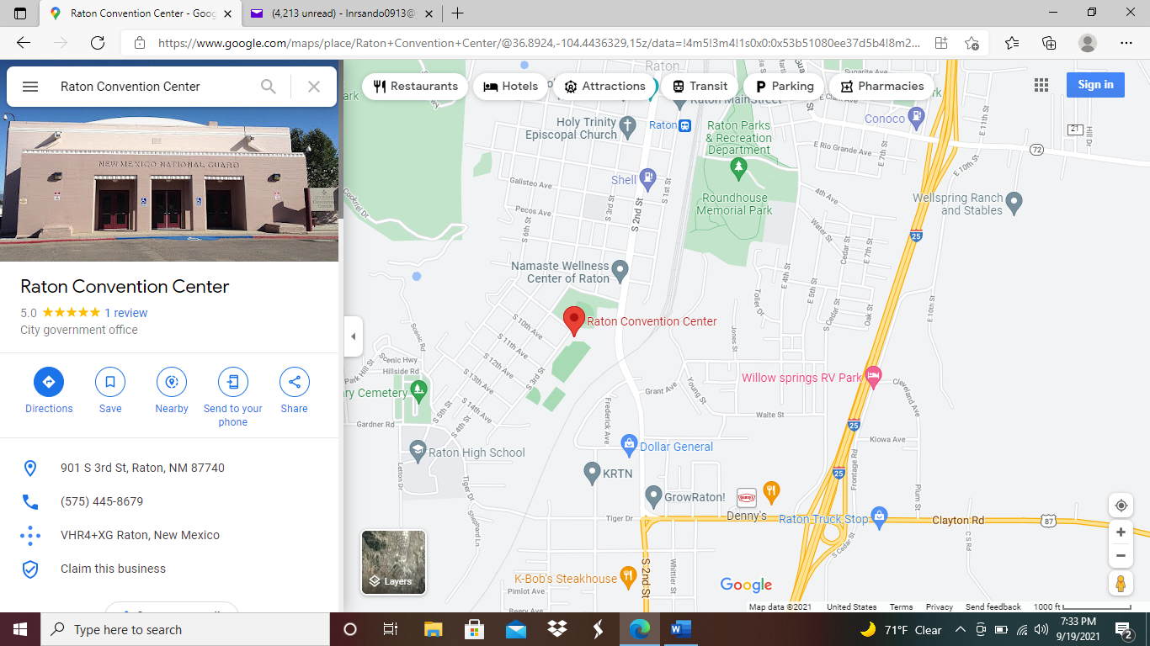

RATON NEW MEXICO
Hotels

HOTEL NAME ADDRESS PHONE RATE
Raton’s Peak Inn 200 Clayton Rd 575-245-7325 $69.99 Use District 46
Holiday Inn Express & Suites 101Card Avenue 575-445-1500 Call For Rate
Super 8 by Wyndham 1610 Cedar Street 575-445-2355 Call For Rate
Travelodge by Wyndham 1600 Cedar Street 505-738-4180 Call For Rate
Quality Inn 533 Clayton Road 575-445-4200 Call For Rate
Microtel Inn & Suites 1640 Cedar St 575-303-4479 Call For Rate
Best Western Plus 473 Clayton Road 575-445-8501 Call For Rate
Budget Host 136 Canyon Dr. 575-445-3655 Call For Rate
Raton Pass Motor Inn 308 Canyon Dr 575-445-3641 Call For Rate
Casa Lemus Inn and Restaurant 350 Clayton Rd 575-445-2737 Call For Rate
Raton KOA Journey 1330 South 2nd Street 575-445-3488 Call For Rate
NRA Whittington Center 34025 US-64 575-4454-3615 Call For Rate
Raton Pass Camp & Café 46020 I-25 575-445-8500 Call For Rate

RATON NEW MEXICO
RESTAURANTS

RESTAURANT NAME ADDRESS PHONE
Bruno’s Pizza and Wings 133 Cook Ave 575-445-9512
Oasis Restaurant 1445 S. 2nd St 575-445-2221
Mulligan’s 473 Clayton Rd 575-445-8501
La Cosina Café 745 S. 3rd St 575-445-9675
The Icehouse 945 S. 2nd St 575-445-0003
K-Bob’s Steakhouse 1228 S. 2nd St 575-445-2548
Sweet Shop 1201 S. 2nd St 575-445-9811
Alfonso’s Mexican Food 412 Clayton Rd 575-445-8022
Denny’s 430 Clayton Rd 575-445-1386
Asian Buffet 1281 S. 2nd St 575-445-9518
McDonald’s 542 Clayton Rd 575-245-5569
Subway 800 Clayton Rd 575-445-9290
The Art of Snacks 1117 S. 2nd St 575-707-8020
Arby’s 415 Clayton Rd 575-445-8078
Candelario’s Food, BBQ 247 E. 8th St 505-617-0383
Sonic Drive-In 327 Clayton Rd 575-445-9601
111 Park Espresso Bar 111 Park Ave 575-445-2219
Domino’s Pizza 129 Clayton Rd 575-245-3030
Los Chanquis Mexican & Seafood 144 N. 1st St 575-445-7644
Casa Lemus Restaurant 350 Clayton Rd 575-445-4024
Year of the Dog 1005 S. 2nd St 505-398-6492

