AREA 46 ASSEMBLY AGENDA

December 4 & 5, 2021 • District 6 – (Host)

Raton Convention Center, 901 S. 3rd St., Raton, NM (Hybrid)

**FRIDAY**

7:00 pmSpeaker meeting: Debbie E., Bastrop, Tx, Tony E., Bastrop, Tx., Paul H., Raton, NM, Leroy S., Raton, NM Raton Convention Center, 901 S. 3rd St. (No business will be done on Friday)

**SATURDAY**

7:15 am **Registration Open –** Please gather in main meeting room by 8:15 am so that the Assembly can begin on schedule.

**8:30 am CALL TO ORDER**

8:45 am Move to Breakout Room (please be patient)

**8:55 am COMMITTEE MEETINGS:** GSR Orientation, Bilingual, Corrections, Finance, Grapevine, Technology

9:45 am Move to Breakout Room (please be patient)

**9:55 am** **COMMITTEE MEETINGS:** Cooperation w/ Professional Community (CPC), *El Farolito,* Finance, Treatment, Literature

10:45 am Move to Breakout Room (please be patient)

**10:55 am** **COMMITTEE MEETINGS:** Archives, Bridge the Gap (BTG), Public Information (PI), Accessibilities & Remote Communities (ARC), Young People

11:45 amMove to Breakout Room (please be patient)

**11:55 am** **MEETINGS:** GSRs, District Committee Members (DCMs), Area Trusted servants, Past Delegates

12:45 pm ***Lunch Break*** *—District 6 providing lunch —* ***(please stay logged in)***

**1:45 pm** **CALL TO ORDER** – Business Meeting

2:00 pm INTRODUCTIONS

2:10 pm SECRETARY’S REPORT: Summary of Minutes – September 2021 Assembly - Virtual

2:15 pm TREASURER’S REPORT

2:25 pm Registrar’s Report

2:30pm Delegate’s Report

2:40 pm Alternate Delegate’s Report

2:50 pm *10-minute break (please stay logged in)*

3.00 pm **Announcements** 

**3:15 pm Old Business**

1. Assembly Report: March 26 & 27, 2022 – District 13, Moriarty
2. Ad Hoc Committee About the Books Report

**3:40 pm** **New Business\***

1. Present New Area 46 Chairs for disapproval
2. Bids for Area State Convention June 3, 4, & 5 2022
3. Bids for Area State Convention June 2, 3, & 4 2023
4. Bids for September Assembly, September 10 & 11 2022
5. Bids for December Assembly December 3 & 4, 2022
6. Motion for the 2022 Budget to be presented by Julio R, Finance Chair
7. Motion to move Sept. Assembly to first weekened in Aug., presented by Bill L., Delegate
8. Other New Business

5:00 pm *Dinner Break*

**7:00 pm** **Sharing session** – Kurt K., Area 46 Inventory

**SUNDAY**

7:30 am **Registration Opens**

**8:00 am** **Call to Order**

**8:10 am** **Vote** on previous day’s bids and motions

8:30 am ASSEMBLY MEETING Reports** Committees, GSR, DCM, Trusted Servants, and Past Delegates

10:00 am Ask It Basket and Sobriety Countdown

10:30 am **Adjourned until March 26, 2022 – District 13, Moriarty, NM**

*— The Planning Meeting for the next assembly will be held on January 29, 2022*

1) Any voting member can make a motion. If you need assistance preparing a motion see any Area trusted servant, past Delegate, or DCM.

2) Motions should be emailed or texted to the Secretary when the motion is made, ideally before Assembly. (Include your name and voting position with the motion)

3) If your motion requires Area funding, include as part of the motion the costs and where the funding will come from (see Finance chair for help)

**\*\* COMMITTEE AND TRUSTED SERVANTS’ MEETING REPORTS WILL BE PUBLISHED IN THE NEXT ISSUE OF *EL FAROLITO***.

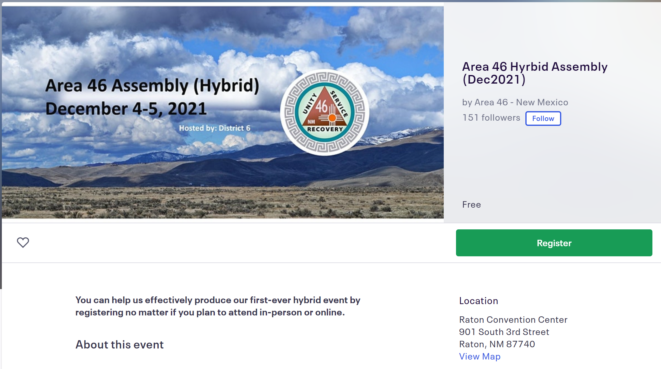

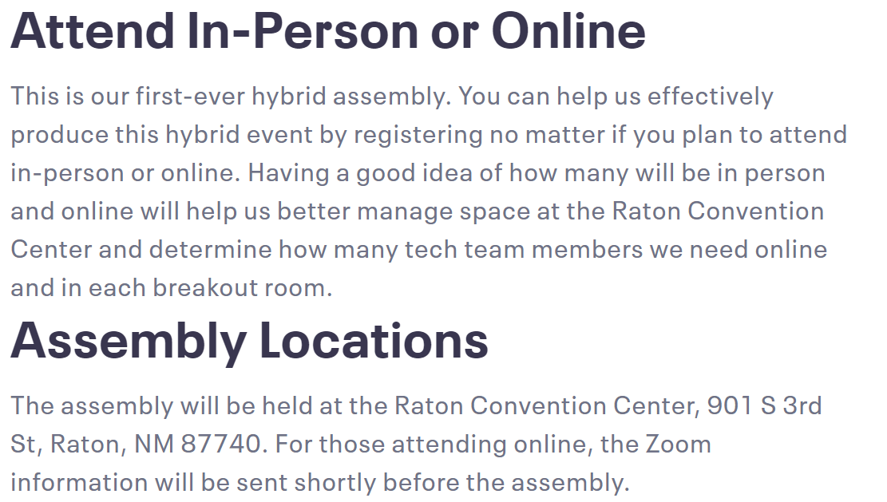

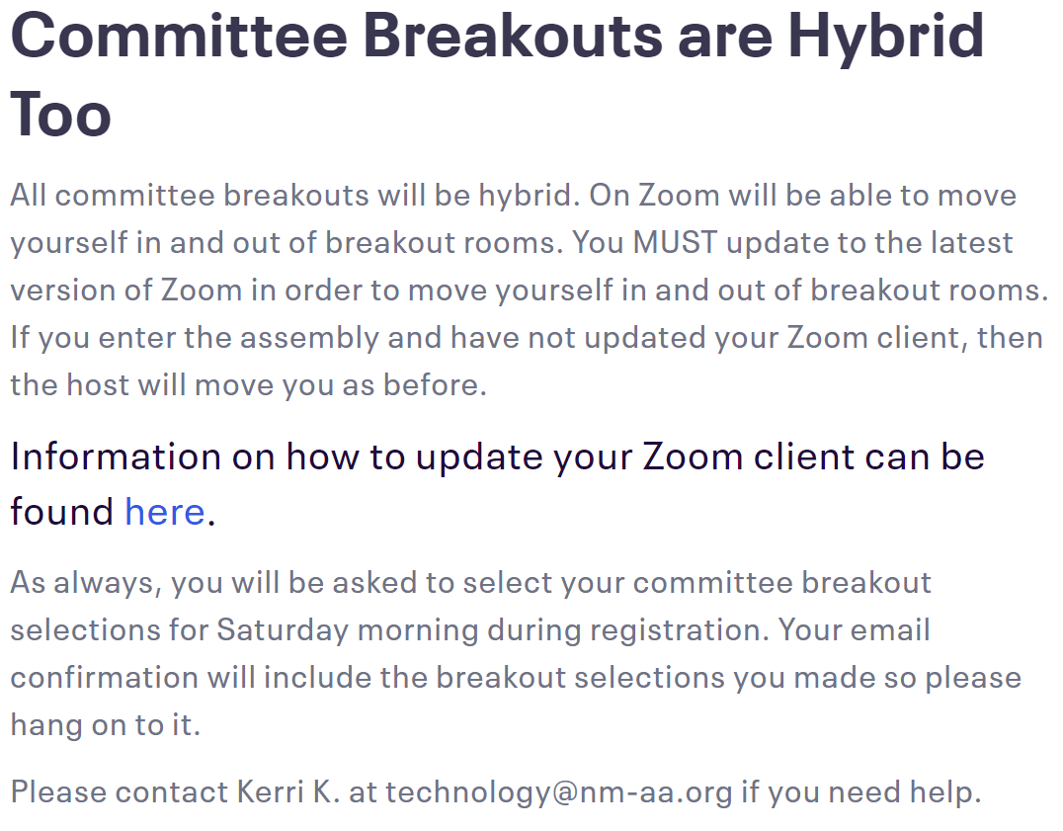

**Link to Register:**

[Area 46 Hyrbid Assembly (Dec2021) Registration, Raton | Eventbrite](https://www.eventbrite.com/e/area-46-hyrbid-assembly-dec2021-registration-195335913977?aff=ServiceHomePage)