Xcel Canine Training Center
Rodeo Dog Trials #57 and #58

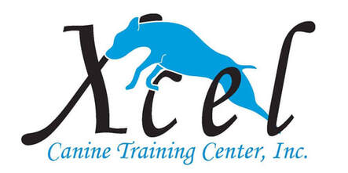
Sunday, March 15, 2020
2 Shows in 1 Day!

Location:
Xcel Canine Training Center
5400 Progress Blvd., Bethel Park, PA 15102

Judges: Machell Koss and Barbara Newman

Pre-entries close on the Saturday, March 7, 2020.
Day of show entries will be accepted.

Daily Schedule
10:00am –Check In
10:30am – Briefing and 1st walk through
After Completion of First Trial – Rodeo Dog remembrance ceremony
Immediately Following Ceremony – Briefing and 2nd walk through

Trials will run concurrent (with small time allotted for remembrance ceremony) and move-up’s accepted.

If you are anticipating a title, please let us know by March 7th so we have your title ribbon available for you.

Good luck, have fun, and Giddy Up!

Rodeo Dog Trials #57 and #58
Sunday, March 15, 2020 - 2 Shows in 1 Day!
Held at Xcel Canine Training Center
5400 Progress Blvd., Bethel Park, PA 15102

Rodeo Dog Company will be having a special small ceremony to remember our Rodeo dogs that have gone to the rainbow bridge this past year. This will be taking place in between the trials.

Show Site:

Xcel Canine Training Center is located at 5400 Progress Blvd., Bethel Park, PA 15102. 412/833-2504. For more information, please visit:
https://xcelcaninetraining.com/
Please bring your own chair, crate, and clean up supplies for your dogs. Limited crating space on a first come, first serve basis on first floor. Additional crating and seating area will be available upstairs. Please be respectful of handler/dog competing in ring.

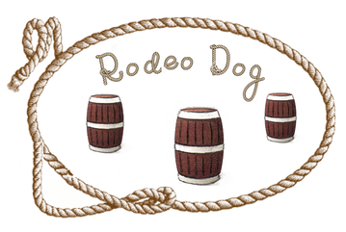

^{RDC #:} |  | ^{Call Name:} |  | ^{Breed:}
^{RDC Registered Name:} |  |  |  | ^{Date of Birth:} |  | ^{Sex:}
Choose Category |  | ___ Regular  ___ Junior Handlers  ___ Special/Seniors*  *Requested Accommodations:
Choose Height |  | ___ Small  ___ Medium  ___ Large
RDC number should be entered as “PENDING” if you don’t have # yet.
^{Owner(s):}
^{Owner’s Address:}
^{City/State/Zip:}
E-mail (required for confirmation): |  |  | ^{Phone:}
Sunday, March 15, 2020 – Trial #57  Small to Tall |  |  | Sunday, March 15, 2020 – Trial #58  Tall to Small
B: Beginner P: Performance H: Halter PC: Performance Champ M: Master
Clover | B P H PC M |  | Clover |  | B P H PC M
Straight Line | B P H PC M |  | Straight Line |  | B P H PC M
Round Up | P H PC M |  | Round Up |  | P H PC M
Lock, Stock, & Barrel | P H PC M |  | Lock, Stock, & Barrel |  | P H PC M
Pre-Entry Fees: $20.00 for the 1st class and $10.00 for each additional class in that trial.
Rodeo Dog rules, regulations, policies, and guidelines are available on the Rodeo Dog website: https://rodeodog.weebly.com/
Trial starts at 10:30am with Clover for small dogs.
It will run with highest level going first.
Opens on January 13, 2020 and Closes on March 7, 2020
Entries accepted the day of the show.
Judges: Machell Koss and Barbara Newman
Entry Fees: $20.00 for the 1st class and $10.00 for each additional class in that trial
Day of Show Entry Fee: $25.00 for the 1st class/$15.00 for each additional class in that trial
Trials will run concurrent and move-up’s accepted.
Make Check payable to: Xcel Canine Training Center

Mail Entries to: Machell Koss – Trial Secretary 5400 Progress Blvd., Bethel Park, PA 15102

I agree that the club holding this event has the right to refuse an entry. I agree to hold Rodeo Dog, the club holding the event, their members and judges, harmless from any claim for loss or injury which may be alleged to have been caused directly or indirectly to any person or thing by the act of this dog while in or about the event premises. I personally assume all responsibility and liability for such claims; and I further agree to hold the aforementioned parties harmless from any claim for loss, injury, or damage to this dog or person. I agree to abide by the rules and regulations of Rodeo Dog Company.
In the event of dangerous weather conditions or an act of God, Rodeo Dog Company has the right to cancel the event with no refunds. Dogs absent due to an injury or sickness must present a valid veterinary excuse to get a full refund.
Name: _____________________________________________
Signature: __________________________________________
Email: _____________________________________________
Phone: ____________________________________________
Date: ______________________________________________
Entry Form – Please Print

Trial Date: March 15, 2020
Make Checks Payable to: Xcel Canine Training Center
Return this completed form with entry fees to:
Machell Koss – Trial Secretary
5400 Progress Blvd., Bethel Park, PA 15102

