Xcel Canine Training Center, Inc.
Rodeo Dog Trials #72, #73 & #78

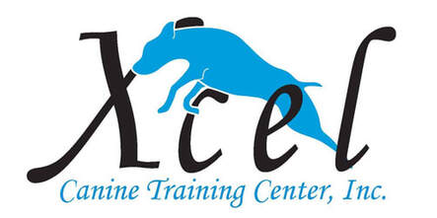
Saturday, November 21,2020 – 2 shows
Sunday, November 22, 2020 – 1 show
3 Shows in 1 Weekend

Location:
Xcel Canine Training Center, Inc.
5400 Progress Blvd., Bethel Park, PA 15102

Judges: Machell Koss and Barbara Newman

Pre-entries close on Monday, November 16, 2020
Day of show entries will be accepted by noon

Daily Schedule
9 am Check In
9:30 am – Briefing and 1st walk through
Immediately Following 1st trial Briefing and 2nd walk through

Trials will run concurrent and move-up’s accepted.

If you are anticipating a title, please let us know by November 9th so we have your title ribbon available for you.

Good luck, have fun, and Giddy Up!

Rodeo Dog Trials #72, #73 & #78

Held at Xcel Canine Training Center, Inc.
5400 Progress Blvd., Bethel Park, PA 15102

Show Site:

Xcel Canine Training Center is located at 5400 Progress Blvd., Bethel Park, PA 15102. 412/833-2504. For more information, please visit:
https://xcelcaninetraining.com/
Please bring your own chair, crate, and clean up supplies for your dogs. Due to COVID19 guidelines, please either crate in your vehicle or you are more than welcome to put a tent or pop up on the Xcel Property. A designated potty area will be on the premises to allow room for tents or pop ups. Be respectful of your neighbor and social distance yourselves. Masks are mandatory at this trial. Please be respectful of handler/dog competing in ring. Please be sure to send in your COVID19 Waiver along with your entry.

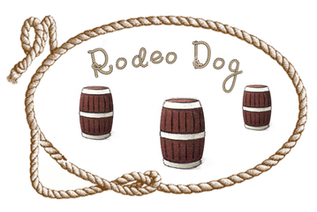

Trial starts at 9:30 am with Clover for small dogs.
^{RDC #:} |  | ^{Call Name:} |  | ^{Breed:}
^{RDC Registered Name:} |  |  |  | ^{Date of Birth:} |  | ^{Sex:}
Choose Category |  | ___ Regular  ___ Junior Handlers  ___ Special/Seniors*  *Requested Accommodations:
Choose Height |  | ___ Small  ___ Medium  ___ Large
RDC number should be entered as “PENDING” if you don’t have # yet.
^{Owner(s):}
^{Owner’s Address:}
^{City/State/Zip:}
E-mail (required for confirmation): |  |  | ^{Phone:}
Saturday, Nov 21 – Trial #72  Small to Tall Judge: Machell Koss |  |  | Saturday, Nov 21 – Trial #73  Tall to Small Judge: Barbara Newman
B: Beginner P: Performance H: Halter PC: Performance Champ M: Master
Clover | B P H PC M |  | Clover |  | B P H PC M
Straight Line | B P H PC M |  | Straight Line |  | B P H PC M
Round Up | P H PC M |  | Round Up |  | P H PC M
Lock, Stock, & Barrel | P H PC M |  | Lock, Stock, & Barrel |  | P H PC M
Pre-Entry Fees: $20.00 for the 1st class and $10.00 for each additional class in that trial.
Rodeo Dog rules, regulations, policies, and guidelines are available on the Rodeo Dog website: https://rodeodog.weebly.com/
It will run with highest level going first.
Opens on September 8, 2020
Entries accepted the day of the show.
Judges: Machell Koss and Barbara Newman
Entry Fees: $20.00 for the 1st class and $10.00 for each additional class in that trial
Day of Show Entry Fee: $25.00 for the 1st class/$15.00 for each additional class in that trial
Trials will run concurrent and move-up’s accepted.
Make Check payable to: Xcel Canine Training Center, Inc.

Mail Entries to: Machell Koss – Trial Secretary 5400 Progress Blvd., Bethel Park, PA 15102

I agree that the club holding this event has the right to refuse an entry. I agree to hold Rodeo Dog, the club holding the event, their members and judges, harmless from any claim for loss or injury which may be alleged to have been caused directly or indirectly to any person or thing by the act of this dog while in or about the event premises. I personally assume all responsibility and liability for such claims; and I further agree to hold the aforementioned parties harmless from any claim for loss, injury, or damage to this dog or person. I agree to abide by the rules and regulations of Rodeo Dog Company.
In the event of dangerous weather conditions or an act of God, Rodeo Dog Company has the right to cancel the event with no refunds. Dogs absent due to an injury or sickness must present a valid veterinary excuse to get a full refund.
Name: _____________________________________________
Signature: __________________________________________
Email: _____________________________________________
Phone: ____________________________________________
Date: ______________________________________________
Entry Form – Please Print

Trial Dates: November 21, 2020
Make Checks Payable to: Xcel Canine Training Center, Inc.
Return this completed form with entry fees to:
Machell Koss – Trial Secretary

Trial starts at 10:30am with Clover for small dogs.
^{RDC #:} |  | ^{Call Name:} |  | ^{Breed:}
^{RDC Registered Name:} |  |  |  | ^{Date of Birth:} |  | ^{Sex:}
Choose Category |  | ___ Regular  ___ Junior Handlers  ___ Special/Seniors*  *Requested Accommodations:
Choose Height |  | ___ Small  ___ Medium  ___ Large
RDC number should be entered as “PENDING” if you don’t have # yet.
^{Owner(s):}
^{Owner’s Address:}
^{City/State/Zip:}
E-mail (required for confirmation): |  |  | ^{Phone:}
Sunday, Nov 22 – Trial #78
Small to Tall Judge: Barbara Newman
B: Beginner P: Performance H: Halter PC: Performance Champ M: Master
Clover | B P H PC M |  | Clover |  | B P H PC M
Straight Line | B P H PC M |  | Straight Line |  | B P H PC M
Round Up | P H PC M |  | Round Up |  | P H PC M
Lock, Stock, & Barrel | P H PC M |  | Lock, Stock, & Barrel |  | P H PC M
Pre-Entry Fees: $20.00 for the 1st class and $10.00 for each additional class in that trial.
Rodeo Dog rules, regulations, policies, and guidelines are available on the Rodeo Dog website: https://rodeodog.weebly.com/
It will run with highest level going first.
Opens on on September 8, 2020
Entries accepted the day of the show.
Judges: Machell Koss and Barbara Newman
Entry Fees: $20.00 for the 1st class and $10.00 for each additional class in that trial
Day of Show Entry Fee: $25.00 for the 1st class/$15.00 for each additional class in that trial
Trials will run concurrent and move-up’s accepted.
Make Check payable to: Xcel Canine Training Center, Inc.

Mail Entries to: Machell Koss – Trial Secretary 5400 Progress Blvd., Bethel Park, PA 15102

I agree that the club holding this event has the right to refuse an entry. I agree to hold Rodeo Dog, the club holding the event, their members and judges, harmless from any claim for loss or injury which may be alleged to have been caused directly or indirectly to any person or thing by the act of this dog while in or about the event premises. I personally assume all responsibility and liability for such claims; and I further agree to hold the aforementioned parties harmless from any claim for loss, injury, or damage to this dog or person. I agree to abide by the rules and regulations of Rodeo Dog Company.
In the event of dangerous weather conditions or an act of God, Rodeo Dog Company has the right to cancel the event with no refunds. Dogs absent due to an injury or sickness must present a valid veterinary excuse to get a full refund.
Name: _____________________________________________
Signature: __________________________________________
Email: _____________________________________________
Phone: ____________________________________________
Date: ______________________________________________
Entry Form – Please Print

Trial Date: November 22, 2020
Make Checks Payable to: Xcel Canine Training Center
Return this completed form with entry fees to: Machell Koss, Trial Sec

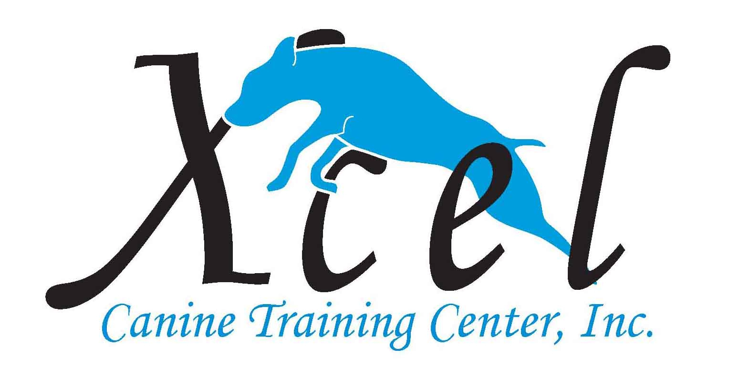 COVID19 WAIVER
I/we certify that I/we do not, to my/our knowledge, have COVID-19 at the time of attending these classes. Nor have I/we been in contact with or exposed to any known carrier of COVID-19 within the past 14 days.
I/we have not been tested within the last 14 days. If I/we have had the virus, I/we certify that we have had at least two negative test 14 or more days prior to these classes starting and have been released by government officials and/or health care providers to resume normal activity without limit.
I/we understand that we are coming to class at my/our own risk and take full responsibility for my/our own health and safety during these weeks.
I/we pledge to follow all of Xcel CTC, Inc.’s rules and requirements to mitigate any possibility of infecting others or becoming infected.
I/we will also cooperate with any health department and/or State/Local guidelines that have jurisdiction in the area.
Xcel Canine Training, Inc., and/or their owners, Landlord or instructors are in no way liable for any present or future COVID-19 infection incurred at any time by any person in attendance or not in attendance, during or after this trial has been completed.

______________________________________ _____________________
Signature of Participant Date
______________________________________
Printed Name of Participant
This waiver is for Rodeo Dog Show 72, 73 & 78

