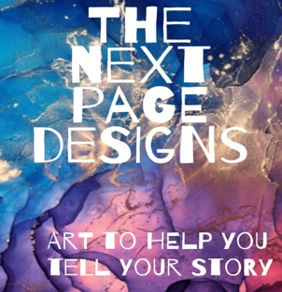
Melissa Ringold
Mixed Media Artist
Custom journal or planner
order form

Name Email

My journals and planners are one-of-a-kind pieces of art that encourage you to write your own story. I want your custom journal or planner to look and feel like it was made explicitly for you!

I include little personalized surprises throughout and use a wide variety of materials in the colors you choose. The more information I have about the person who will be using the journal/planner, the better. If you would like something that is not included in these questions, please ask me! I love to create new ways to customize.

If the journal/planner is going to be a gift, please think about what the recipient would love.
Share as much info as you’d like and I will be in touch via email to give you an expected completion date and total cost.

Please select either Journal or Planner and the size you would like.
(If you want to order more than one item, please use a separate order form for each.)
Journal Size OR Planner Size
5 in x 8 in $65 ☐ 5 in x 8 in $80 ☐
7 in x 9 in $75 ☐ 7 in x 9 in $90 ☐
8.5 in x 11 in $85 ☐ 8.5 in x 11 in $100 ☐

Cover type Soft ☐ Hard ☐

For Journals: What type of paper would you like? Lined ☐ Blank ☐ Both ☐

For Planners:
Please select how many months and when you would like the planner to start.
12 months ☐ Starting Month and Year
OR
18 months (additional $30) ☐ Starting Month and Year

Select planner layout: Monthly pages ☐ Weekly pages ☐ Both ☐
All planners include “Notes” pages after each month and at the back of the book.

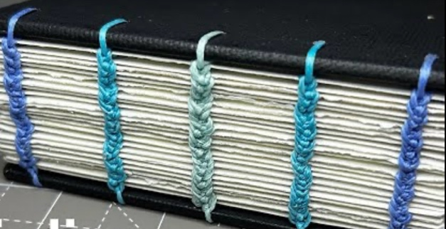
Select Binding
*Coil bound (most popular) ☐

*3 ring punched ☐
(best choice if you like to add/rearrange/remove pages)

*Coptic stitching ☐
(additional $30 – This binding method is a delicate process that must be done by hand and takes quite a bit of time)

Coptic stitching is a binding method using waxed thread and a system of knots. It creates an interesting spine and allows the book to lay completely flat when open. See photo above.

On to the FUN stuff!
Tell me about yourself or the recipient in as much detail as you can.

- What is the recipient’s name and/or name they like to be called?

- When is the recipient’s birthday (month and date)?

- What colors should I make sure to use? Any colors to avoid?

- Favorite activities, places, people?

- Images or symbols that you associate with them? (ex. They love butterflies)

- I often sprinkle quotes and phrases throughout my books. What should I include?

- Positive uplifting quotes ☐
- Silly/snarky, sarcastic humor ☐
- Both ☐
- None ☐

- Is there anything I should avoid? (Ex. Don’t use floral designs or anything with a glitter look.)

- What else can you tell me so I can make the journal/planner truly personalized?

