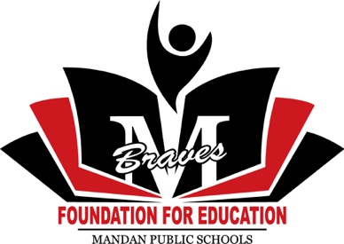
Arnold E. Larson Graduate Scholarship Application Form
Due April 15, 2022 – To be awarded Spring 2022

This scholarship is open to someone pursuing advanced study of instrumental music including, but not limited to performance, music history, composing, conducting, and music education. The scholarship may become open to Mandan School District employees interested in advancing their study of instrumental music.
The scholarship will be for up to $10,000, paid by semester, for the period July 1-June 30.
Criteria:
- Graduate of Mandan High School
- Graduate of an undergraduate program in instrumental music
- Accepted into an advanced program on or before April 1. Applicant must verify with letter from the college or university and/or their advisor.
Applications must include, in detail, your program, goals, timeline, costs, and two letters of recommendation.
Completed application, transcripts, and letters of recommendation must be submitted to the Mandan Public Schools Foundation for Education: PO Box 893; Mandan, ND 58554.
Personal Information
Name (Last, First, Middle) _
Mailing Address (Street/PO Box) ____________
City
State
Zip _____

Telephone (home) Telephone (cell)
Email Address _
Parents/Legal Guardian(s) _______________________________________
Mailing Address (Street/PO Box) _

City
State
Zip ___________

Arnold Larson Graduate Scholarship Supplemental Information
- Describe in detail your involvement/participation in music related classes, performances, competitions, etc. in school and the community?
- Describe in detail your graduate degree program.
- Describe your academic plans in relation to your music advanced degree.
What are your short-term and long term goals upon achieving your advanced degree?
- How will receiving this scholarship assist you in achieving your educational goals?
- Describe the timeline for your advanced studies.
- What are the costs associated with your advanced degree program?

