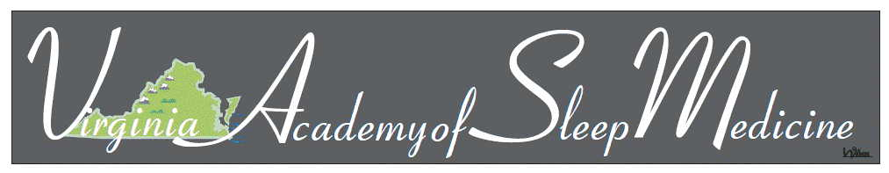

2020 Katherine Florio Vorona Scholarship Program

The Virginia American Academy of Sleep Medicine (VASM) is pleased to announce the 2020 Katherine Florio Vorona Scholarship Program. The scholarship is available for those with special interest in the study and advancement of sleep medicine and understanding its impact on our community or our state. This year’s conference is being held at the Richmond Hilton at Short Pump, VA on November 12 & 13, 2020. The number of scholarships awarded will be determined by available funding.

The Scholarship will include:
  - Registration to the Virginia Academy of Sleep Medicine’s Annual Conference
  - A free year of VASM membership
  - Up to $1,000 USD in reimbursement for reasonable related costs to attend the meeting. Reimbursable expenses are outlined on the VASM Reimbursement Request form.
  - Networking opportunities with leaders in the field of sleep medicine

2020 Katherine Florio Vorona Scholarship Program

Eligibility:
This opportunity will be available on a competitive basis to undergraduate or graduate student(s) (including medical/ dental resident(s)) interested in the study and advancement of sleep medicine.
How to Apply:
The candidates are required to submit supporting documents via email to: smcconnell@ramdocs.org
Supporting Documents:
- Curriculum vitae
- Applicants are required to submit a short essay (250 words or less). The essay must indicate interest in Sleep Medicine and reasons for applying for the scholarship.
- One letter of recommendation from a faculty member of the program you are currently attending.
Application Deadline:
Application deadline is September 15, 2020.
Link for More Information:
http://www.vasleepmedicine.com

