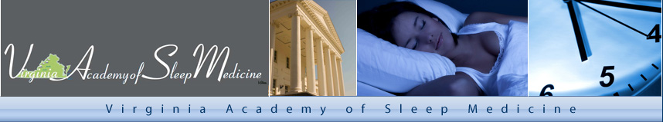

2020 VASM Michael O’Neill McMunn, DDS
Distinguished Service Award Application

To be considered for the award the nominee must be a current VASM member in good standing. The VASM Award committee will review each application and the recipient will be notified by letter. * The VASM Board will present the award to the recipient at the VASM Annual Conference in Richmond and it will be announced on the VASM website.

Application Process
- Download the Application
- The completed 2020 VASM Michael O’Neill McMunn, DDS Distinguished Service Award Application must include:
  - Nominee’s CV
- The completed application must be received by the VASM no later than September 15, 2020.
- Send the required information to:

VASM Service Award Committee
Virginia Academy of Sleep Medicine
Attn: Susan McConnell, Society Manager
2821 Emerywood Parkway
Suite 200
Richmond, VA 23294
smcconnell@ramdocs.org
Fax: 804.788.9987

*The winner will be notified as soon as possible to allow for arrangements to attend the annual meeting.

2020 VASM Michael O’Neill McMunn, DDS Distinguished Service Award Application
NAME OF NOMINEE: |  |  | CREDENTIALS:
NOMINEE CONTACT INFORMATION
E-MAIL:

PHONE (H):

PHONE (M):

PRACTICE NAME:
ADDRESS:

NOMINEE INFORMATION
DESCRIPTION OF NOMINEE'S SERVICE THAT HAS IMPACTED THE HEALTH OF THE POPULATION SERVED

WHAT, PRECISELY, MAKES THIS NOMINEE SPECIAL?

PLEASE LIST & EXPLAIN ACTIVITIES, ACHIEVEMENTS, & CONTRIBUTIONS THAT DEMONSTRATE THE NOMINEE’S COMMITMENT TO DENTAL SLEEP HEALTH CARE.

PLEASE PROVIDE ANY ADDITIONAL COMMENTS OR INFORMATION YOU FEEL WOULD BE BENEFICIAL TO THE SELECTION PANEL.

I KNOW THE NOMINEE TO HAVE UPHELD THE PROFESSIONAL STANDARDS AND ETHICS OF THE VIRGINIA ACADEMY OF SLEEP MEDICINE THROUGHOUT HIS/HER CAREER.  __________________________________________________  SIGNATURE OF NOMINATOR |  |  |  | ____________________________________________  NOMINATOR NAME  ____________________________________________  NOMINATOR EMAIL  _______________________  DATE:

