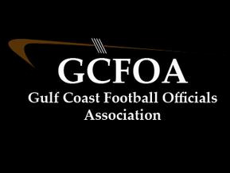

2021 Committees

Evaluation Committee Assignment Committee
*Bill Siedlecki *Drew Myers
Jeff Leaf Adam Heitl
Mark McCrone

Training Committee Grievance Committee
*Kevin Fruchey *Ken Sclotterbach
Bill Flanagan Greg Hagopian
David Boyette Jeff Lacey
Ken Middelton

Recommendation Committee
*David Hall
Bill Flanagan
Tony Cavalier
Jerry Couch
Steve Osburne

