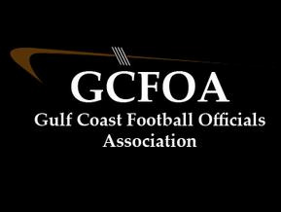

2022 Committees

Evaluation Committee Assignment Committee

\*Bill Siedlecki \*Adam Heitl

Jeff Leaf Mark McCrone

Wes Fritz Greg Besaw

Training Committee Grievance Committee

\*Dan Musick \*Ken Sclotterbach

Sean McCue David Boyette

Steve Osborne Patrick Ford

Recommendation Committee

\*Dave Riedel

Kurt Surh

Greg Hagopian

Jim Ask

Mark McCrone