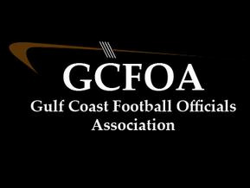

Fall Meeting #8 – October 12th 2021

President: Ron called meeting to order at 7:05pm No new members were present

* Spoke to finishing the season strong

Treasurer Report: Jeff not present – on Zoom Call

* Had ran thru the financials and said he would send them out in a separate e-mail
* Motion to approve by Matt G, second by Drew M

Secretary Report: Geoff passed out attendance sheet.

* Spoke to the upcoming elections on 10/26/21. How to vote via e-mail or maybe using Survey Monkey

Assigner report: Jason Heckman

* Will be using 4 man crews this Friday
* 10/22 & 10/29 are good for coverage
* 11/5 is heavy, everyone needs to work that can please

Vice president Report: Ron – not present

* Glen H spoke to the play from Miami. And there was some discussion
* Some short discussion on a few plays from our games

The only committee report was that from the Recommendation Committee

David Hall announced the playoff crews after some discussion on how they were put together

Glen H motioned to pass; Sean M seconded. 39 members were present in person or on Zoom and there were no “Nays” when the vote was taken. Playoff crews were approved

Ron E opened up the nominations for Vice president, Drew Myers was nominated by Ken S, and seconded by Glen H. Drew accepted the nomination but later withdrew his consideration. Drew M nominated David Hall and it was seconded by Glen H. David Hall accepted hie nomination

Ron E opened up the nominations for Booking commissioner, Jason Heckman was nominated and accepted. Dave H made the motion to accept and Sen M seconded

Ron E opened up the nominations for Treasurer, Jeff Philips was nominated but declined the nomination. Glan H was nominated and accepted the nomination. Sean M made the motion to accept and Ken S seconded

No Old business, No new business

Motion to adjourn at 7:49pm by Drew M and seconded by David H