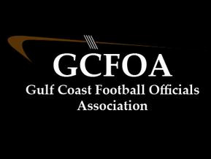

Meeting #1 – May 11th 2021

President: Ron called meeting to order at 7:00pm and welcomed new members
- Spoke to raising dues to $50.00
- Spoke to having paid evaluators this year

Treasurer Report: Jeff passed out the financial statements for the members to view. Cash on hand is currently at $19,570.13. Motion to accept by Jim N and seconded by Ken S
- Spoke to adding Arbiter Pay this year for end of season payment. Still a work in progress

Secretary Report: Geoff passed out attendance sheet.
- Spoke to JLA cards and making sure all members have a card that does not expire during the season. Also spoke to that GCFOA will not be reimbursing members the cost to renew their JLA card. GCFOA will only reimburse first time officials.
- Announced 2021 committees. Attached on a separate form

Assigner Report: Jason spoke to the spring games and scrimmages. Let the member ship know that if you are not assigned a game on the 21st you should report to Venice for the Jamboree
- He spoke to getting your blocks in Arbiter for the fall season
- Spoke to the new officials about getting out to one of the scrimmages and getting on the field if they wish

Vice president Report: Ron – training Spoke to the new rule for 2021, blocking below the waist at the line of scrimmage
- Spoke to the 2021 points of emphasis, specifically personal fouls and unsporting conduct
- Spoke to meeting with the training committee in order to get a plan in place for test preparation
No Committee reports

New business – Jeff McCrosky wanted to recognize members that had been given college assignments.

Motion to adjourn at 8:06pm by Lon S and seconded by Jim N

