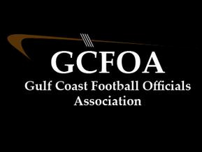

Spring Meeting #2 – May 17th 2022

President: Ron non present. Geoff called the meeting to order at 7:00pm. There were no new members present to introduce

Vice President: David explained how he would like to run the training this fall with breakouts for each position and position coaches. Any one that would be interested in being a position coach should let David know. We watched some clips from the Mooney Clinic and had discussion on them

Treasurer Report:
- Nothing had changed since last meeting

Secretary Report: Geoff passed out attendance sheet.
- There was discussion on Hudl. If you are not signed up for Hudl or do not have access let Geoff know

Assigner report: Jason Heckman
- Lots of changes this week to spring games. Please check your Arbiter and communicate with your crew leader
- He wants your blocks in by July 15th for the fall. Goal is to send out full years schedule by second meeting in August. When you block a date(s) for the fall send Geoff an e-mail with those dates. He will create a calendar for Jason to make his process more efficient.

Committees are not formed yet, still a work in progress
Assignment, Education, Evaluation, Grievance, Recommendation
Reach out to Ron for more info on any of those committees or let him know if you are interested in serving on a committee

No New business

Old business, the amendment to the by-laws was read again and there was a vote on it. We had a quorum 44 members and the amendment was passed on a vote of 39 yes to 5 no. The amendment is listed below and is now part of the GCFOA by-laws

Proposed Amendment to the current ARTICLE IV, duties of membership, paragraph B, Line 3:

3. Wear the proper game uniform with proper FHSAA patches and ensure that the uniform is neat and clean. Possess the necessary accessories to officiate a high school football contest. Maintain a neat appearance, including having a conservative haircut along with, if you choose, a neatly trimmed (no longer than ¼ inch) mustache, goatee or facial hair. All hair must be of a natural color and all appearance duties are subject to Gulf Coast Football Officials Association Board of Directors review.
There will be a vote on this proposal next week. More info on the voting procedures to come.

Motion to adjourn at 8:06pm by Glen hand seconded by Drew M

