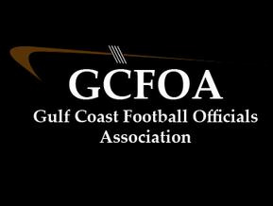

Fall Meeting #2 – August 3rd 2021

President: Ron called meeting to order at 7:03pm and welcomed new members

* Spoke to the formation of crews and that we had to postpone the draft until Sunday night

Treasurer Report: Jeff not present. Cash on hand is currently at $16,149.24. No change from last week. Motion to accept by Fred D seconded by Glen H

* Via Zoom Jeff reminded the member ship to get their Arbiter Pay accounts set up
* JLA reimbursement will be thru AP and will start next week

Secretary Report: Geoff passed out attendance sheet.

* Registration is open and closes on 9/7 for veteran officials
* Test opened on 8/2. Board would like officials not to submit their tests until there is more discussion
* JLA cards, Geoff needs to see them, especially those that have been e-mailed and asked to send a copy
* Handed out rule books after the meeting

Assigner report: Jason Heckman

* He spoke to getting your blocks in Arbiter for the fall season
* Lots of heavy nights this year, we will need everyone available to work when needed
* Underclassman Schedules coming out for August
* Varsity schedules will start to come out after crews are formed

Vice president Report: Ron – training

* Held a new member / new official training meeting at 6pm
* Showed low block training video
* Announced new to GCFOA officials meeting on 8/10 at 6pm
* First test meeting will be on 8/10 – just in person

Recommendation committee – David Hall spoke to the 2021 Playoff selection process. That committee met after the meeting and will be presenting those criteria to the membership soon

Motion to adjourn at 8:00pm by Jamie V and seconded by Sean M