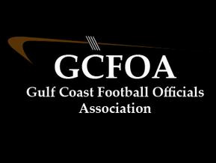

Fall Meeting #3 – August 10th 2021

President: Ron called meeting to order at 7:02pm No new members were present

* Spoke to the formation of crews and that the draft was done last Sunday 8/8

Treasurer Report: Jeff present

* He wrote checks for JLA reimbursement
* No new expenses or income

Secretary Report: Geoff passed out attendance sheet.

* Registration is closed for returning officials. New officials have until 9/7
* JLA cards, Geoff needs to see them, especially those that have been e-mailed and asked to send a copy
* Handed out rule books after the meeting

Assigner report: Jason Heckman

* He spoke to getting your blocks in Arbiter for the fall season
* Lots of heavy nights this year, we will need everyone available to work when needed
* Varsity schedules are coming out for 8/20 & 8/27

Vice president Report: Ron – training

* Held a well-attended test meeting at 5:30pm
* Showed training video that Ron shared the link

Recommendation committee – David Hall spoke to the 2021 Playoff selection process. That committee met after the meeting and will be presenting those criteria to the membership soon

Motion to adjourn at 7:40pm by David H and seconded by Sean M