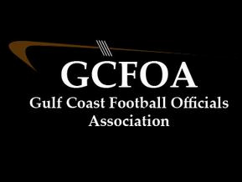

Fall Meeting #3 – August 16th, 2022

President: called the meeting to order at 7:00pm

Vice President: Training - Broke into our position breakouts until 7:40pm

Seam M did a presentation on the kicking game. Very well done

Test review again next Tuesday 6pm before the meeting

Assigner report: Jason Heckman

* Schedule is out but still some changes coming. The first two weeks have been a challenge. We appreciate all your understanding
* Spoke to being to Varsity games 90 minutes. Before game time. OK to go out on the field 60 minutes prior to game time when the teams are there. Can go back to locker room when teams go in. JV & MS games 30 minutes prior and come dressed
* Dress code for varsity is business casual or golf shorts and polo. As always check with your crew chief as to their expectations
* White hats, communicate with your crew and school administration

Treasurer Report: Jeff not present

* Nothing had changed since last meeting

Secretary Report: Geoff passed out attendance sheet.

* Registration is closed for returning officials. All of you are registered – Thank you!
* Spoke to JLA cards, you know who you are
* Test is open, closes on 9/12, need 75% to do varsity and 80% for playoffs. If you miss the deadline, you can take the make up test but will not be eligible for playoff

No Committee reports

No New business

No Old Business

Announcements – Andy Gugs has youth opportunities in Manatee County. Contact him if interested

Motion to adjourn at 8:33pm by Jamie V (of course) and seconded by Glen H