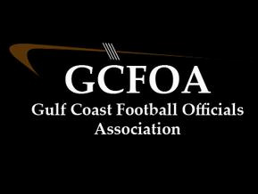

Fall Meeting #4 – August 23rd, 2022

President: called the meeting to order at 7:00pm

- Ron spoke to player safety and the importance of always erroring on the side of it when officiating a play. We all must do a great job of dead ball officiating

Vice President: Training – Dan Musick gave a presentation on the passing game. He did a nice job and brought up good discussion point
Test review again next Tuesday 6pm before the meeting

Assigner report: Jason Heckman
- White hats, communicate with your crew and school administration
- Penalty reports to David Hall by Saturday evening
- Went around to the white hats for game reviews from last Friday

Treasurer Report: Jeff not present
- Nothing had changed since last meeting

Secretary Report: Geoff passed out attendance sheet.
- Spoke to JLA cards, you know who you are

No Committee reports

No New business

No Old Business

Announcements – Greg Hagopian has a contact that can embroider our GCFOA logo on any shirt you provide her. Her contact info is VaL Wheat, 941.545.4495 or runningwithscissors.llc@gmail.com
Glen Harter has a pair of new Reebok field shoes size 10 – 10.5 that he has to return. If interested in them contact Glen - $80.00

Motion to adjourn at 8:20pm by Jamie V (of course) and seconded by Drew M

