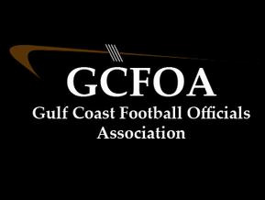

Fall Meeting #5 – August 30th, 2022

President: called the meeting to order at 7:04pm

* Ron spoke to ejections and how to handle as a crew. Report is due to the state within 24hrs. Copy a board member when you submit. Will work to get a sample form up on the web page

Vice President: David, training –

* Geoff showed some clips from our games last week and there was some discussion around them. We will not meet again until after the test is due

Assigner report: Jason Heckman

* Thanked the members for their patience and understanding as he works through some changes over the next few weeks

Treasurer Report: Jeff not present

* Nothing had changed since last meeting

Secretary Report: Geoff passed out attendance sheet.

* Test is due by 9/12 at midnight

No Committee reports

No New business

No Old Business

Motion to adjourn at 7:45pm by Jamie V (of course) and seconded by Drew M