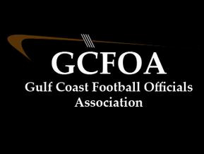

Fall Meeting #6 – September 14th 2021

President: Ron called meeting to order at 7:00pm No new members were present

* Spoke to security at the fields, incident at Sarasota
* State has not finalized the test yet
* Make sure and use the correct AT6 form for ejections

Treasurer Report: Jeff not present

* Had sent out financials via e-mail before the meeting
* Motion to approve by Sean M, second by Drew M

Secretary Report: Geoff passed out attendance sheet.

* All dates for registration and testing have passed
* JLA cards, Geoff needs to see them, especially those that have been e-mailed and asked to send a copy
* Asked about any issues at schools, Riverview was brought up
* Handed out rule books after the meeting

Assigner report: Jason Heckman

* Underclassman schedule is out through 2nd week in October
* With all the changes, best we can do is have the varsity schedule out 2 weeks
* The first two weeks of Varsity in October will be out by next week

Vice president Report: Ron – not present

* We had some discussion on unique plays in our games
* Sean M had a case book play discussion

Recommendation committee – David Hall spoke to the 2021 Playoff selection process. Evaluations are coming in and they are waiting for the state to release the test scores

No Old business, No new business

Motion to adjourn at 7:46pm by Drew Mand seconded by David H