Lisa Pavelka’s Tips for Clay Striping

© Lisa Pavelka, All Rights Reserved

www.lisapavelka.com

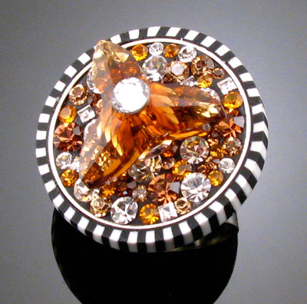

Adding striped veneers and borders to your creations is a great way to make them “pop.” It can add a fresh look for framing jewelry or accenting accessories and home décor. While making stripped loaves sounds easy, it’s the tips and tricks that make execution of the motif clean and sharp. Striped loaves of polymer clay have many applications for embellishment, both as accents made from flat sheets and as edging that is seen from two angles. While there are unlimited variations for stripping regarding color and widths used for each stripe, this tutorial focuses on one basic formula. It’s up to you to play and vary the results of your stripping for your creations. Try more than two colors, varied thickness layers, etc.

1. Stack two - 1½” x 3” sheets of clay (in contrasting colors) that have been rolled through the 3rd largest setting of the pasta machine. Working with larger sheets of clay will also produce larger loaves.

2. Cut this sheet into quarters (3/4” lengths) and stack one over the other, with the colors alternating.

3. No need to trim the edges to make them neat. Rolling the slices to make them a uniform thickness will distort the stripes on the edges and along the top and bottom. Retaining these uneven edges will lessen the amount of distorted stripes you will need to trim away later making your clay go farther. Tip: When cutting slices from a stripped loaf, always slice with the stripes lying horizontally.

4. For a single slice, roll the strip through the pasta machine on the desired setting with the stripes facing vertically (or upwards). Cut away the distorted top and bottom edges to create the desired width of your striped strip. Cut in 2-3 stripes from the outer edges to ensure you’ve removed the distorted stripes when the clay was stretched and thinned through the pasta machine.

5. To make continuous strips from multiple slices of stripped clay, cut as many slices as you need (as evenly as possible). Follow the direction in Step 4 to make each slice a uniform thickness. Abut the trimmed and flattened slices side by side (with strip colors alternating) over a thin sheet of background clay rolled out on the 5th or 6th largest setting of the pasta machine. Tips: using an acrylic rod to thin the stripes may offer more control over thinning and stretching of the stripes. Always roll in the direction of the stripes. If the outer stripes on each slice appear distorted, cut away (inward) as many stripes as needed until you see a uniform width for each stripe and then abut the sections together over the clay base layer.

6. Place a deli sheet over the stripped strip and gently roll over the stripes with an acrylic rod. Be sure to roll back and forth following the direction the stripes are going. Rolling from side to side, so that the roller is parallel with the stripes will stretch and distort the width between the stripes. This will meld the slices together and prevent them from separating when rolled through the pasta machine.

7. Lastly, place the striped strip (with deli paper still in place) through the desired setting of the pasta machine with the stripes facing upward (vertically) and roll out. Trim and apply as desired. Rolling the stripes horizontally will result in exaggerated distortion.

Tip: The thickness of your slices will depend on how you are applying them. If the striping will only show from the front, it can be made very thin. If striping will appear from the front and along the top edge (as when wrapped around something such as a box or a pendant) you may wish to make the slices thicker for use in wrapping items or framing bezels, roll through the 1st, 2nd or 3rd largest settings to give the top edge depth and dimension from all visible angles.

Tip: If the striping will appear from two angles, the color of a backing strip (if used to join two or more slices) will show. Consider this when selecting the backing color. Using one of the stripe colors will create a complimentary framed appearance. Selecting a completely different color from any of the ones used will create a contrasting appearance.

