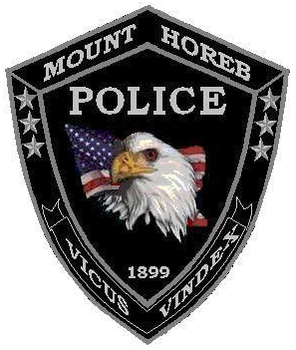
MOUNT HOREB POLICE DEPARTMENT
BUSINESS INFORMATION FORM

Business Name______________________________________
Phone____________________ Fax_____________________
Address___________________________________________, Mount Horeb, WI 53572

Business Owner Telephone # Email
______________________ ______________ _____________________

Building Owner Telephone # Email
______________________ ______________ _____________________

PLEASE CHECK ALL THAT APPLY
- Hazardous Material _____Yes _____No
- Surveillance Video _____Yes _____No
- Alarm – Type and Company __________________________________________
- Safe _____Yes _____No Location ________________________________

CONTACT PERSON / KEY HOLDER INFORMATION
Contact #1 ________________________________ Phone_____________________
Contact #2_________________________________ Phone_____________________

MISCELLANEOUS INFORMATION
__________________________________________________________________________________________________________________________________________________________________________________________________________________

WAIVER
I hereby authorize Mount Horeb Police Department personnel to enter my premises after hours in the event of a police or fire emergency, investigation, and/or if the business appears to have been broken into or found unsecure.

________________________________________ ______/_______/_______
Signature and Title Updated Date

