How to Insert iPad into Stand
- Slide iPad in from the left, oriented like in Figure 3, with the iPad Home button positioned on the right
- Make sure the iPad’s USB port (the slot at the bottom of the iPad) is securely connected to the Square Stand
- Lock in the iPad by pushing the metal screw located in the bottom left of the Square Stand in. If the iPad is securely connected, the pin should slot in smoothly
- To confirm if the iPad is securely connected, if the Square Stand is connected to a power outlet, the iPad should also start charging, indicated by a green battery icon (red circle in Figure 4). The icon would be white otherwise.

How to Remove iPad from the Stand
- To remove the iPad, first pull out the metal screw located in the bottom left of the Square Stand
- Then, push the button behind the Square Stand to push the iPad out (red circle in Figure 5)
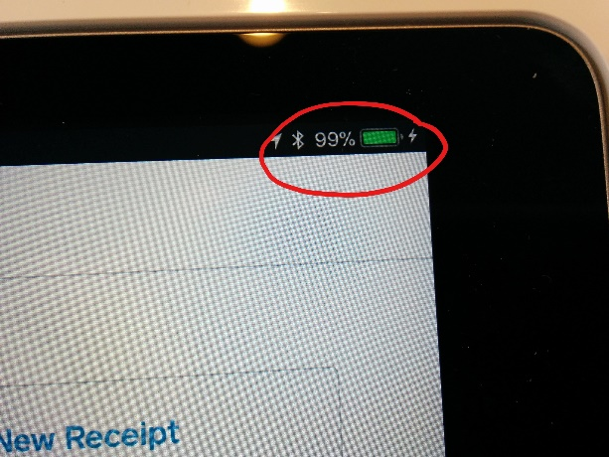
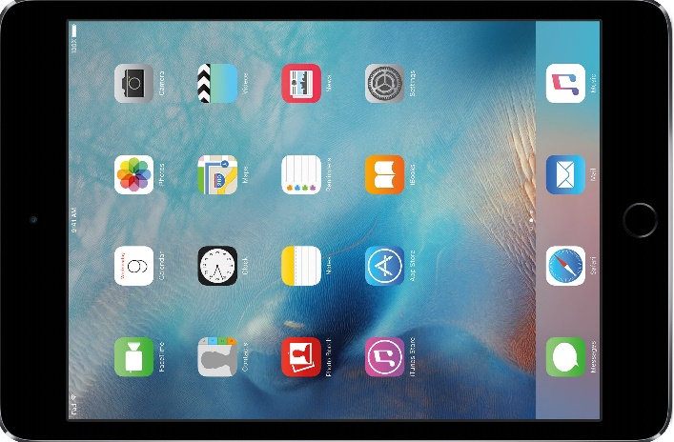
- Pull the iPad out from the left side, might take a few gentle tugs before the iPad comes free

Figure 4
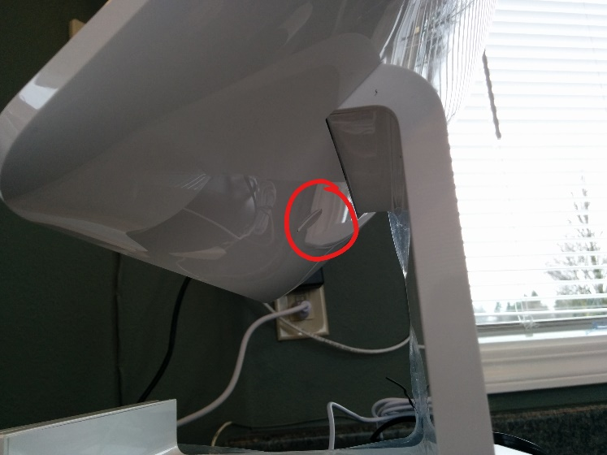
Figure 3

Figure 5

