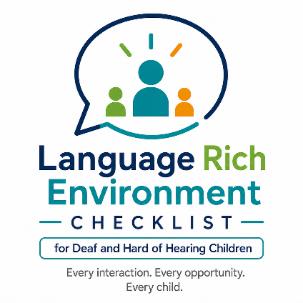

Language-Rich Environment
Checklist: Family/Caregiver

Child’s Name: Date:
Family Member/Caregiver: Provider:
As you coach the family regarding language acquisition opportunities, discuss each of the following practices using examples and referencing typically developing milestones. Record suggestions for the family member or caregiver to strengthen the language learning environment.

Do you... | Yes | Some-times | No | What I do / What I will do...
- Consider the environment to reduce background noise and visual distractions before communicating with your child. Examples: Turn off TV, video, and any other sources of sound or visual interference/competition.
- Use various means to gain your child's attention before talking/signing. Examples: physical (such as touch) spoken or signed prompts or signals.
- Consider your child’s listening and visual bubble to maximize access to facial expressions and speech/sign to encourage attention and focus during communication. Examples: Remind others to talk/sign one at a time and to repeat or rephrase when needed.
- Use language matched to your child’s age and development to describe activities, routines, and events. Examples: Repeat language at an appropriate level to ensure your child understands and can use a variety of language structures. If your child is using a single word or putting two words together, use phrases; if they are using phrases, respond with sentences.

Do you... | Yes | Some-times | No | What I do / What I will do...
- Embed words, sounds/signs, and letter play into daily activities and routines. Describe what you are doing so the same words/signs are connected to routine acts. Examples: diaper changes, bathing, eating, playing).
- Model developmentally appropriate forms of grammar (ASL, English, Spanish, other languages). Examples: Expand simple (words) to more complex phrases and sentences. English based word signs expand to developing ASL.
- Use language to talk about your child’s and other people’s emotions and thoughts. Examples: Start with simple words such as happy, sad, scared, angry and explain why they are feeling those emotions. Increase language complexity as warranted.
- Include your child in communication occurring around them such as family/group meals, conversations, and activities. Tip: Remind others to talk/sign one at a time/repeat-rephrase when needed.
- Respond to every, or almost every, communication attempt made by your child. Tips: Make sure the response relates to the topic or words made by the child.
- Read daily with your child. Tip: In addition to the words, illustrations in books present unlimited talking/signing opportunities.
- Include daily writing or drawing activities. Tip: Children love to express themselves; drawing is a great way if words are hard to find.
- Know how many words/signs per sentence you generally use. Tip: Record a conversation with your child, then count the number of words/signs you have used.
- Know what sounds/signs your child knows, and which sounds/signs are current targets. Tip: keep a list of the first 100 words that your child understands.

We would appreciate your feedback on this checklist. Please complete the feedback form at this link:
https://forms.gle/tMgJLUzf5CcrKPu3A

Adapted 2026 by Cheryl DeConde Johnson, Patricia Smolko, and Carrie Davenport with permission from Lang, S.N., Buettner, C.K., Knight, K. M., Buettner, D., Pickett, J., Artman-Meeker, K., et al. (2016-2024). Language-rich environment inventory from the Family Child Care Track, Communication & Language Development Course, Lesson 4. The Department of Defense Child Development Virtual Laboratory School, https://www.virtuallabschool.org/fcc/communication-and-language-development/lesson-4/act/19946. Adapted version available at www.adevantage.com/resources.

