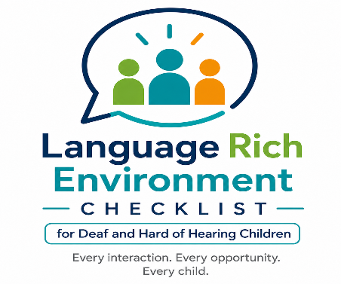

Language-Rich Environment Checklist: Preschool

Child’s name: Date:
Classroom Teacher: Teacher of the Deaf/Interviewer:
As you support the preschool teacher regarding language acquisition opportunities, discuss each of the following practices using examples and referencing typically developing milestones. Record suggestions for the preschool teacher to strengthen the language learning environment.

Do you... | Yes | Some-times | No | What I do / What I will do...
- Consider the environment: reduce background noise and visual distractions before communicating; gain the child’s attention and eye contact prior to initiating communication.
- When communicating, utilize the “bubble” principle (within 3 feet) that defines the listening and visual distance to maximize access to the speaker.
- Use developmentally appropriate language in all daily activities and routines including incidental learning opportunities.
- Embed words, sounds/signs, and letter play into daily activities and routines.
- Adapt/expand your language based on each child’s language level/ability.
- Model appropriate forms of grammar (ASL/English/Spanish or other language).
Do you... | Yes | Some-times | No | What I do / What I will do...
- Note the communication styles and language levels of the children in your classroom.
- Note how many words/signs per sentence you generally use.
- Track the sounds/signs the children know, and which sounds/signs are current targets.
- Read daily to children.
- Include daily writing or drawing activities.
- Keep families aware of the books and stories you use in the classroom.
- Encourage frequent family visits to the classroom.
14. Encourage families to read to their children.

We would appreciate your feedback on this checklist Please complete the feedback form at this link:
https://forms.gle/7EnX7TV5pScK1Kft5

Adapted 2026 by Cheryl DeConde Johnson, Patricia Smolko, and Carrie Davenport with permission from Lang, S.N., Buettner, C.K., Knight, K. M., Buettner, D., Pickett, J., Artman-Meeker, K., et al. (2016-2024). Language-rich environment inventory from the Family Child Care Track, Communication & Language Development Course, Lesson 4. The Department of Defense Child Development Virtual Laboratory School, https://www.virtuallabschool.org/fcc/communication-and-language-development/lesson-4/act/19946. Adapted version available at www.adevantage.com/resources.

