Key Facts for Having Darts Boards

* Each board should be about two feet from each other. You want to make sure you have enough room for a white board (for scorekeeping) and so if you do have dart league there eventually people have enough room to safely write their score and retrieve their darts.
* You can order black back drops for the dart board OR you can reach out to your local beer distributor and see if they can provide backdrops. (I have attached pictures of both below)

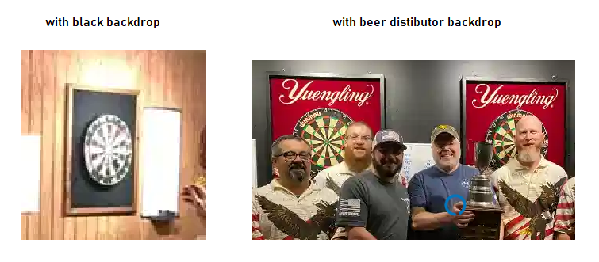

* Lights are a big part of a successful dart board set up. You can use whatever lights you want, but they make some on Amazon that are cheap!
* We have 4 darts boards for each bar we play out of, because normal league play consists of 8 players (1 on 1). You can start off with like 2, and then the league can help with 2 also, that way you have 4.
* You need lines so far back from the dart board. (In the diagram below) You can use tape, order some online, or ask your local beer distributor if they have any. Some bars do that, and some just have duct tape.
* In league play, there are a few main games we play. We play 501, 301, and cricket.
* For now, while you’re just trying to get something started, I recommend going to Dunhams, Walmart, or even Amazon and ordering at least 5 sets of darts. You can keep them behind the counter or beside the dart boards so people can play as they want even if they don’t have darts of their own.

Dart set on Amazon: <https://www.amazon.com/DARTSPACE-Premium-Aluminum-Flights-Protector/dp/B091F1F4Z1/ref=asc_df_B091F1F4Z1/?tag=hyprod-20&linkCode=df0&hvadid=507718513187&hvpos=&hvnetw=g&hvrand=1591787427959562934&hvpone=&hvptwo=&hvqmt=&hvdev=c&hvdvcmdl=&hvlocint=&hvlocphy=9009441&hvtargid=pla-1290115156286&th=1>

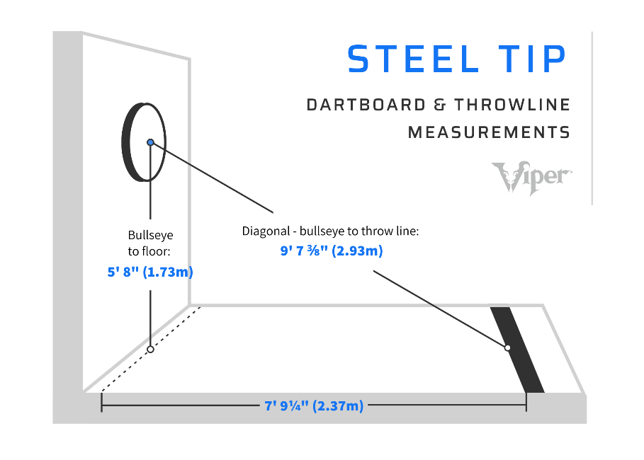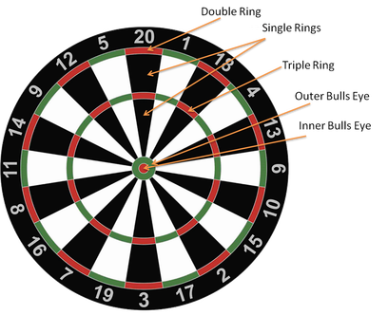

**501** (usually one vs one) - Both players or teams start with a score of 501 points. Each player then takes alternating turns at throwing their darts at the dartboard. The points scored are removed from the total, and then the opposing player/team does the same. The first to reach zero wins the game. Players have to double out, which means if you have 32 points left, the player would have to hit a double 16 to win. If they hit a single 16, they would have 16 points left, and they would need to move to a double 8. If they hit a triple 16 for example (48 points), they would have busted and their turn would be over.

**Cricket** (usually doubles) - Players take turns throwing three darts at the board, trying to hit 20 through 15 and the bullseye. If you hit any other number, nothing happens. Cricket requires each person to “close out” numbers, meaning players have to score each number (20 through 15) and the bullseye three times before the game can end. If you hit the outer ring of a number, that counts for two, and if you hit the inner ring, that counts as three (unless you’re aiming for the bullseye, in which the outer ring counts for one and the inner circle counts for two). So, if you hit the inner ring of 15, for example, that closes it out for your team. If a player closes out a number before the other does, that player can start racking up points every time they hit that number until the other player closes it out. Once both teams have closed out a number, it is no longer in play and neither team can score points on it. The team that closes out the board with greater or equal points wins.

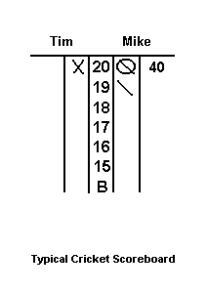**301** (usually doubles) - Both players or teams start with a score of 301 points. Each player then takes alternating turns at throwing their darts at the dartboard. THEY HAVE TO DOUBLE IN BEFORE THEY CAN START SUBTRACTING. The points scored are removed from the total, and then the opposing player/team does the same. The first to reach zero wins the game. Players have to double out, which means if you have 32 points left, the player would have to hit a double 16 to win. If they hit a single 16, they would have 16 points left, and they would need to move to a double 8. If they hit a triple 16 for example (48 points), they would have busted and their turn would be over.

In this example, Mike and Tim are playing cricket. Mike has the 20’s closed, one 19, and pointed Tim 40 points because he hit two 20’s and Tim did not have them closed out. Once the player has a circle, they cannot be pointed.