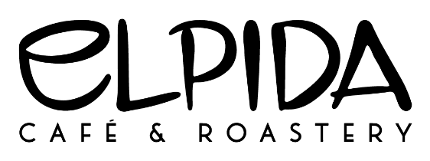

Artist of the Month Application 2022

If you are interested in showcasing your work for sale at our café, please take the time to fill out this form, and submit it to hello@elpidacafe.com with the subject line “Artist of the Month Application 2022”

Note: The artist has full control over the selling price of their artwork on display, but we ask for a 25% commission upon sale.

Artist Information
Name: |  |  |  |  |  | Date:
Phone: |  |  | Email

Do you live within Georgina? __________________________________________________________

Do you have your work featured anywhere else in Georgina? _________________________________

Artwork
Type of Artwork:

Social Media Accounts?

Facebook:

Instagram:

Website:

Examples of Art

Please submit photos within this document or attached separately in the email of examples of art pieces that you would wish to display. So we can get a feel for your style, and better assign artists of similar medias throughout the year. We do have a large volume of requests and cannot guarantee that we will be able to schedule your artwork for 2022, but thank you for applying!

Would you be able to display your art for any month of the year? ______________________________

Would you be willing to display your art in 2023 if not 2022? __________________________________

Notes

- An artist is assigned one month of the year, to display 6-8 pieces of their art for sale.
- Artwork may be switched up midway to bring in new pieces. We have some hooks in place on the wall. Bringing command strips is also recommended to better position art of varying sizes.
- We will collect payment upon sale of the artwork, and give the artist 75% upon the last day of the month when they come to collect what remains
- If we believe a piece of art is not suitable for display in the café, a family setting, we reserve the right to request an alterative piece to be displayed
- Each Artist of the Month will be featured in a post on our Facebook and Instagram pages to help promote their work

Photos
Insert 4-6 photos of examples of artwork you’d like to feature below, or for better quality, you can submit photos as attachments in an email or let us know which pieces of artwork in your social media accounts you’d like us to see.

We will contact you through the email provided if you’ve been assigned a month for 2022! We wish you all the best!

