Little Sneakers Daycare
Rockville, Maryland
PARENT HANDBOOK

Table of Contents
Daycare Address, contact information, welcome…….…..……………..2
Policies on Inclusion, Enrollment and Positive Behavior........…..….3
Wellness Policy and CACFP………………………………………………… ……..4
Meal patterns…………………………………………………..…………...……….…..5
Daily Schedule ……………….……………………………………….………………….6
Emergency Preparedness Plan………………….………………..……………7-8
Outdoor play and clothing, updates to important information,
Vaccine requirements, Immunization Schedule…………………………..9
What to Bring and What Not to Bring with checklist…………….……10
Basic care Topicals, Inclement weather, school closings,
Paid Holidays…………………………………………………………………………..…11
Administration of Medications, Potty Training,
Parent Conferences…………………………………………………………………….12
Payments and Other Fees…………………..………………….……..……………13
Sick Policy……………………………………………………..…………………………...13
Division of Early Childhood resources………………………………………...14

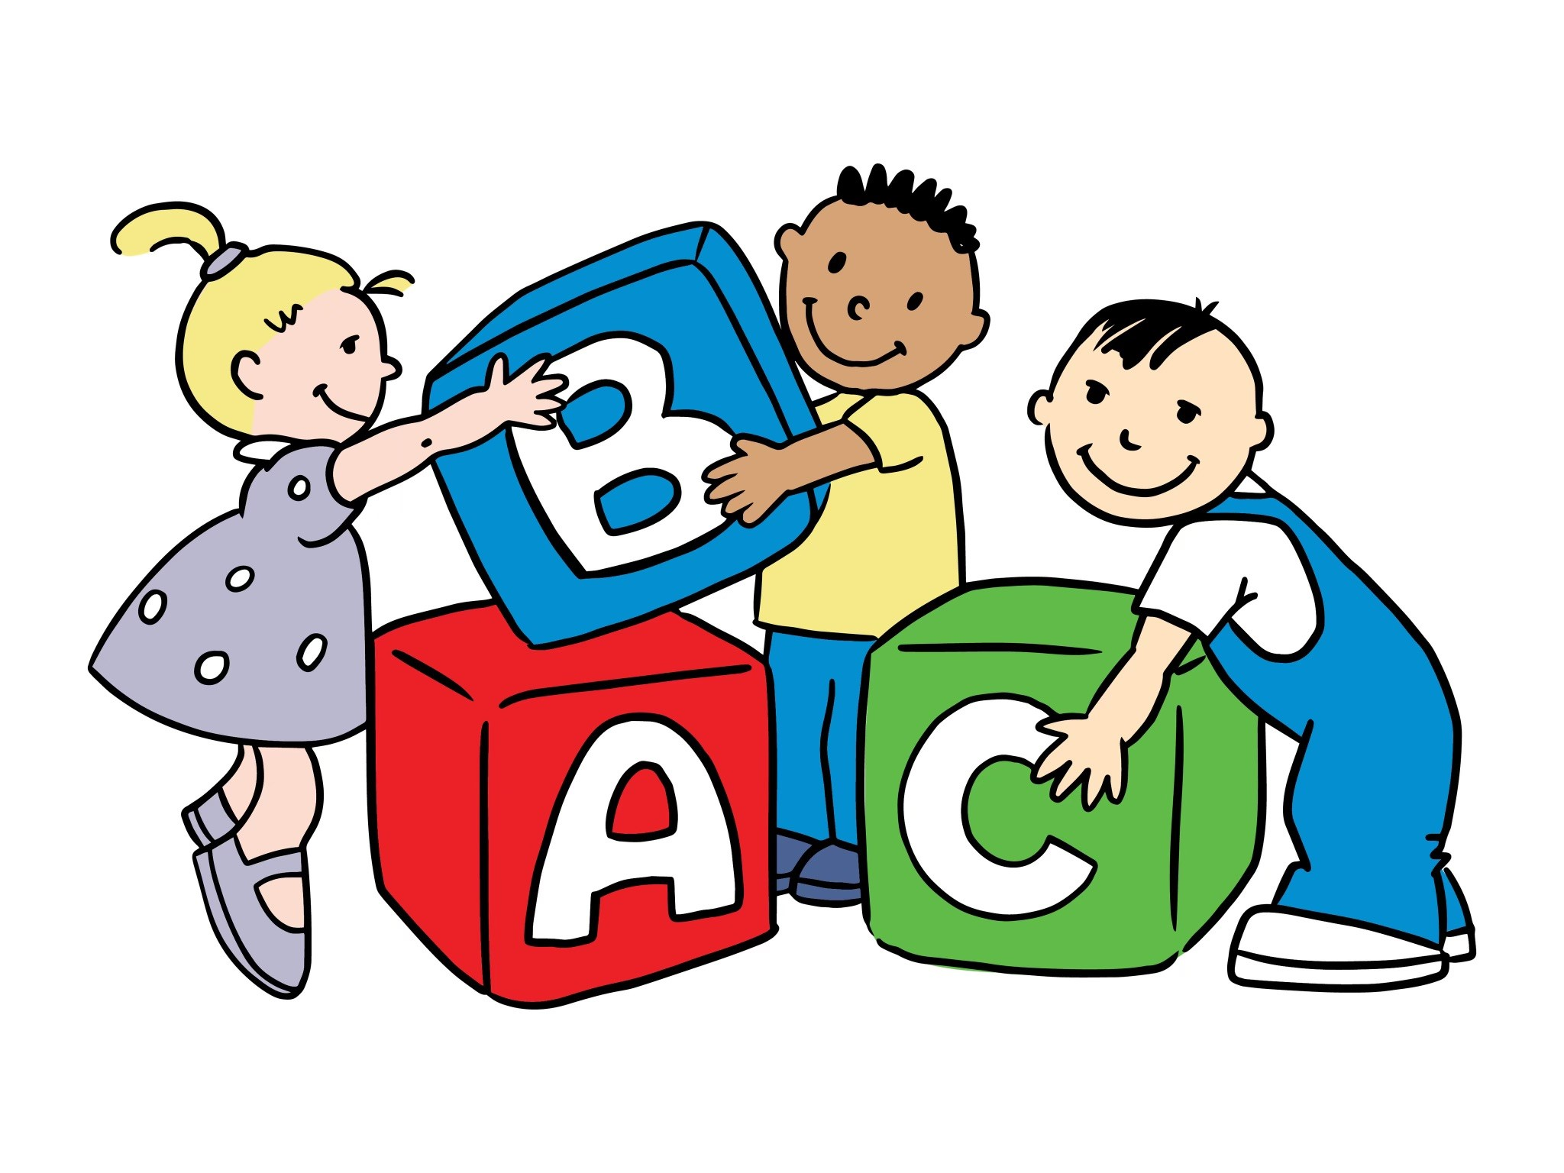

Little Sneakers Day Care
Lisa Froble
103 Tall Grass Court
Rockville MD, 20850
Cell 240-281-1748
MyLittleSneakersDaycare@hotmail.com
www.LittleSneakersDaycare.com

Daycare is open
Monday through Friday from
7:30 AM to 5:30 PM

Welcome to Little Sneakers Daycare
Little Sneakers Daycare offers a fantastic environment for early childhood development by combining play-based learning with 30 years of proven expertise. Miss Lisa’s long-standing license and commitment to exceeding state requirements mean your child receives safe, high-quality care tailored to their specific developmental stage.
The daycare is fully equipped to care for and educate your child. I will provide a loving and safe environment for your child(ren) and all educational supplies needed to teach him/her appropriately for their age, interest and skill level.

Inclusion Policy
My Little Sneakers Daycare welcomes all children to fully participate in my family daycare, including children with disabilities and special healthcare needs. I will support you and your child in meeting their developmental needs. If outside service agencies are needed for your child, I will work with them to support your child. If your child has an IFSP/IEP please share a copy.
Enrollment Policy
I have an informal wait list that will require you to give email addresses and cell phone numbers to be used solely for contacting you when I know that I will have an opening. You may be contacted by text, phone call, or email asking you to respond if interested. A copy of the daycare handbook will be attached. If you have not contacted me in 3 days, I will contact the next person on the list and so forth. The first scheduled in-person meeting, where we both are able to have our needs met, will have first refusal.
If the needs of the family and the child care are met to satisfaction leading to enrollment: The parents will receive a contract and registration forms to be completed as soon as possible. All forms need to be submitted no later than 3 working days prior to the start date in order to have the time to be reviewed for completion and errors. All forms need to be submitted and error-free before the first day of care.
Positive Behavioral Policy
Children are taught how to identify feelings by expressions early on. They learn that it feels good to them if they approach a situation in a positive way. Many times, a small child will hand you something if you just hold your hand out and smile even if they do not understand what you are saying. That is the positive. No one is forced to share. They learn to through a method of asking, holding their hand out, and smiling. When the item is shared, everyone is smiling. There are enough of the same popular toys for 3-6 children. In a case where the child is upset and/or trying to hurt someone, they will be placed on a time-out until they are calm enough to talk. I will then walk the child back to the group and show them how we ask for toys. The child can play with the same toys with the group or away from the group if they choose, and of course, move on to something else. Children are always rewarded with a high five, a smile, and maybe a sticker when they are caught being a good friend, as we call it. I think it is very important to notice when a child is doing what you want them to do rather than only pointing out what you do not approve of.
Wellness Policy
The health and wellness of children is a national concern. By offering healthier foods and scheduling more physical activity in my family child care program, I will encourage children to adopt healthy habits.
Nutrition Goals:
1. I will offer three or more different fruits and/or vegetables to the children each day.
2. I will prepare meals from scratch.
Physical Activity:
- Children will be provided with at least 60 minutes of outside free play each day.
2. Children will participate in structured physical activity each day.
Scheduled rest period:
- Children under the age of 5 will be provided a quiet space to rest for two hours each day.
I will review this policy monthly to see if we are meeting these goals and consider how to keep meeting them or improve them.

CACFP
Under my agreement with the Child and Adult Care Food Program, all enrolled children will be offered appropriate servings of nutritionally balanced meals daily. In the case of food allergies of a required component, a doctor’s note will be added to the child’s records and an allergy action form.
You will receive an email around your start date from KidKare asking you to sign up. There will be a form for you to review, make changes if necessary, electronically sign, and send back. This will automatically repeat annually.

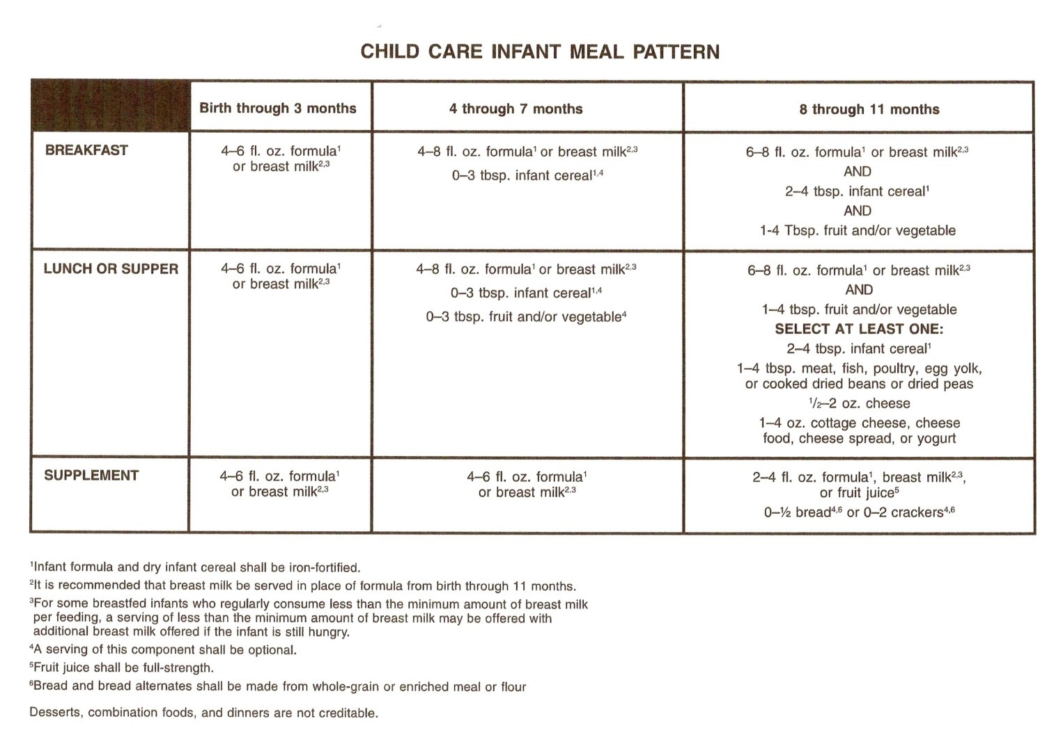

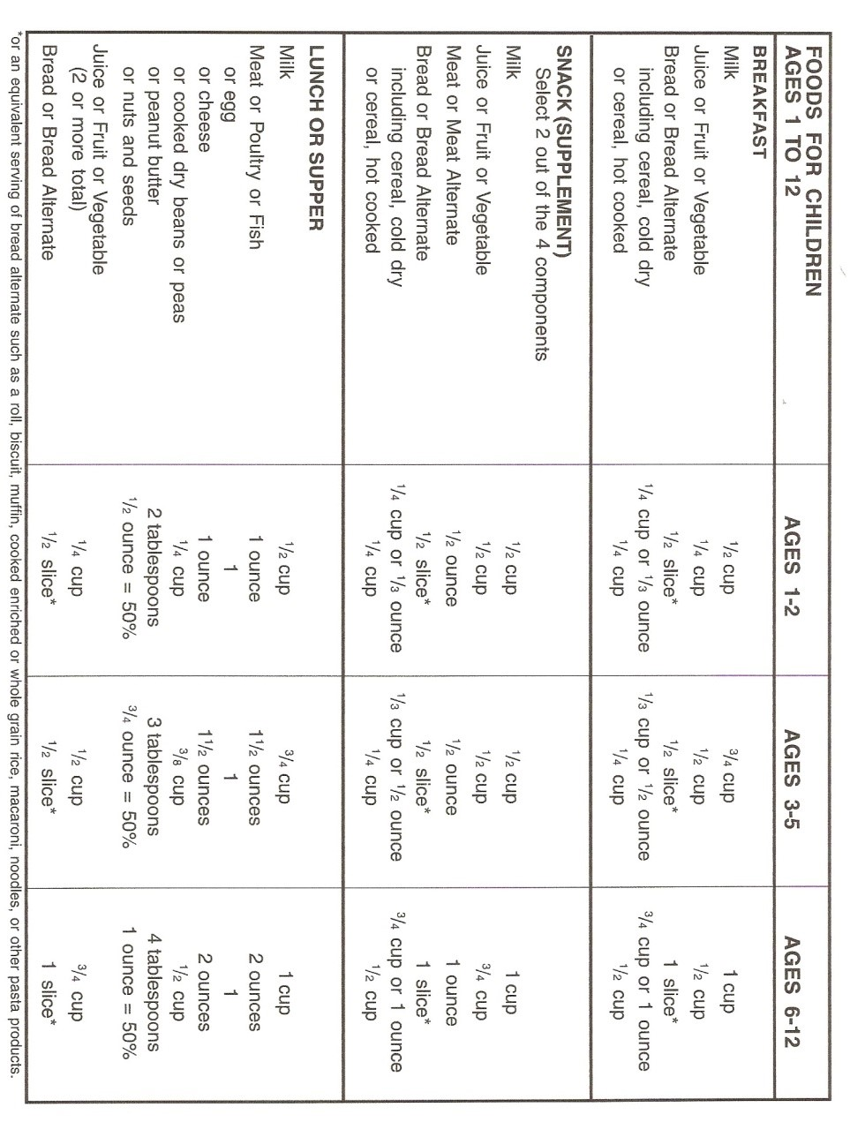

Daily Schedule
7:30 AM…………..Daycare opens
8:00 AM……………Breakfast
9:00 AM……………morning walk and outdoor play
9:45 AM…………..morning activity in the kitchen or educational curriculum
and free play in the playroom
10:45 AM………..clean up
11:00 AM………… mini educational curriculum
11:30 AM…………Lunch/reading
12:00 PM…………clean up
12:30 PM…………Story Time
1:00 PM…………..nap time
3:15 PM…………..snack time
4:00 PM…………..park and outdoor play
5:00 PM………….clean up
5:30 PM………….Day Care closes

EMERGENCY PREPAREDNESS PLAN

Little Sneakers Daycare Owner/operator Lisa Froble
Family childcare registration #113012 Montgomery County
103 Tall Grass Court Rockville, MD 20850
(C) 240-281-1748 MyLittleSneakersDaycare@hotmail.com
1. Local Emergency Operations Center
This is who we contact for instructions in case of emergency. They are aware of our location. MCDEM is located at 100 Maryland Ave. room 220 Rockville, MD 20850. 240-777-2300.
2. The following position(s) at the childcare site are responsible for:
Declaring an emergency: LISA
Arranging transportation for children/staff: LISA
Calling for assistance: LISA
Carrying needed medications: LISA
Contacting families: LISA Completing final building checks after evac:LISA
Making the decision to evacuate: LISA Media contact person: LISA
Initiating contact with evac site: LISA Conducting emergency drills: LISA
Carrying “ready to go” File: LISA Communicating Emergency plan to parents: LISA
Carrying Disaster supply kit: LISA Pet arrangements if time allows: LISA
Bringing children’s activities to evac site: LISA Determining when the emergency is over :LISA
3. Children, Staff and Program records
Records will be on a flash drive (“ready to go” file) in or near the emergency supplies updated as needed or annually by LISA
4. Local emergency numbers
Police Fire Ambulance Emergency Operations
911
Office of Childcare
240-777-2300 240-314-1400
Health Department Utilities Poison Control Hospital
240-777-3986 240-314-8567 800-222-1222 301-279-6000

Amanda Katzer (daycare substitute) Tammy Dunlop (Lisa’s daughter)
913-593-7546 240-888-5755

5. The local Emergency Alert System radio station is 630 AM and 105.9 FM
6. The locations in the child care site where the emergency phone numbers are posted:
One set on each floor of the house near the telephone.
7. Emergency communication
LISA is responsible for communicating emergency information.
The items used for communicating will be my cell phone. The cell phone will be kept with me at all times and a recharge system will be kept with the emergency supply kit which will be stored in the basement near the playroom.
8. Disaster Supply Kit
The disaster supply kit will contain food, water, a First aid kit, records, a radio, and various additional emergency supplies. LISA is responsible for checking the supplies in the kit on a regular basis and LISA will transport the kit in case of evacuation
9. The sites that are evacuation locations for the childcare site are:
Julius West Middle School 651 Great Falls Road Rockville 301-279-3979
If school is in session then the alternate locations to evacuate to are:

First Baptist Church of Rockville 55 Adclare Road Rockville 301-279-2400
Rockville United Methodist Church 112 W. Montgomery Ave. Rockville 301-762-2288
Lutheran Church of the Cross 12801 Falls Road Rockville 301-762-7565
Contact persons and formal written agreement have been secured with First Baptist Church Contact persons: Lindsay Folkerts or Kevin Crawley at 301-279-2400
Agreements will be reviewed and updated by LISA as necessary.
Children will either be transported by car or by walking with the use of a double stroller to the evacuation site.
10. Accounting for children after an emergency
LISA will be responsible for accounting for the children after an emergency by a head count.
11. Natural Emergency Situations
The Natural emergencies that are more likely to occur in our area are:
Wind storms, hurricanes, tornadoes, and power outages from high winds.

12. Difficult situations with adults
In the event that an authorized adult comes to pick up a child in an “impaired” condition:
I will step away as if preparing for the child to depart, lock the door, and call 911.

13. Emergency Plan Review
The emergency plan will be reviewed and/ or revised by LISA every 6 months.

14. Child Care Site Emergency Readiness
In order to strengthen our ability to handle emergency situations, the following strategies will be implemented:

Practice drills
Review emergency handbook
Check for updates

The format for this plan was designed for childcare centers and homes and created by Chesapeake College in cooperation with the State of Maryland. I attended a 6-hour EMERGENCY PREPAREDNESS TRAINING course which included creating this plan.

Outdoor play and Clothing
Children will wear socks or indoor-only shoes throughout the day.
Our daily activities include being outdoors twice every day as the weather permits. Your child must have fitting shoes for walking, running, jumping, and climbing. Sandals, crocs, and shoes with open toes or backs are not allowed for outdoor play.
Outdoor summer play includes water play. Please bring a bathing suit, water/swim shoes
Please provide the necessary changes of clothes, jackets, and sweaters as the temperatures during some seasons fluctuate during the day.
A simple pair of gloves is fine for cool weather outdoor play.
We love playing in the snow! Bring a complete outfit similar to what you would wear on a very cold day to go sledding with a good pair of well-fitting waterproof gloves. It is important that the snow outfits fit well, cover the skin, and allow the children to move freely.
Updates to important information
Please update important information as soon as possible. If your contact phone numbers change, your home address, your work address, or your emergency backup- up people change their contact information. Please send your child’s updated immunization record immediately following their most recent immunization visit. You may add or update any information in your child’s file at any time and as needed. You will also be asked to do it on an annual basis around your anniversary date.
Your child may only be picked up from daycare by an adult listed on the emergency information form.
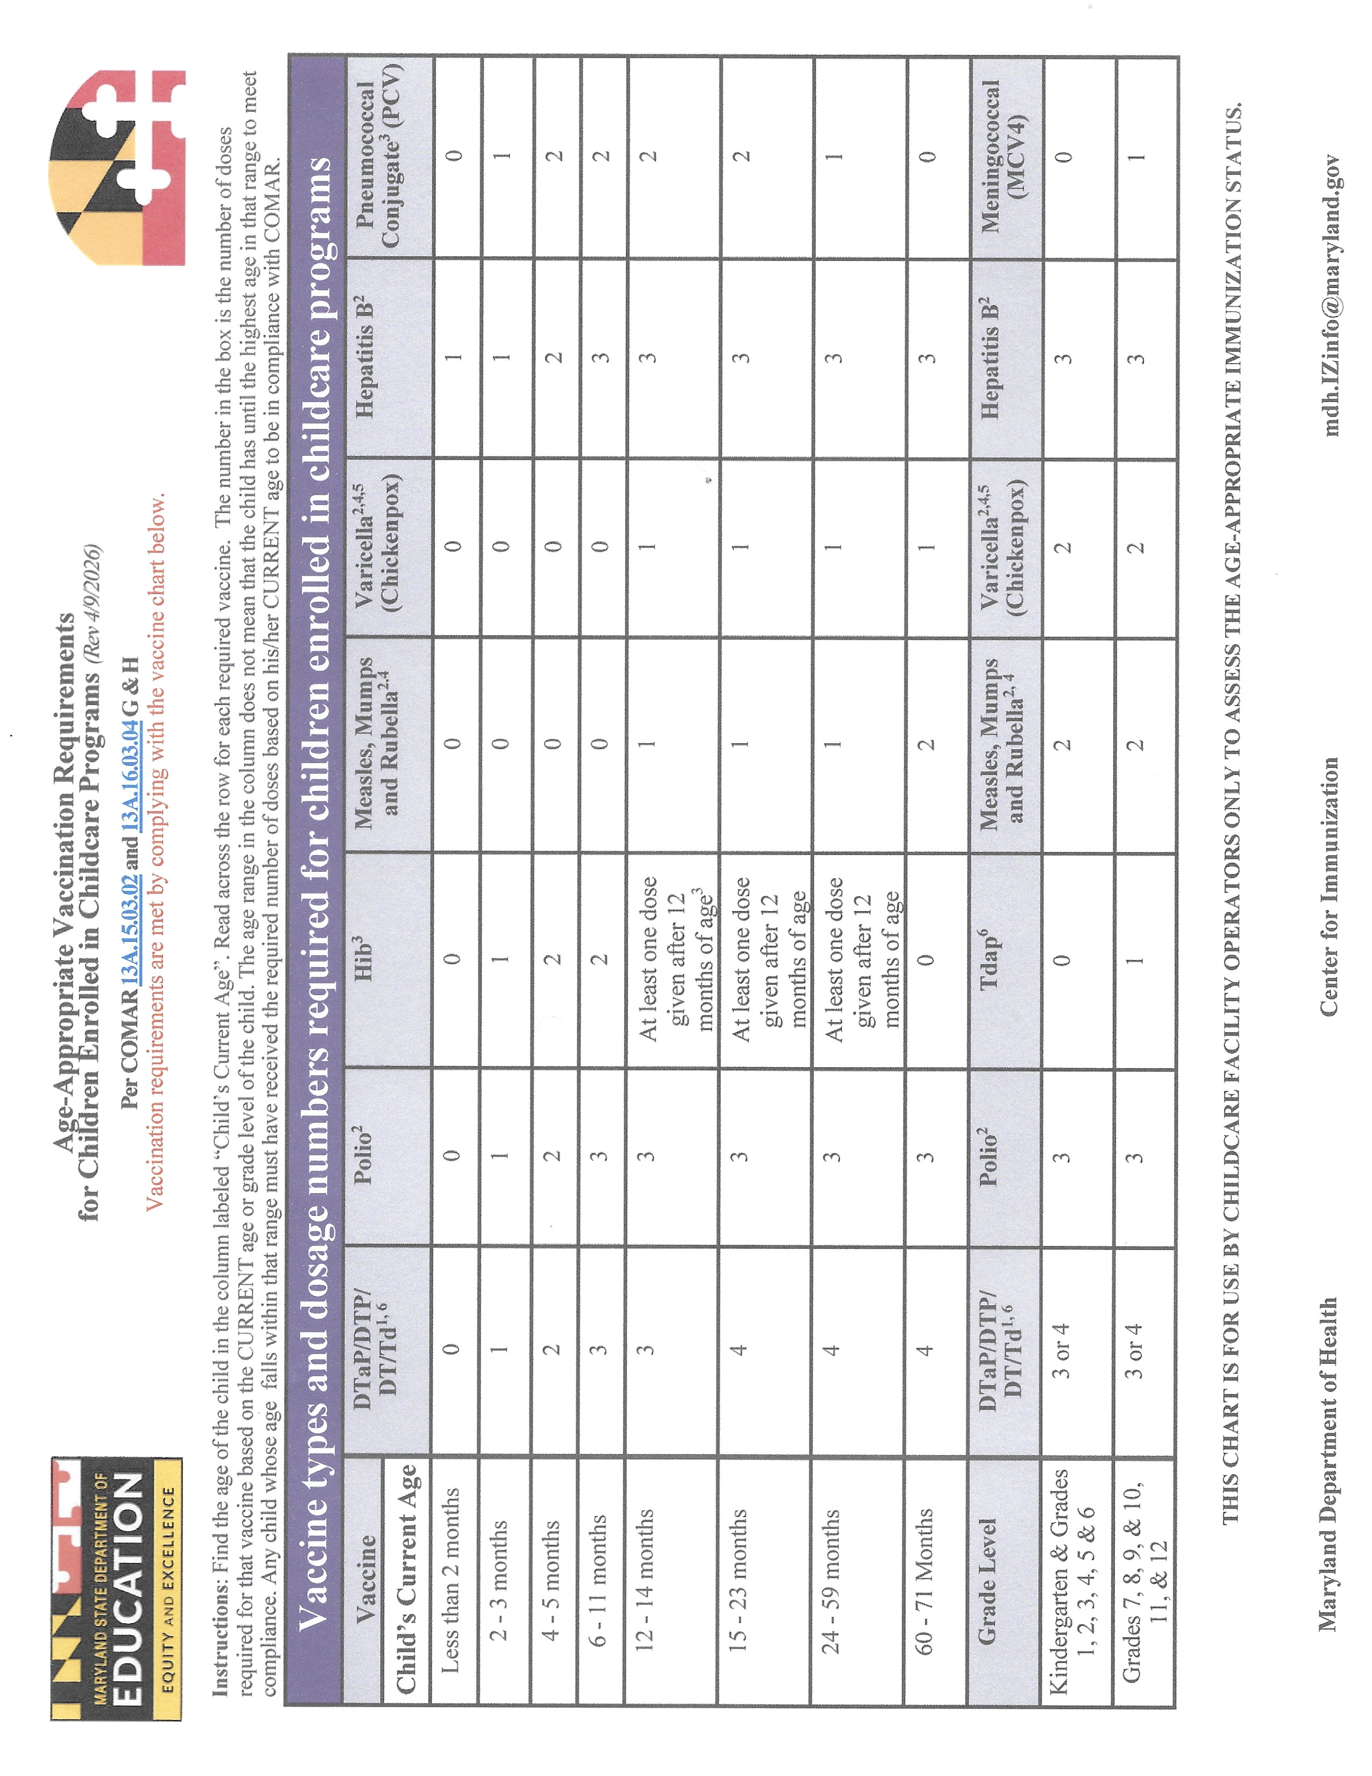

Food serving guidelines for children 1 year and up

What to bring and what not to bring
Please bring and maintain a supply of:
Diapers
Wipes
2 or more complete changes of clothing including socks
Extra tennis shoes and socks
Basic health care items
Please do not bring or allow your child to walk in with:
Toys
Food/candy/gum/ doughnuts
Pacifiers or bottles (infants under the age of 1 year may use a pacifier for sleeping only)
Pull-ups
It is not necessary to bring a diaper bag daily. Your child should have what they need here with their name labeled on.
Books are a great thing to bring and share!!

Checklist
____ diapers ____wipes
____naptime blanket ____ walking shoes
____coat _____jacket____ gloves___hat
____bathing suit ____water shoes
____change of clothes with socks
____book to share
____payment (due Mondays preceding care)
_____basic care items- sunscreen, lotion for dry hands, diaper ointment, bug spray, chapstick, etc.

Basic care topicals include sunscreen, insect repellant, lip balm, and diaper cream.
Sunscreen application for the morning is the responsibility of the parent.
Sunscreen is applied by me prior to the afternoon outdoor play.
Any new topical should have a home trial prior to being used at daycare in case of a reaction.
OVER THE COUNTER items used to treat something need a doctor’s note. The Medication Authorization Form would need to be filled out by your child's doctor's office and is located on the website under FORMS.

Inclement weather/school closings
If Montgomery County announces the schools closing due to snow and/or icy conditions then this daycare will have a one-hour delay in opening to allow time to make conditions safe to enter and exit the house. Under extreme conditions, you will automatically enter and exit through the side door. In rare cases when there is a thick coating of ice and the temperature remains below 30 degrees, the ice cannot be removed during that one-hour delay in opening. In this case, avoid parking or walking in the driveway, front steps, or front porch. A path will be created from the street to the side door. Watch your phone around 730am for a “safe to open instructions” daycare text.

Paid Holidays
Daycare is closed

The daycare will be closed 15 days per year for vacation and 14 holidays including New Years Day, Martin Luther King Day, Presidents Day, Easter (Monday), Memorial Day, Independence Day, Labor Day, Juneteenth, Columbus Day, Veterans Day, Thanksgiving Day, the day after Thanksgiving, Christmas Eve and Christmas Day. When a holiday falls on a Saturday, the previous Friday will be closed. When a holiday falls on a Sunday, the following Monday will be closed in observance of those holidays. I will usually give a 30-day’s notice when closing for vacation.

Administering Medication
Any medication including prescription, non-prescription, and any topical (except for bug repellant, sunscreen or diaper ointments, Chap Stick) requires a completed and signed Medication Authorization form. The parent must supply the item in its original container with instructions on the label and the child’s name on the container. The Medication Authorization form is found on the website under FORMS.
MSDE regulations only permit me to wash cuts and scrapes with soap and water and apply a bandage and a hug. I am not permitted to supply or give any other type of topical or medicines without a Medication Authorization Form filled out by your child’s Doctor's office including Neosporin, after bite, hydrocortisone, etc.
Potty Training
Potty time is another fun learning experience that works when the parents are 100% involved. All children progress at it differently. I strongly encourage that we teach them and encourage them to do it on their own. They are not truly “potty trained” if you are telling them to go all the time. A potty-trained child is one who can take himself to the bathroom when needed without assistance anytime, anyplace. This is one of their greatest accomplishments in life and one they must have control over. Relax, it will be fine. I do not require pull-ups during training. They are not magic and make for a difficult clean-up in case of an accident. Please leave them at home. Typically, around the age of 2, some children have already developed some key ideas related to going to the bathroom. They see the other children going, getting praised for trying and then trying themselves without hesitation. Please encourage them to do as much as they can by themselves and to ask for help when they need it. It is necessary for them to make certain cognitive connections to successfully potty train. One example is for them to remove their own pants. Give them space and encouragement.
Parent Conferences

Informal family conferences will be held as needed via phone. The parent will be notified through text or email to work out a time to meet through a phone call or virtual meeting.

Payments
Payments are due every Monday morning preceding care. Childcare fees are paid through the Bright wheel app. You will need to sign up for the Bright wheel app prior to signing the contract.
Unless the child is absent due to illness, payments made after Monday are considered late and charged a late fee of $10, per day. This can be avoided by signing up for auto pay in the Bright Wheel app. The app will send you a notice 2-3 days in advance that a payment is due. You can also see your balance anytime on the app with your phone.
Advanced payment(s) must be made, also due on the preceding Monday, for a planned absence, e.g.: vacation or the daycare is closed.
There is an additional $5.00 per minute late fee for an unscheduled late pick-up that is due at the time of pick-up.
There are no discounts for time not used or refunds given for any reason.
All weeks are paid in full whether the daycare is open or closed and whether your child attends or not.

Sick Policy
Children cannot come to care or remain in care with signs of a possible contagious illness. If a child has or is sent home with a fever, vomiting, diarrhea or rash, I do not expect to see the child the following day. The state requires that children not return to care until they have been symptom free for 24 hours without the aid of medication. In other cases of illness, they may be required to stay home until they are no longer contagious, back to a normal diet and can carry out normal daily activities. Please help me to encourage the children to cover their coughs and sneezes. If your child is coughing and/or sneezing chronically and they are not covering or not able to cover, they will be sent home.
Children may also be send home for uncontrollable crying, pain, unexplained discomfort, unusual behavior, or they are not able to carry out normal daily activities with the other children. Please keep in mind that following some viruses, it can take some time for them to build back up to their normal energy levels.

Parents and families in Rockville, MD can access early childhood resources through the Maryland State Department of Education Division of Early Childhood (MSDE DEC) Division of Early Childhood and the Montgomery County Child Care Support Services (CCSS) Child Care Support Services - Family Support. These agencies offer free, personalized consultations to help you find licensed care, navigate tuition assistance, and support child development. [1, 2]
Key Resources and Services
- Child Care Referrals & Counseling: Use free personalized consultations (available in-person, by phone, or virtually) to find licensed, high-quality local child care tailored to your family's needs. [1]
- Tuition Assistance: Get guided help applying for state and local subsidy programs such as the Child Care Scholarship (CCS) and the county's Working Parents Assistance (WPA) Child Care Support Services - Family Support. [1]
- Developmental Support: Access resources designed to help children (ages 0-5) with disabilities or developmental needs achieve school readiness FOR FAMILIES – Maryland State Department of Education. [1, 2]
- Maryland Families Engage: A comprehensive database of family engagement initiatives, child development tips, community events, and early learning strategies Family Engagement | Division of Early Childhood. [1, 2]
Local Points of Contact
- Montgomery County Child Care Support Services
  - Phone: (240) 777-3110
  - Website: Montgomery County Child Care Support Services [1]
- Maryland Division of Early Childhood
  - Website: MSDE Division of Early Childhood

