`First United Methodist Church Bradbury Heights
Ryland Epworth Bradbury Heights Cooperative Parish
Ninth Sunday after Pentecost
Pastor Bernard M. Harris, Sr., Pastor
July 26, 2026, 10:30 AM
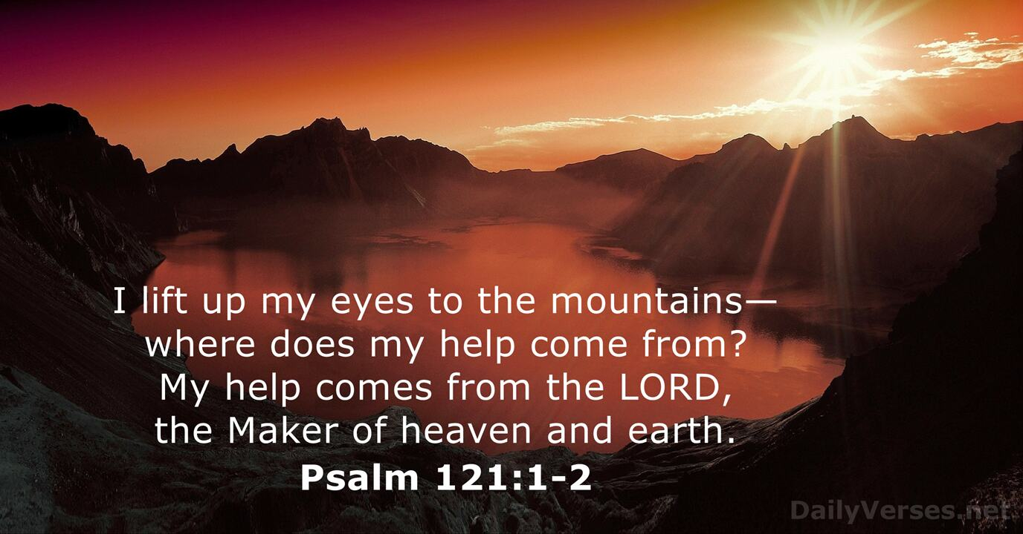
**Please stand in body or in spirit.
Greetings Pastor Bernard M. Harris, Sr.
**Call to Worship Liturgist and Congregation
Leader: Come and worship, proclaim God’s ways of faithfulness and steadfast love.
People: We will tell of God’s love, which unfolds in our lives.
Leader: Come and worship, for we are God’s people, rejoicing in his graciousness.
People: God is always with us, there is nothing which can keep us apart.
Leader: Come to the One who tells stories; worship our God who keeps promises.
People: We rejoice with God who is with us always. Amen.
**Opening Hymn My Faith Looks Up to Thee Congregation
**Affirmation of Faith – The Apostle’s Creed (Traditional Version) I believe in God, the Father Almighty, maker of heaven and earth; And in Jesus Christ his only Son, our Lord; who was conceived by the Holy Spirit, born of the Virgin Mary, suffered under Pontius Pilate, was crucified, dead, and buried;* the third day he rose from the dead; he ascended into heaven, and sitteth at the right hand of God the Father Almighty; from thence he shall come to judge the quick and the dead. I believe in the Holy Spirit, the holy catholic** (universal) church, the communion of saints, the forgiveness of sins, the resurrection of the body, and the life everlasting. Amen.
Prayer Denise McCray, Liturgist Ever-present God, there is no place where you are not with us. You see us at our worst and at our best. There is much we would hide from you—the ways we harm your creation, the ways we mistreat others, the ways we turn away when we should turn toward. Even as you know us, forgive us. Guide our thoughts, our words, our actions, that you may delight in us as we delight in you. In the blessed name of Jesus Christ, we pray. Amen!
Scripture Reading Psalm 121 (NIV) Denise McCray, Liturgist
Leader: This is the word of God for the people of God.
People: Thanks be to God.
Hymn of Preparation God Will Take Care of You Congregation
Sermon Selection God is Watching Over You by Faith Humen
Message Certified Lay Minister Gayle Hebron
Announcements Rosalyn Stephens
**Benediction Certified Lay Minister Gayle Hebron
Please join us for our Summer small group bible study: Trusting God Through the Storm - July 27- 31 6:30-8:00PM. Please email rozzstephens@gmail.com to register for this free study.
The Tuesday Prayer Ministry is on hiatus until September. The Wednesday Bible Study is on hiatus until September.
Please remember the sick and those who grieve in your prayer time with God. “Therefore, confess your sins to each other and pray one for another, that you may be healed. The prayer of a righteous person is powerful and effective.” James 5:16 (NIV)
Pastor Harris’ Office Hours: Monday: 12P-4P; Wednesday: Sick visitation; Thursday: Study and sermon prep; Friday: Day off

Prayer For July
Located in the height of summer, July is a perfect month for introspection, development and rejuvenation. The opportunity to pursue God's presence in our lives and develop our spiritual path is presented by the season's warmth and longer days. Through prayer, we can establish a strong connection with the divine and receive consolation, strength and guidance.
Dear Lord, as we welcome the month of July, we seek Your guidance and blessings for new beginnings. Help us to leave behind any regrets or failures from the past and to embrace the fresh opportunities that lie ahead. Fill us with hope, optimism and a renewed spirit to face this new month with confidence.
Isaiah 43:18-19 "Forget the former things; do not dwell on the past. See I am doing a new thing. Now it springs up; do you not perceive it? I am making a way in the wilderness and streams in the wasteland." Lord, thank You for the promise of new beginnings and for guiding me towards a brighter future. Amen!
Black History Events That Happened in July
1. Frederick Douglas speech "Fourth of July" Delivered July 15, 1852. (His feelings on July 4th celebration and what it means to slaves).
2. July 26, 1948 - President Truman desegregated the armed forces, impacting many black servicemen.
3. July 1948 - Alice Coachman was the first black female to win a gold medal in the Olympics excelling in high jumps and dominating the track and field competition.
4. July 2, 1964 - The Civil Rights Act was signed into law, prohibiting discrimination based on race.
5. July 20, 1969 - Astronaut Charles Bolden was part of the Apollo 11 mission, marking a significant moment in space exploration.
6. July 28, 1967 - The Detroit riots highlighted racial tensions and led to significant discussion on Civil rights and police reform.
7. July 1992 - Dr. Mae Jemison was the first black female that flew into space aboard Space Shuttle Endeavour.
Frederick Douglas' speech is a "Must Read". Please take the time to read it if you haven't read it already -it’s a long one!

