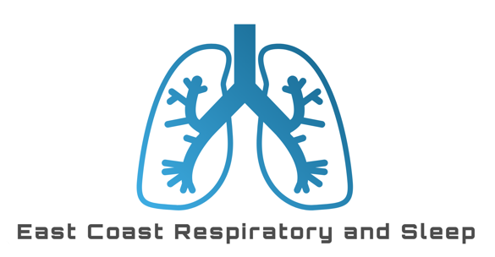

# Adult and Paediatric Pulmonary Request Form

Patient Information:

Name: ___________________________Date of Birth: __/__/__Gender: _______________

Height: ____________________ Weight: ___________ Phone: _______________________

Smoking history:_____________________Current inhalers:Choose an item.

Reason for Test: Please check all that apply:

Assessment of lung function prior to surgery

Evaluation of lung function in patients with respiratory symptoms (cough, wheezing, shortness of breath)

Assessment of lung function in patients with known lung disease (COPD, asthma, etc.)

Monitoring of lung function in patients with known lung disease

Other (please specify): __________________________________________

Test Requested: Please check all that apply:

Spirometry (Pre & Post BD)  Diffusion capacity measurement  Bronchial challenge test (Mannitol)

Fractional exhaled nitric oxide (FeNO) measurement  1 Min sit/stand

Other (please specify): __________________________________________

Special Instructions:

**Patient should refrain from smoking for at least 6 hours prior to the test. Patient should refrain from using bronchodilators for at least 36 hours prior to the test. Inhalers need to be ceased for 72hrs prior to mannitol**

Physician Information:

Name: ________________________________ Provider #________________________________

Clinic/Hospital: _________________________________________________________________

Phone: ________________________________ Fax: ___________________________________

Date of Referral: ___/___/___

Additional Comments/Notes: ________________________________________________________ __________________________________________________________________________________