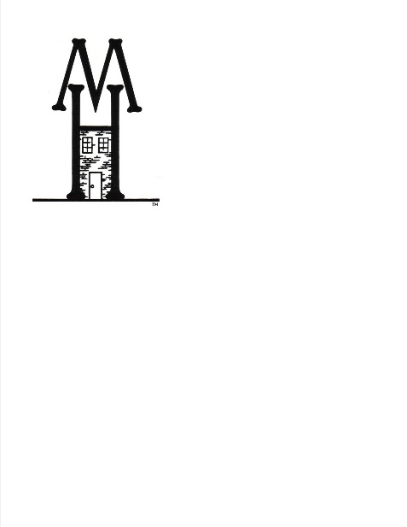
Mom’s House,® Inc. of Johnstown
1325 Franklin St.
Johnstown, PA 15905
814.535.4848
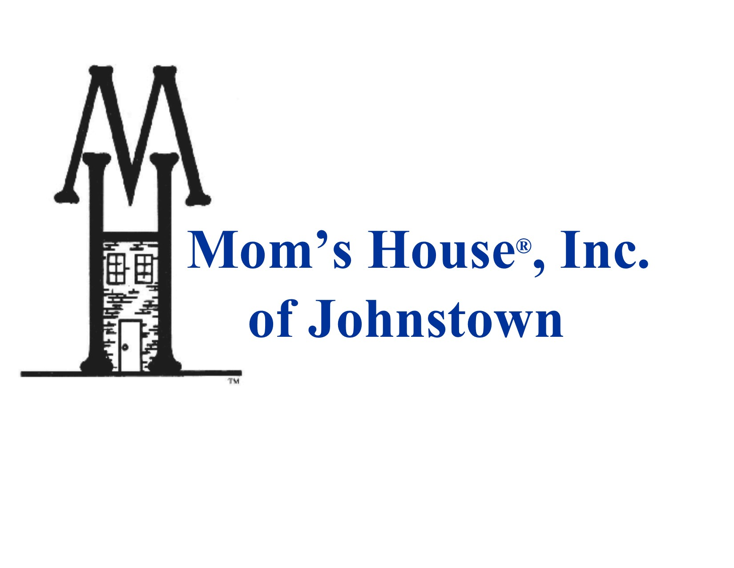
Wish List

Paper towels
Diaper wipes
Batteries (AA)
Kitchen sized garbage bags (13 gallon)
Gallon size zip-lock bags
Reynolds Wrap Aluminum Foil
Fabric Softener
Laundry Detergent
Dishwasher Detergent
Whole wheat grain crackers
100% juice

Giant Eagle and Wal-Mart gift cards

THANK YOU!!!!!

If you have questions, please contact me at 535.4848

Allegra P. Slick, M.Ed.
Executive Director

