ENGINE START
Exterior Inspection/ Cockpit set up COMPLETE
Parking Brake ON
Doors CLOSED/ LIGHT OFF
PAX Brief COMPLETE
Annunciator Panel Appropriate
Anti-Collision Light RED
Boost Pump ON
Engine 2, 3, 1 Start
Engine Parameters CHECKED

AFTER START/ BEFORE TAXI
DC Power Selector NORMAL
External Power DISCONNECTED
Circuit Breakers IN
Bus Tie FLIGHT NORMAL /LIGHTS OUT
Electrical Volts/Amps CHECKED
Engine Controls CHECKED
Fuel Panel 6 ON/ 4 CLOSED
Bleed Air TESTED/ CHECKED
Compass COMPARE
Windshield Heats NORMAL/ ON
*Anti-Ice TESTED / SET FOR TO
Cockpit Lighting AS REQUIRED
EMER Horizon ON
Altimeters SET
GPWS TESTED
Anti Skid TESTED
Hydraulics 2 PRESSURES 2 QUANTITES
Hydraulic Standby Pump ON
*No 1 Stall Tested
Auto Pilot CHECKED/DISINGAGED
Yaw damper AS REQUIRED
Transponder/TCAS TA/ Tested
Slats/Flaps CYCLED/SET FOR T.O.
Flight Director & Instruments BRIEFED
T.O. Briefing BRIEFED
Masks & Oxy CHECKED
DV Window CLOSED

TAXI
Parking Brake OFF
Taxi Light ON
Brakes 1&2 CHECKED/ #1& ON
Thrust Reverser CHECKED/ STOWED
*Engine Computers CHECKED/ ON
Flight Controls CHECKED
Xpndr, TCAS TA
Radar AS REQUIRED

BEFORE TAKEOFF
Parking Brake IN/ LIGHT OUT
APU& Bleed air CONFIRM OFF
Start Selectors AIR START
Exterior lights SET
FATSP CHECK

LINE UP CLEARED FOR TAKE OFF
Pitot Heats ON
Landing Light ON
Warning Panel / Flags CLEAR
Engine Instruments RNWY Heading ALT

CLIMB
LDG Gear/ Taxi Light/ YD UP OFF ON
Slats & Flaps CLEAN
Start Selectors GROUND START
Anti-ice AS REQUIRED
Cabin Pressure CHECK
Cabin Temp CHECKED
Hydraulics CHECK
Climb Power CHECK

* First Flight of The Day

N980DM FALCON 50

10K CHECKS
Lights SET
No Smoking Seat Belts AS REQUIRED
Stby Hyd Pmp AUTO

18K CLIMB/ CRUISE/ STATION
Masks/ Oxy CHECK
Altimeters 29.92
Circuit Breakers CHECK
Gen/ Volts/Amps CHECK
Fuel Panel CHECK
Anti-ice systems AS REQUIRED
Ext Lts. / S. Belts/ No Smoking AS REQUIRED
Engine Parameters CHECK
Cabin Press / Temp CHECK
Hydraulics CHECK

DESCENT
Cabin Door Curtain AS Required
Cabin Controller SET
Anti-icing. AS REQUIRED
Land Data/ Bugs COMPLETE / SET
ATIS NOTED
Risk Assessment BRIEF
Fuel Panel XFR Intercom/X-feed CLOSED

25 | 26 | 27 | 28 | 29 | 30 | 31 | 32 | 33 | 34 | 35
106 | 108 | 110 | 112 | 114 | 116 | 118 | 120 | 121 | 123 | 125

18K DESCENT/ APPROACH
Altimeters (at transition) SET/CROSS CHECK
Circuit Breakers CHECK
Gen/ Volts/Amps CHECK
Anti-ice AS REQUIRED
Ext lights/ Belts/ Smoke Lights AS REQUIRED
LDG Light AS DESIRED
Engine Parameters CHECK
Cabin Press / Temp CHECK
Hydraulics/ STBY Pump CHECK/ON
FMS/Avionics CHECK/ SET
Radio Altimeter SET
Approach Brief COMPLETE
Crew/ PAX Brief COMPLETE
Start Selectors AIR START/IGN ON

BEFORE LANDING
Landing Gear/ Anti-skid DOWN / CHECK
Slats–Flaps LDG POSITION
Airbrakes IN/LIGHTS OUT
Yaw Damper AS REQUIRED
Warning Panel CHECK
Hydraulics CHECK
Auto Pilot OFF
Taxi Light ON CLEARED TO LAND

AFTER LANDING
Pitot/ Windshield Heat ALL OFF
Anti-ice WING OFF/ ENG AS REQ
Ignition GRD START
Bus Tie TIED
APU (as applicable) MASTER/ GEN/ START
Landing Lights, Strobes OFF
Air Brakes 0
Slats/ Flaps CLEAN
Thrust Reversers STOWED
Trim SET FOR TAKEOFF
Radar/ Transponder OFF/ AS REQ
APU/ Bleed Air AS REQ

PARKING
Taxi Light OFF
Parking Brake SET
STBY Pump OFF
Engines CUT OFF
Fuel Panel SET
Anti Collision Light OFF
Seat Belts/ No Smoking Light AS REQ
Transponder AS REQ
Flight Time/ Fuel Burn RECORD

* First Flight of The Day

SHUTDOWN
APU SHUTDOWN
Boost Pumps OFF
NAV Lights OFF
Seatbelt/ Emer Lights/ cabin OFF
Cabin Lights OFF
FMS/ Avionics Masters OFF
Emerg Battery OFF
Interior lights SET
Bus Tie FLIGHT NORMAL
Pilot window CLOSED
APU Master OFF
BAT 1 and BAT 2 OFF
Bus C & D OFF
Chocks/ Parking Brake IN / RELEASE

QUICK TURN
FMS Flight time / Fuel RECORD / ZERO
Clocks ZERO
Fuel Quantity / Counters CHECKED / ZERO
Cabin Press SET
Clearance and Code COPY AND SET
FMS LOAD/SET
TOLD/ Vspeeds COMPLETE/ SET
Engines START
Bus Tie FLIGHT NORM
Generator Amps/Volts CHECK
Windshield Heats ON
Anti-ice AS REQ
Warning Panel CHECK
Slats–Flaps SET FOR TAKEOFF

Passenger briefing Smoking Seatbelts.
Emergency exits and entry door
Emergency exits diagram
Survival equipment
Flotation equipment &Ditching
Oxygen equipment
Briefing cards

FUELING
LO level 13,195 lbs High 15,514 lbs

PROFILE
Climb 260/.72 849°

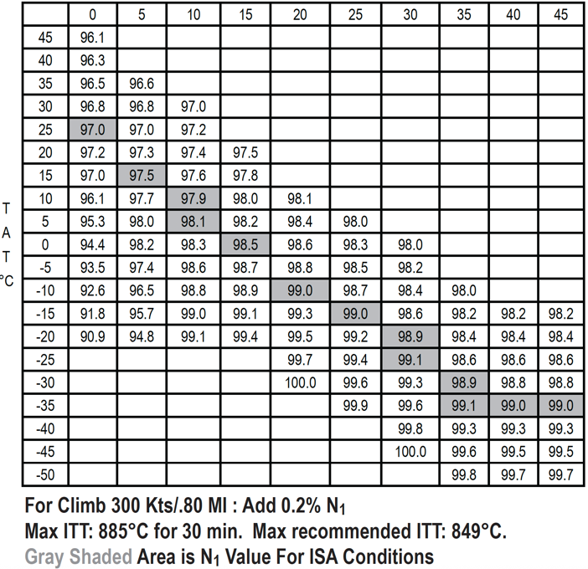

N980DM Falcon 50 Normal Checklist
Oct 11 2026 Orig

