**OPERATING LIMITATIONS TABLE OF CONTENTS**

PAGE

**OPERATING LIMITATIONS** . . . . . . . . . . . . . . . . . . . . . . . . . . . . . . . . . . . . . . . . . . . . . . . 2-3

Certification Status . . . . . . . . . . . . . . . . . . . . . . . . . . . . . . . . . . . . . . . . . . . . . . . . . . . 2-3

Weight Limitations . . . . . . . . . . . . . . . . . . . . . . . . . . . . . . . . . . . . . . . . . . . . . . . . . . . . 2-3

Center-of-Gravity Limits . . . . . . . . . . . . . . . . . . . . . . . . . . . . . . . . . . . . . . . . . . . . . . . . 2-3

Weight and Balance Data . . . . . . . . . . . . . . . . . . . . . . . . . . . . . . . . . . . . . . . . . . . . . . 2-3

Powerplant Limitations . . . . . . . . . . . . . . . . . . . . . . . . . . . . . . . . . . . . . . . . . . . . . . . . 2-5

Engine Start Limitations (Ground) . . . . . . . . . . . . . . . . . . . . . . . . . . . . . . . . . . . . . . . . 2-9

Engine Start Limitation (Air) . . . . . . . . . . . . . . . . . . . . . . . . . . . . . . . . . . . . . . . . . . . . 2-10

Engine Fan Inspection . . . . . . . . . . . . . . . . . . . . . . . . . . . . . . . . . . . . . . . . . . . . . . . . 2-10

Starter Cycle Limitations . . . . . . . . . . . . . . . . . . . . . . . . . . . . . . . . . . . . . . . . . . . . . . 2-10

Battery Limitations . . . . . . . . . . . . . . . . . . . . . . . . . . . . . . . . . . . . . . . . . . . . . . . . . . . 2-11

Prolonged Ground Operation . . . . . . . . . . . . . . . . . . . . . . . . . . . . . . . . . . . . . . . . . . . 2-11

Windshield Ice Protection Fluid . . . . . . . . . . . . . . . . . . . . . . . . . . . . . . . . . . . . . . . . . 2-11

Hydraulic Fluid . . . . . . . . . . . . . . . . . . . . . . . . . . . . . . . . . . . . . . . . . . . . . . . . . . . . . 2-11

Fuel Limitations . . . . . . . . . . . . . . . . . . . . . . . . . . . . . . . . . . . . . . . . . . . . . . . . . . . . . 2-11

Approved Oils . . . . . . . . . . . . . . . . . . . . . . . . . . . . . . . . . . . . . . . . . . . . . . . . . . . . . . 2-12

Unusable Fuel . . . . . . . . . . . . . . . . . . . . . . . . . . . . . . . . . . . . . . . . . . . . . . . . . . . . . . 2-12

Speed Limitations . . . . . . . . . . . . . . . . . . . . . . . . . . . . . . . . . . . . . . . . . . . . . . . . . . . 2-13

Takeoff and Landing Operational Limits . . . . . . . . . . . . . . . . . . . . . . . . . . . . . . . . . . . 2-13

Enroute Operational Limits . . . . . . . . . . . . . . . . . . . . . . . . . . . . . . . . . . . . . . . . . . . . 2-14

Operations Authorized . . . . . . . . . . . . . . . . . . . . . . . . . . . . . . . . . . . . . . . . . . . . . . . . 2-14

Minimum Crew . . . . . . . . . . . . . . . . . . . . . . . . . . . . . . . . . . . . . . . . . . . . . . . . . . . . . 2-14

Load Factor . . . . . . . . . . . . . . . . . . . . . . . . . . . . . . . . . . . . . . . . . . . . . . . . . . . . . . . 2-17

Cabin Pressurization Limitations . . . . . . . . . . . . . . . . . . . . . . . . . . . . . . . . . . . . . . . . 2-17

Passenger Seating . . . . . . . . . . . . . . . . . . . . . . . . . . . . . . . . . . . . . . . . . . . . . . . . . . 2-17

Audio Control Panel . . . . . . . . . . . . . . . . . . . . . . . . . . . . . . . . . . . . . . . . . . . . . . . . . 2-17

Instrument Markings . . . . . . . . . . . . . . . . . . . . . . . . . . . . . . . . . . . . . . . . . . . . . . . . . 2-18

Honeywell SPZ 5000 Integrated Flight Control System . . . . . . . . . . . . . . . . . . . . . . . . 2-19

Standby Gyro Horizon . . . . . . . . . . . . . . . . . . . . . . . . . . . . . . . . . . . . . . . . . . . . . . . . 2-19

Oxygen Mask . . . . . . . . . . . . . . . . . . . . . . . . . . . . . . . . . . . . . . . . . . . . . . . . . . . . . . 2-20

Icing Limitations . . . . . . . . . . . . . . . . . . . . . . . . . . . . . . . . . . . . . . . . . . . . . . . . . . . . 2-20

Operations in Severe Icing Conditions . . . . . . . . . . . . . . . . . . . . . . . . . . . . . . . . . . . . 2-20

Kinds of Operations Equipment List . . . . . . . . . . . . . . . . . . . . . . . . . . . . . . . . . . . . . . 2-21

FAA APPROVED

525FM-14 Configuration AA U.S. 2-1/2-2

# OPERATING LIMITATIONS

### NOTICE

CERTIFICATION AND OPERATIONAL LIMITATIONS ARE CONDITIONS OF THE TYPE AND AIRWORTHINESS CERTIFICATES AND MUST BE COMPLIED WITH AT ALL TIMES AS REQUIRED BY LAW.

## CERTIFICATION STATUS

This airplane is certified in accordance with FAR 23 Normal Category and FAR 36 (noise). Takeoff and Landing performance special condition certification requirements are equivalent to FAR 25.

## WEIGHT LIMITATIONS

Maximum Design Ramp Weight . . . . . . . . . . . . . . . . . . . . . . . . . . . . . . . 10,500 Pounds

Maximum Design Takeoff Weight . . . . . . . . . . . . . . . . . . . . . . . . . . . . . . 10,400 Pounds

Maximum Design Landing Weight . . . . . . . . . . . . . . . . . . . . . . . . . . . . . . 9700 Pounds

Maximum Design Zero Fuel Weight . . . . . . . . . . . . . . . . . . . . . . . . . . . . . 8400 Pounds Takeoff weight is limited by the most restrictive of the following requirements:

Maximum Certified Takeoff Weight . . . . . . . . . . . . . . . . . . . . . . . . . 10,400 Pounds Maximum Takeoff Weight Permitted by Climb

Requirements . . . . . . . . . . . . . . . . . . . . Refer to Procedures for Use of Takeoff

Performance Tables in Section IV Takeoff Field Length . . . . . . . . . . . . . . . . . Refer to Procedures for Use of Takeoff

Performance Tables in Section IV

Landing weight is limited by the most restrictive of the following requirements:

Maximum Certified Landing Weight . . . . . . . . . . . . . . . . . . . . . . . . . . 9700 Pounds Maximum Landing Weight Permitted by Climb Requirements

or Brake Energy Limit . . . . . . . . . . . . Refer to Procedures for Use of Approach

and Landing Performance Tables in Section IV Landing Distance . . . . . . . . . . . . . . . . . Refer to Procedures for Use of Approach

and Landing Performance Tables in Section IV

## CENTER-OF-GRAVITY LIMITS

Center-of-Gravity Moment Envelope . . . . . . . . . . . . . . . . . . . . . . . . . Refer to Figure 2-1

## WEIGHT AND BALANCE DATA

The airplane must be operated in accordance with the approved loading schedule. (Refer to Weight and Balance Data in Section VI.)

**CENTER-OF-GRAVITY MOMENT ENVELOPE**

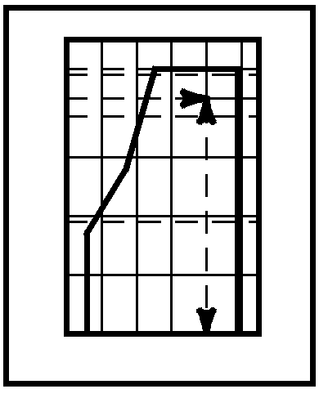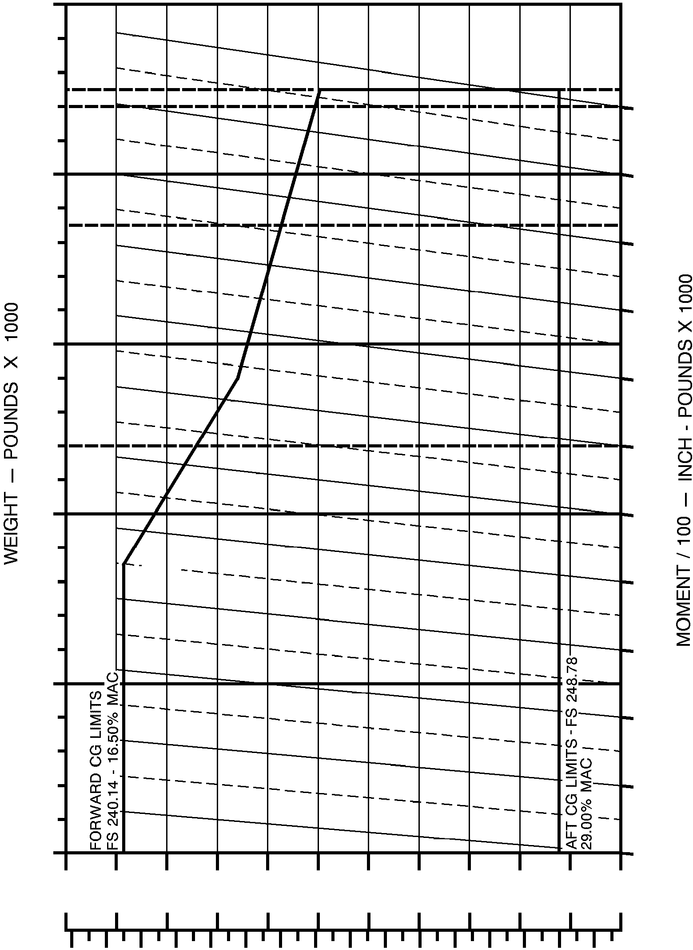

11

FORWARD CG LIMITS 22.14% MAC

MAXIMUM RAMP WEIGHT - 10,500 POUNDS

MAXIMUM TAKEOFF WEIGHT - 26

10,400 POUNDS

10 25

FORWARD CG LIMITS 8800 POUNDS -

19.81% MAC

MAXIMUM LANDING WEIGHT - 9700 POUNDS 24

23

9

FORWARD CG LIMITS

7700 POUNDS - 22

* 1. % MAC

21

ZERO FUEL WEIGHT - 8400 POUNDS

8 20

19

18

7

17

16

6

239 241 243 245 247

CENTER-OF-GRAVITY — INCHES

15

249

15 17 19 21 23 25 27 29

CENTER-OF-GRAVITY — PERCENT MAC

Figure 2-1

FORM NUMBER 1887, 1 Sept. 1992

REVISED 30 January 1998

## POWERPLANT LIMITATIONS

Engine Type . . . . . . . . . . . . . . . . . . . . . . . . . Williams International FJ44-1A Turbofan

Engine Operating Limits . . . . . . . . . . . . . . . . . . . . . . . . . . . . . . . . . Refer to Figure 2-2

Engine Overspeed Limits . . . . . . . . . . . . . . . . . . . . . . . . Refer to Figures 2-5 and 2-6

Takeoff/Go Around Thrust Setting . . . . . . . . . . . . . . . . . . . . . . . . . Refer to Figure 4-8 Recommended Maximum Continuous Climb Thrust

Setting . . . . . . . . . . . . . . . . . . . . . . . . . . . . . . . . . . . . Refer to Figures 4-9 and 4-10 Recommended Maximum Continuous Cruise Thrust

Setting . . . . . . . . . . . . . . . . . . . . . . . . . . . . . . . . . . Refer to Figure 4-11 and 4-11A

**ENGINE OPERATING LIMITS**

|  |  |  |  |  |  |  |
| --- | --- | --- | --- | --- | --- | --- |
| **OPERATING CONDITIONS** | **OPERATING LIMITS** | | | | | |
| **THRUST SETTING** | **TIME LIMIT (MINUTES)** | **ITT TEMPERATURE**  **°C** | **N2 % TURBINE RPM** | **N1 % FAN RPM** | **OIL PRESSURE PSIG** | **OIL TEMPERATURE**  **°C** |
| START |  | REFER TO FIGURE 2-4 |  |  | 25 PSI MIN.  (NOTE 6) | -40 TO 121  (NOTE 7) |
| IDLE | CONTINUOUS | 620 MAX. | 56.2 ±1.3 |  | 35 MIN. | -40 TO 121  (NOTE 7) |
| TAKEOFF | (NOTE 1) | 820 MAX. | 99.3 | 104.4 | 45 - 90 | 10 - 121 |
| MAXIMUM CONTINUOUS | (NOTE 2) | 796 MAX. | 99.3 | 104.4 | 45 - 90 (NOTE 3) | 10 - 121 |
| TRANSIENT | --- | REFER TO FIGURE 2-3 | REFER TO FIGURE 2-5 | REFER TO FIGURE 2-6 | 25 MIN. (NOTE 4)  100 MAX. (NOTE 5) | -- |

### NOTES

* + 1. ENGINE LIMIT: Time is 5 minutes, provided engine limits above are not exceeded, and begins when the throttle lever is advanced for takeoff thrust. THRUST LIMIT: Takeoff thrust (5 minutes limit), for engine life to TBO, is defined in Figure 4-8. Performance data, including VMCA and VMCG in Section IV is based on use of the takeoff thrust setting, (Figure 4-8).
    2. Continuous operation is acceptable provided the engine limits above are not exceeded. Recommended maximum continuous climb thrust is defined in Figures 4-9 and 4-10. Recommended maximum continuous cruise thrust is defined in Figure 4-11 and 4-11A. For extended component life, to achieve TBO, the recommended limits should be observed. Performance data in Section IV is based on use of the recommended thrust setting.
    3. Minimum oil pressure is 45 PSIG when operating above 80% N2; 35 PSIG when operating below 80% N2.
    4. During idle periods after high thrust operation for up to 5 minutes

maximum.

* + 1. During periods of high thrust operation for up to 5 minutes maximum.
    2. Maximum allowable cold day start oil pressure is 100 psig for 5 minutes with oil pressure returning to normal range.
    3. The engine should not be operated above 85% N2 until oil temperature is above 10°C.

Figure 2-2

**OVER TEMPERATURE LIMITS (EXCEPT STARTING)**

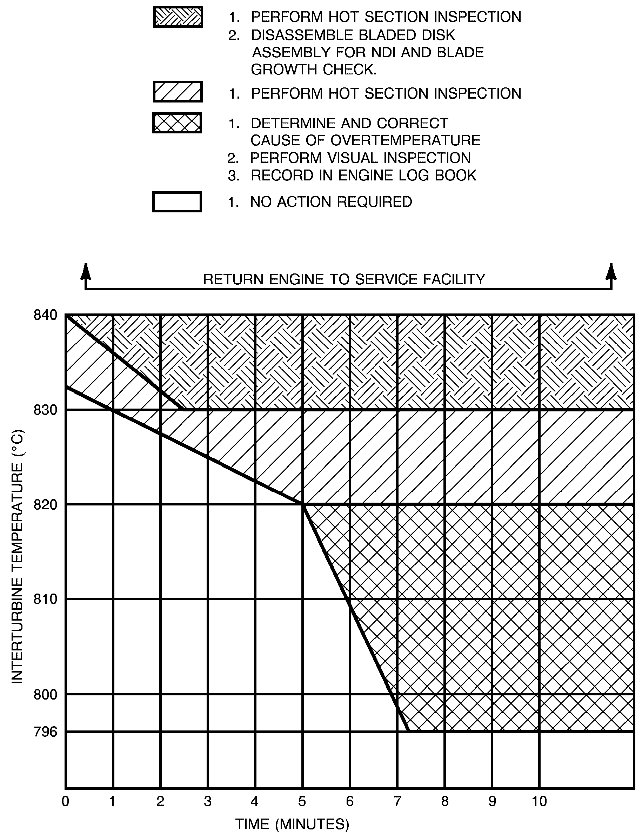

Figure 2-3

6384C6001

**OVER TEMPERATURE LIMITS (STARTING)**

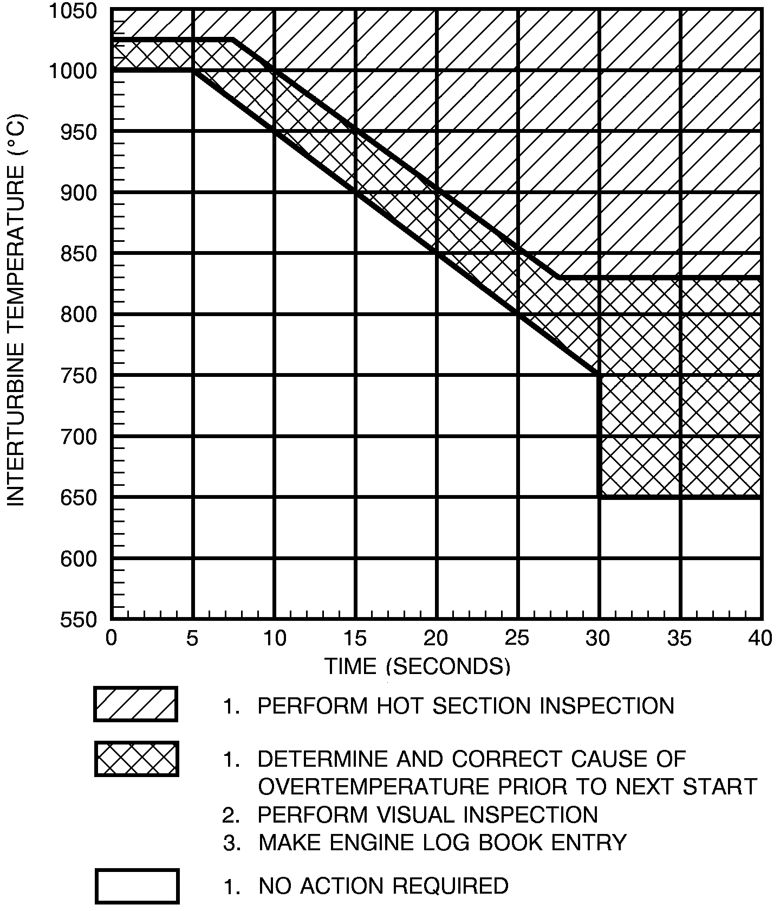

6384C6002

Figure 2-4

**N2 ENGINE OVERSPEED LIMITS**

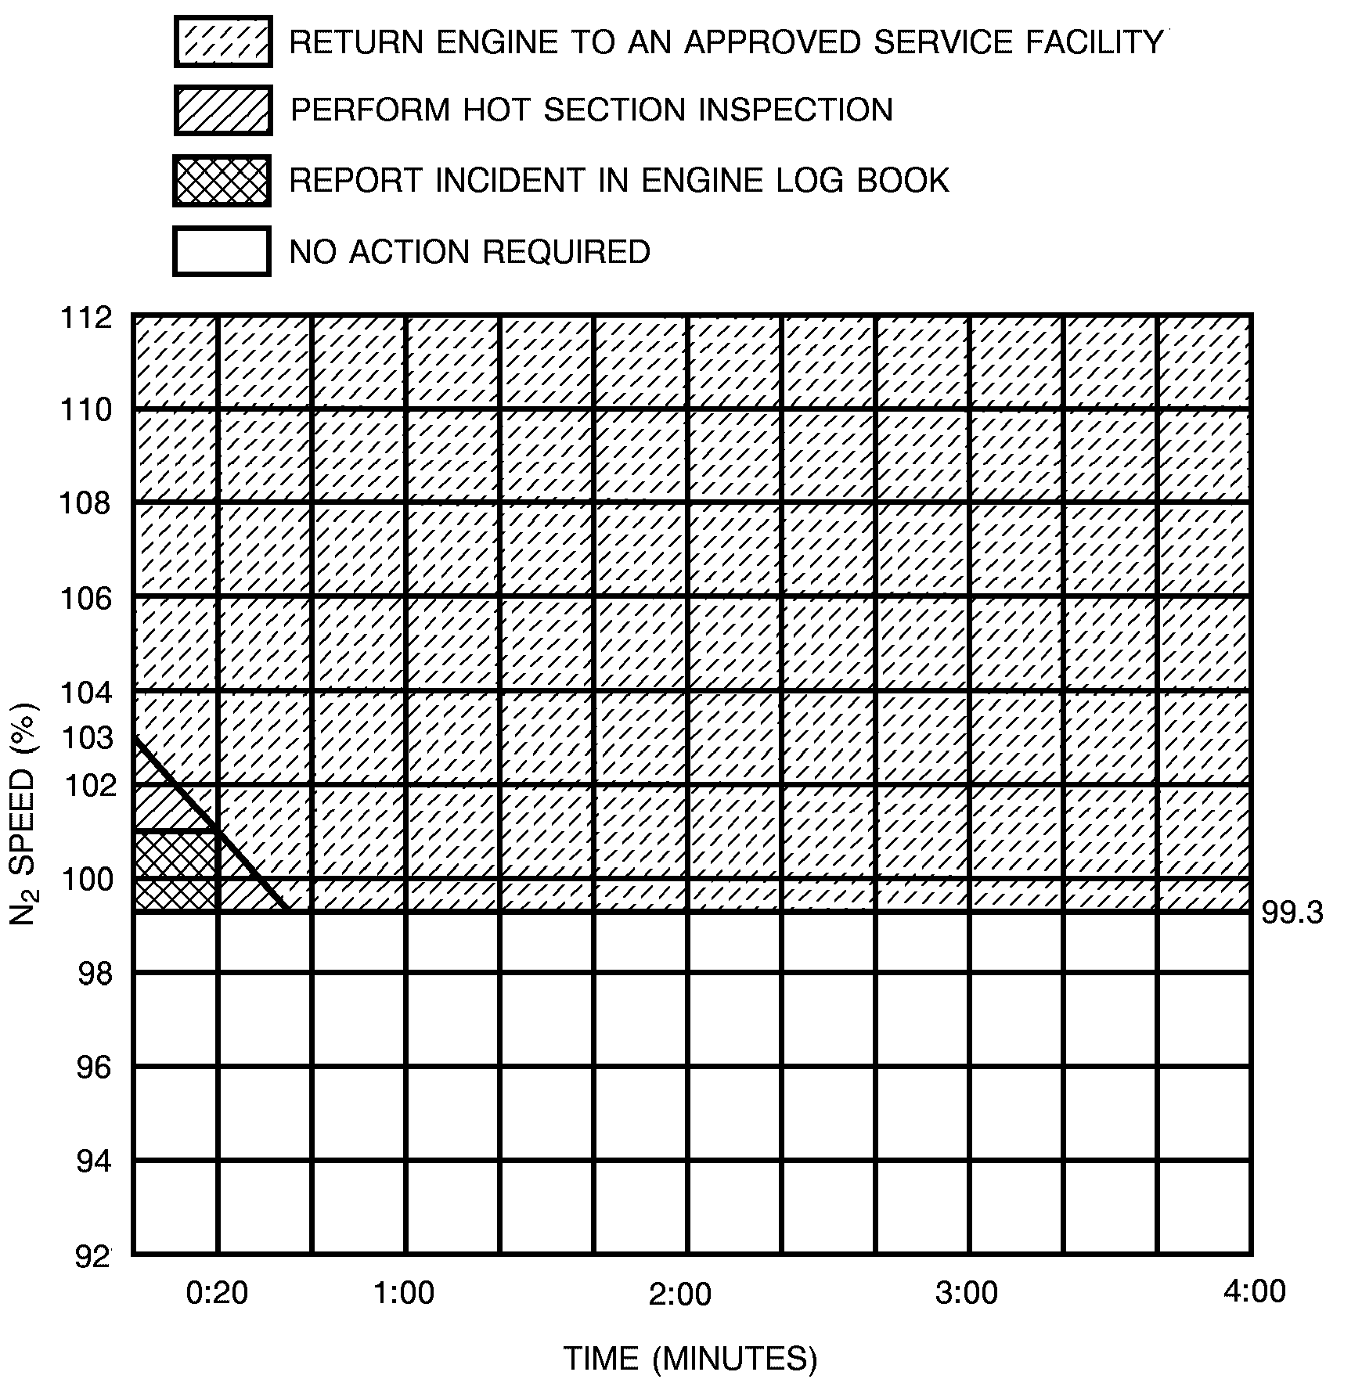

6384C6003

Figure 2-5

**N1 ENGINE OVERSPEED LIMITS**

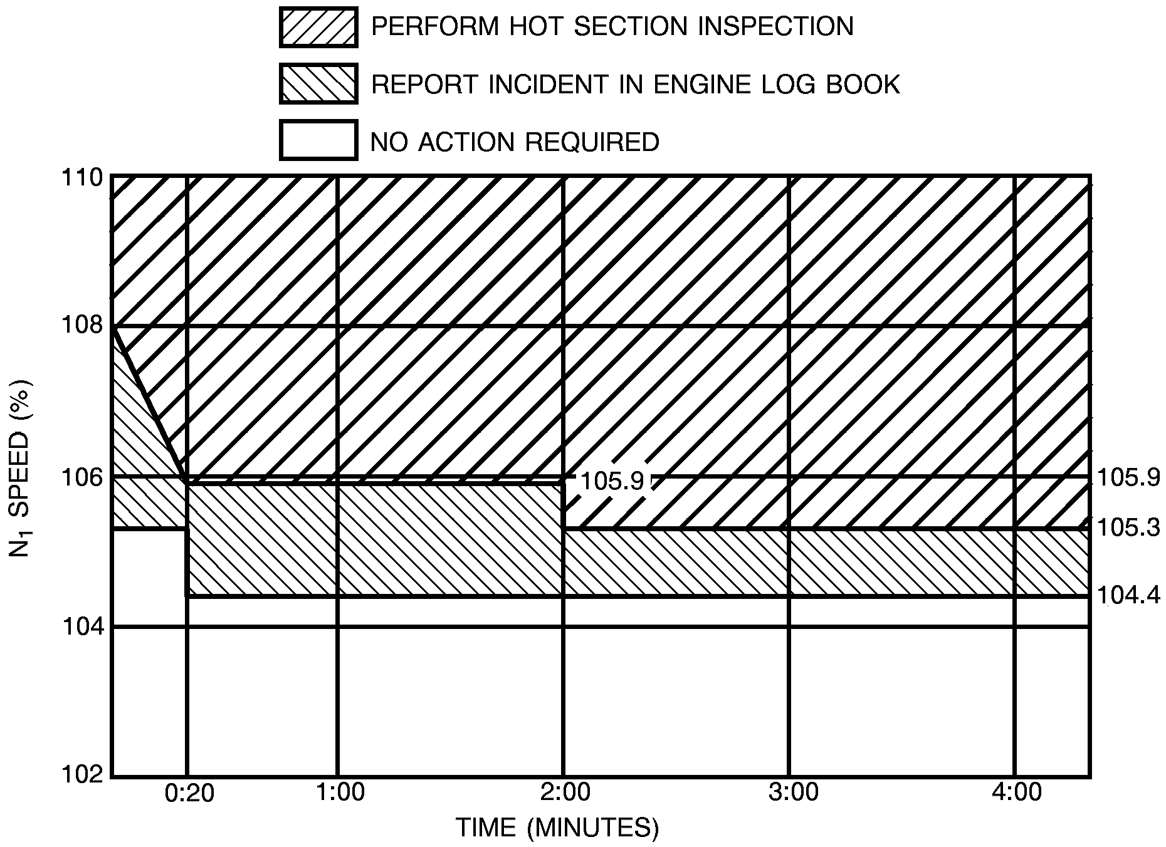

Figure 2-6

6384C6004

## ENGINE START LIMITATIONS (Ground)

Over temperature (ITT) Limits . . . . . . . . . . . . . . . . . . . . . . . . . . . . . Refer to Figure 2-4

Maximum Tailwind Component . . . . . . . . . . . . . . . . . . . . . . . . . . . . . . . . . . . 10 Knots

Maximum Crosswind Component . . . . . . . . . . . . . . . . . . . . . . . . . . . . . . . . . 12 Knots

### NOTE

Thrust attenuator switch must be in AUTO for tailwind within ±30 degrees of the tail.

Maximum Time to Light-off . . . . . . . . . . . . . . . . . . . . . . . . . . . . . . . . . . . . . 10 Seconds

### NOTE

Time to light-off is defined as the time after the throttle lever is moved from cutoff to idle position until light-off is indicated.

(Continued Next Page)

**ENGINE START LIMITATIONS (Ground)** (Continued)

Minimum Ambient Temperature For Battery Start (If Airplane Is Cold Soaked) . . -18°C

### NOTE

f If the airplane is cold soaked below -35°C, it must be preheated or hangared prior to engine start.

f If the battery is warm (removed and stored above -18°C) and the engine

is preheated, battery starts may be conducted at ambient temperature below -18°C.

Maximum Temperature For Engine Start . . . . . . . . . . . . . . . . . . . . . . . . . . ISA + 39°C Maximum Airport Elevation For Ground Battery Start . . . . . . . . . . . . . . . . . 10,000 Feet Maximum Airport Elevation for Ground External Power Start . . . . . . . . . . . 14,000 Feet Minimum Battery Voltage For Battery Start . . . . . . . . . . . . . . . . . . . . . . . . . . . . 24 VDC Minimum/Maximum External Power Current Capacity For Start . . . . . . 800/1100 AMPS

### NOTE

Normal starter current draw is approximately 1000 amperes peak. External power units with variable maximum current shutoff should be set to 1100 amperes.

**ENGINE START LIMITATIONS (Air)**

Over Temperature Limits . . . . . . . . . . . . . . . . . . . . . . . . . . . . . . . . . Refer to Figure 2-4

Airspeed/Altitude Limits . . . . . . . . . . . . . . . . . . . . . . . . . . . . . . . . . . Refer to Figure 3-1

Maximum Time to Light Off . . . . . . . . . . . . . . . . . . . . . . . . . . . . . . . . . . . . 10 Seconds

### NOTE

Time to light-off is defined as the time after the throttle lever is moved from off to idle position until light-off is indicated.

## ENGINE FAN INSPECTION

To assure accurate fan speed thrust indication, inspect the fan for damage prior to each flight.

### NOTE

Refer to the EXTERIOR INSPECTION in the NORMAL PROCEDURES

Section of this manual for engine duct and fan inspection.

## STARTER CYCLE LIMITATIONS

Starter Limitation . . . . . . Three engine starts per 30 minutes. Three cycles of

operation with a 60-second rest period between cycles is permitted.

### NOTE

This limitation is independent of starter power source: i.e. battery, generator assisted cross start, or external power unit.

## BATTERY LIMITATIONS

The battery temperature warning system must be operational for all ground and flight operations. The battery warning system must be operational as verified by a satisfactory preflight test as contained in Section III, ELECTRICAL SYSTEM.

If the BATT O'TEMP light illuminates during ground operation, do not take off until the proper maintenance procedures have been accomplished.

Battery Cycle Limitations: Three engine starts per hour. Refer to Notes (2) and (3).

### NOTES

1. If battery limitation is exceeded, ground maintenance procedures are required. Refer to Chapter 24 of the Maintenance Manual for procedure.
2. Three generator assisted cross starts are equal to one battery start.
3. If an external power unit is used for start, no battery cycle is counted.
4. Use of an external power source with voltage in excess of 29 VDC or current in excess of 1100 amps may damage the starter.

## PROLONGED GROUND OPERATION

Continuous engine ground static operation up to and including five minutes at takeoff thrust is limited to ambient temperatures not to exceed + 39°C above ISA (refer to Figure 2-9).

Generator Current (Less than 15 minutes) . . . . . . . . . . . . . . . . . . . . . . . 300 Amperes

(15 minutes or more) . . . . . . . . . . . . . . . . . . . . . . . . . 250 Amperes

Limit ground operation of pitot/static heat to two minutes to preclude damage to the pitot/ static tubes and angle of attack probe.

Prolonged ground operation at high engine RPM with engine, wing, and/or windshield anti-ice on is prohibited. Do not operate with the wing anti-ice on more than one minute after the WING ANTI-ICE LH/RH annunciators have extinguished.

## WINDSHIELD ICE PROTECTION FLUID

Use TT-I-735 isopropyl alcohol for windshield anti-ice.

## HYDRAULIC FLUID

Use MIL-H-83282 Type fluids only.

## FUEL LIMITATIONS

Approved anti-icing additive must be added to all approved fuels not presently containing the additive.

Boost Pumps - ON; when LH and/or RH FUEL LOW LEVEL caution lights illuminate or at 185 pounds or less indicated fuel.

### NOTE

If crossfeed or fuel transfer is required, turn boost pump OFF on side that is receiving fuel.

Refer to Figure 2-7 for fuels that are approved for use.

**FUEL LIMITATIONS**

|  |  |  |  |
| --- | --- | --- | --- |
| **GRADE (TYPE)**  **(REFER TO CAUTION AND NOTE 1 BELOW)** | **SPECIFICATION** | **MINIMUM FUEL TEMPERATURE**  **°C/°F** | **MAXIMUM FUEL TEMPERATURE**  **°C/°F** |
| JET A |  | -29/-20.2 | 57.2/135 |
| JET A1 | ASTM-D1655 | -29/-20.2 | 57.2/135 |
| JET B |  | -54/-65 | 57.2/135 |
| JP-4 | MIL-T-5624 | -54/-65 | 57.2/135 |
| JP-5 |  | -29/-20.2 | 57.2/135 |
| JP-8 | MIL-T-83133 | -29/-20.2 | 57.2/135 |

**CAUTION**

FUEL NOT HAVING ANTI-ICING ADDITIVE PREBLENDED AT THE REFINERY MUST HAVE ANTI-ICING FLUID ADDED.

Fuel must contain 0.10 to 0.15 percent (by volume) anti-icing additive per MIL-I-27686 (EGME), or MIL-I-85470 (DiEGME).

### NOTES

1. Dupont Stadis 450 anti-ice additive or equivalent is permitted to bring fuel up to 300 conductive units, but not to exceed 1 ppm (parts per million).
2. SOHIO Biobor JF biocide additive is approved at a concentration not to exceed 20 ppm (270 ppm total additive) of elemental boron.
3. EGME/DIEGME additive is approved at a concentration not to exceed

0.15 percent volume.

## APPROVED OILS

Figure 2-7

|  |  |
| --- | --- |
| **APPROVED BRAND** | **SPECIFICATION** |
| Mobil Jet II | MIL-L-23699 |
| Mobil 254 | MIL-L-23699 |
| Exxon 2380 (Emergency only) | MIL-L-23699 |

Exxon 2380 oil may be used pure or mixed with Mobil Jet II oil only for a maximum of 25 hours run time between major periodic Inspections. Record in the engine log book the total amount of run time with Exxon 2380 oil. Following any usage of Exxon 2380 oil, the oil tank must be drained, flushed with Mobil Jet II oil, and serviced with pure Mobil Jet II oil. (Definition of oil flush is removal of chip collector screens, and pouring one quart of Mobil Jet II oil through the oil fill port).

The maximum permissible oil consumption during normal operation (engine running), is

* 1. gallons per hour during normal operation.

### NOTE

During in-flight windmilling, the engine will vent oil overboard. Typical consumption is approximately 0.20 gallons per hour.

## UNUSABLE FUEL

Fuel remaining in the fuel tanks when the fuel quantity indicator reads zero is not usable in flight.

## SPEED LIMITATIONS

Maximum Operating Limit Speeds

MMO (Above 30,500 Feet) . . . . . . . . . . . . . . . . . . . . . . . . . 0.710 Mach (Indicated)

VMO (Between Sea Level and 30,500 Feet) . . . . . . . . . . . . . . . . . . . . . . . 263 KIAS

The maximum operating limit speeds may not be deliberately exceeded in any regime of flight (climb, cruise or descent) unless a higher speed is authorized for flight test or pilot training.

Maximum Maneuvering Speeds - VA . . . . . . . . . . . . . . . . . . . . . . . . Refer to Figure 2-8

Full application of rudder and aileron controls as well as maneuvers that involve angle-of-attack near the stall should be confined to speeds below maximum maneuvering speed. Refer to LOAD FACTOR limitations for pitch maneuvering limitations.

Maximum Flap Extended Speed - VFE

Partial Flaps - TAKEOFF & APPROACH Position (15°) . . . . . . . . . . . . . . 200 KIAS Full Flaps - LAND Position (35°) . . . . . . . . . . . . . . . . . . . . . . . . . . . . . . . 161 KIAS

Ground Flaps (60°) . . . . . . . . . . . . . . . . . . . . . . . . . . . . . . . . . Prohibited In Flight Maximum Speed With Flaps Failed to Ground Flaps (60°) . . . . . . . . . . . 140 KIAS

**WARNING**

### THE GROUND FLAPS POSITION IS NOT LOCKED OUT IN FLIGHT. SELECTION OF GROUND FLAPS WILL SIGNIFICANTLY INCREASE DRAG AND SINK RATE. INTENTIONAL SELECTION OF GROUND FLAPS IN FLIGHT IS PROHIBITED.

Maximum Landing Gear Extended Speed - VLE . . . . . . . . . . . . . . . . . . . . . . . 186 KIAS

Maximum Landing Gear Operating Speed - VLO . . . . . . . . . . . . . . . . . . . . . . 186 KIAS

Maximum Speed Brake Operation Speed - VSB . . . . . . . . . . . . . . . . . . . . . . . . No Limit Maximum Autopilot Operation Speed . . . . . . . . . . . . . . . . . . 263 KIAS or 0.710 MACH

### NOTE

For minimum control speeds (VMCA, and VMCG) refer to the respective definition in Section IV, Performance - General.

## TAKEOFF AND LANDING OPERATIONAL LIMITS

Maximum Altitude Limit (refer to Supplement 8 for high altitude procedures) 14,000 Feet Maximum Tailwind Component . . . . . . . . . . . . . . . . . . . . . . . . . . . . . . . . . . . 10 Knots Maximum Ambient Temperature . . . . . . . . . ISA +39°C (Refer to Figures 2-9 and 4-7) Minimum Ambient Temperature . . . . . . . . . . . . . . . . . . . . . . . . . . . . . . . . . . . . –53°C

The maximum intentional asymmetric fuel differential is 200 pounds, however, controllability for safe return and landing has been demonstrated with an emergency asymmetrical difference of 600 pounds.

(Continued Next Page)

FAA APPROVED

525FM-15 Configuration AA U.S. 2-13

**TAKEOFF AND LANDING OPERATIONAL LIMITS** (Continued)

Takeoff with thrust attenuators stowed is prohibited for flaps 0° and for flaps 15° corrected takeoff field lengths greater than 4500 feet.

The autopilot and yaw damper must be OFF for takeoff and landing. Engine synchronizer must be OFF for takeoff and landing.

Cabin must be depressurized for takeoff and landing. Speed brakes must be retracted prior to 50 feet on landing. Touch and Go landings utilizing ground flaps are prohibited.

Goodyear tire part number 184F68-1, and tire part numbers 030-611-0 and 031-613-8 (manufactured by BFGoodrich/Michelin) are the only nose tires approved. The nose tire must be inflated to 120 PSI +5 or –5 PSI.

Maximum Tire Ground Speed . . . . . . . . . . . . . . . . . . . . . . . . . . . . . . . . . . . 165 Knots

## ENROUTE OPERATIONAL LIMITS

Minimum airspeed for sustained flight in icing (except approach and landing) 160 KIAS Maximum Operating Altitude . . . . . . . . . . . . . . . . . . . . . . . . . . . . . . . . . . . 41,000 Feet

Maximum Temperature . . . . . . . . . . . . . . . . . . . . . . . . . . . . . . . . . . Refer to Figure 2-9

Minimum Temperature . . . . . . . . . . . . . . . . . . . . . . . . . . . . . . . . . . Refer to Figure 2-9

Generator Load . . . . . . . . . . . . . . . . . . . . . . . . . . . . . . 300 Amperes Up to 41,000 Feet

## OPERATIONS AUTHORIZED

This airplane is approved for day and night, VFR, IFR flight and flight into known icing when the required equipment is installed as defined within the KINDS OF OPERATIONS EQUIPMENT LIST.

Acrobatic maneuvers, including spins, are prohibited. Intentional stalls with flaps at other than zero or with gear down are prohibited above 18,000 feet.

## MINIMUM CREW

Except where otherwise prescribed by applicable operating limitations, Minimum crew for all operations:

1 Pilot, provided:

* + 1. The pilot holds a CE525(S), single pilot, type rating.
    2. The airplane is equipped for single pilot operation as specified in the Kinds of Operations Equipment List.
    3. The pilot must occupy the left pilot’s seat.

Or

1 Pilot and 1 Copilot provided:

1. The pilot in command holds a CE525(S) or CE525 (second-in-command required) type rating.

FAA APPROVED

* 1. U.S. Configuration AA 525FM-15

**MAXIMUM MANEUVERING SPEEDS**

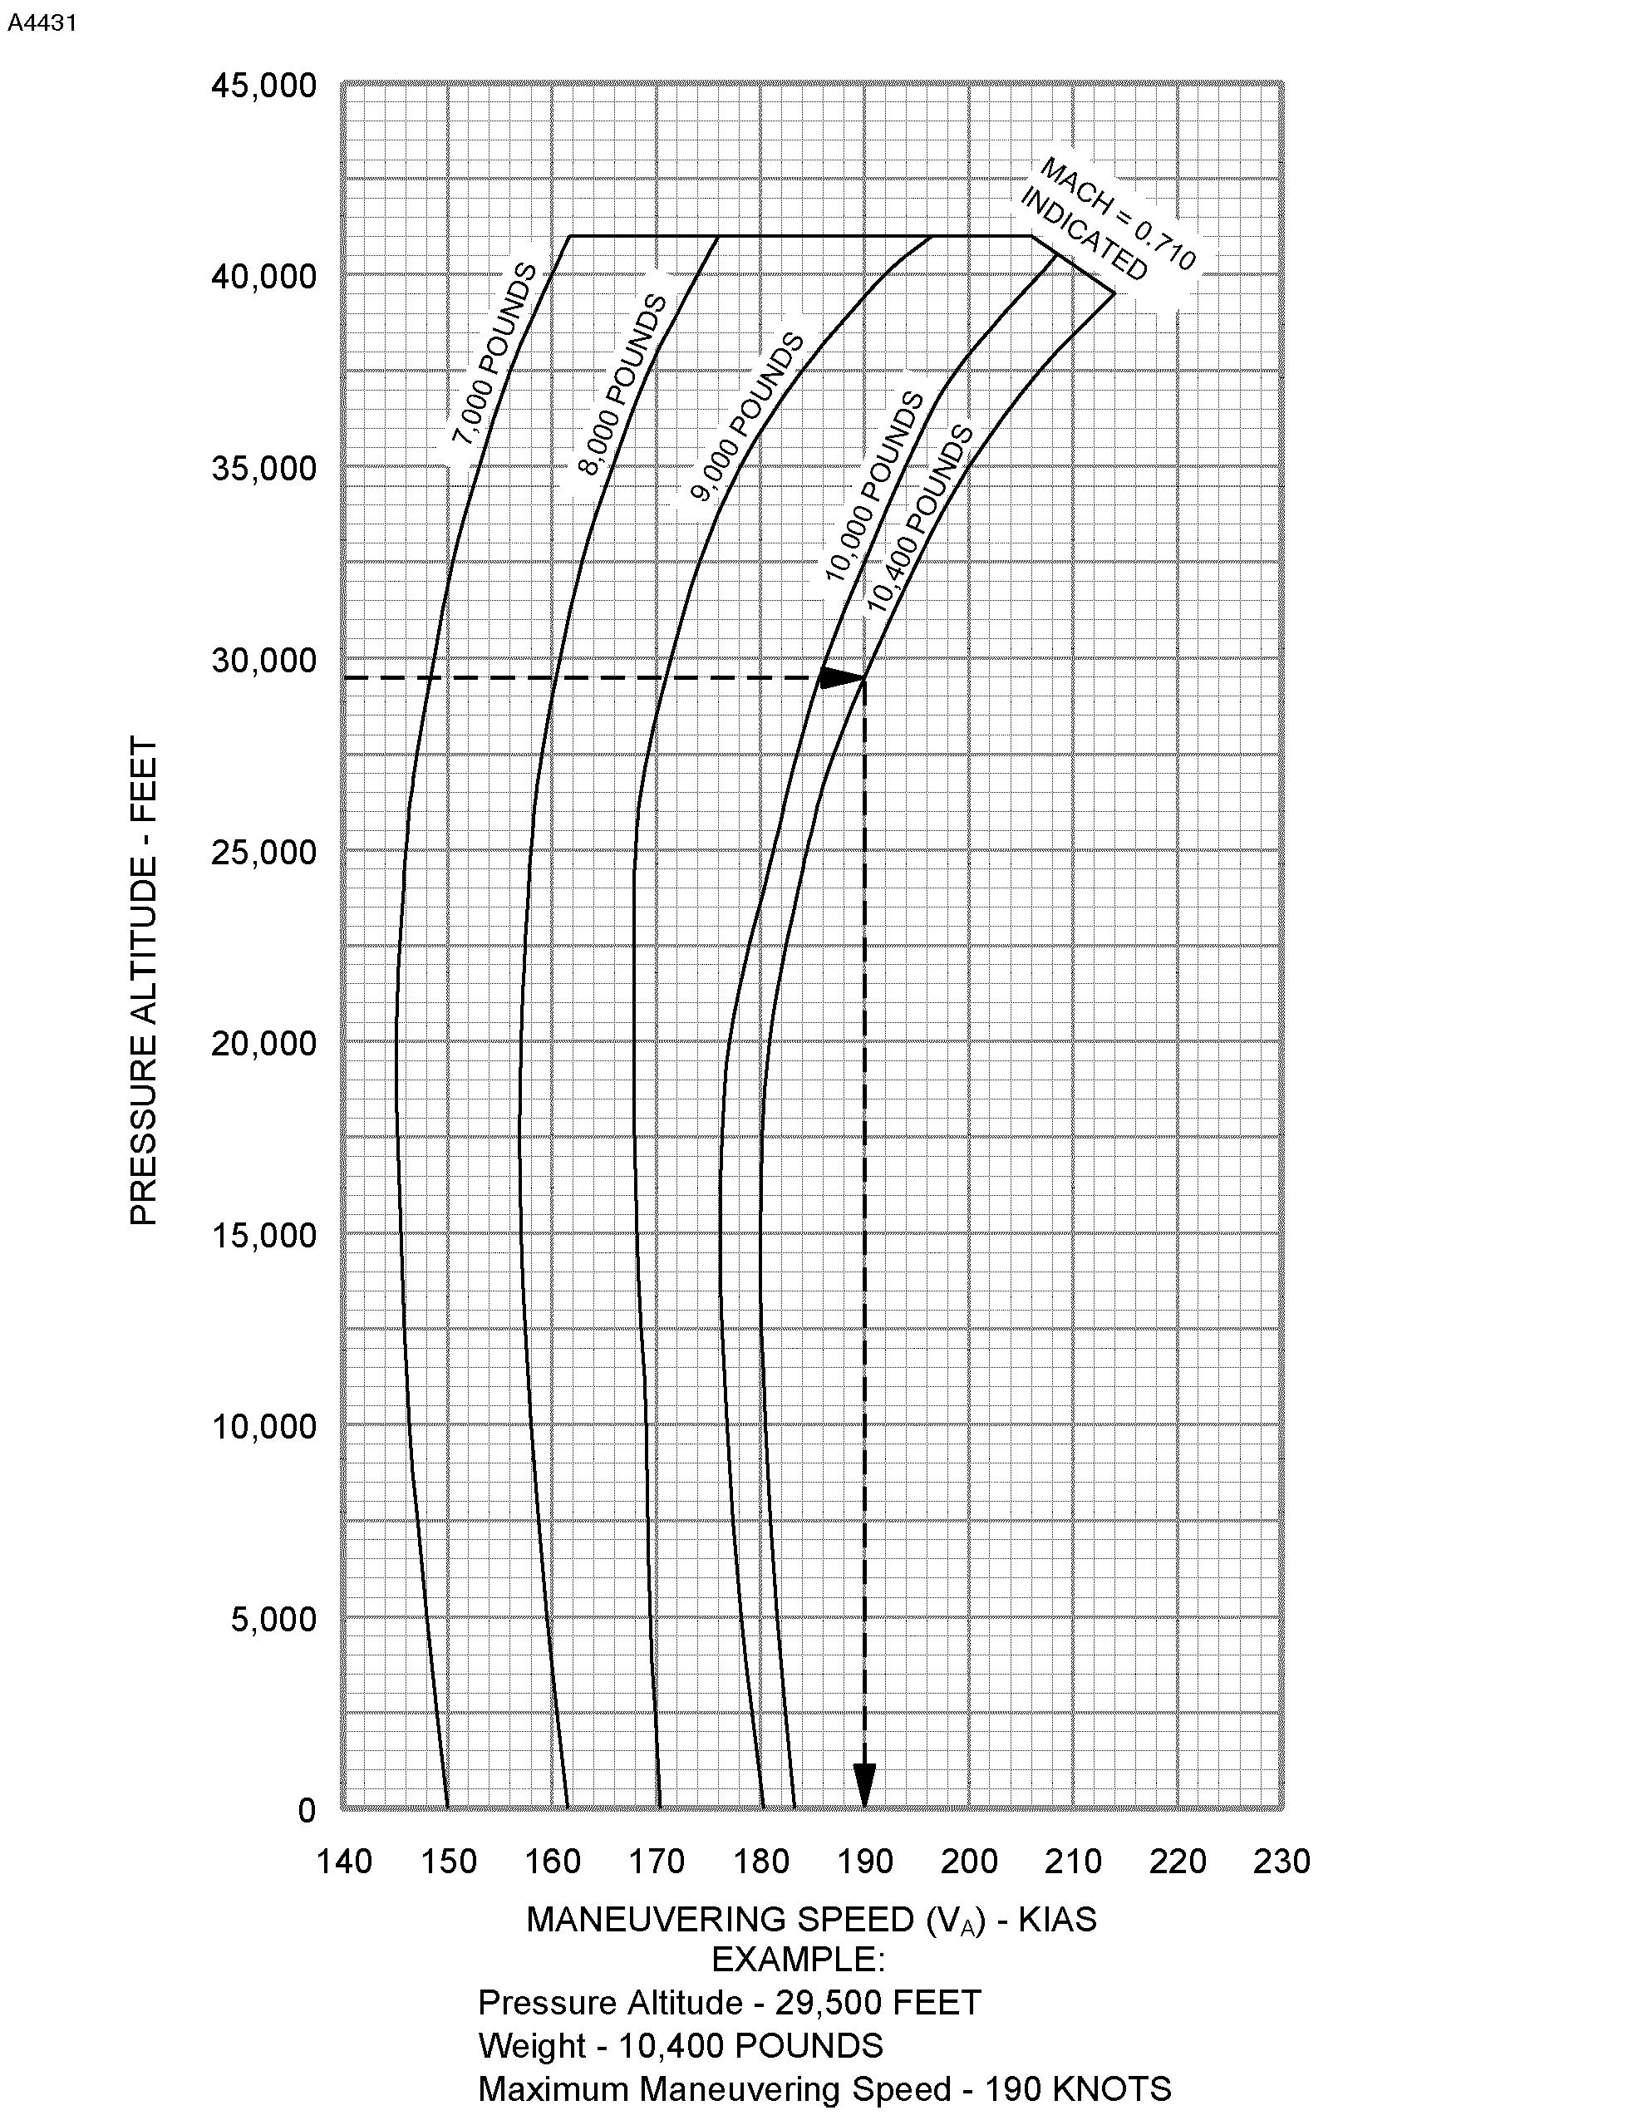

 Figure 2-8

FAA APPROVED

525FM-15 Configuration AA U.S. 2-15

**TAKEOFF/LANDING/ENROUTE TEMPERATURE LIMITATIONS**

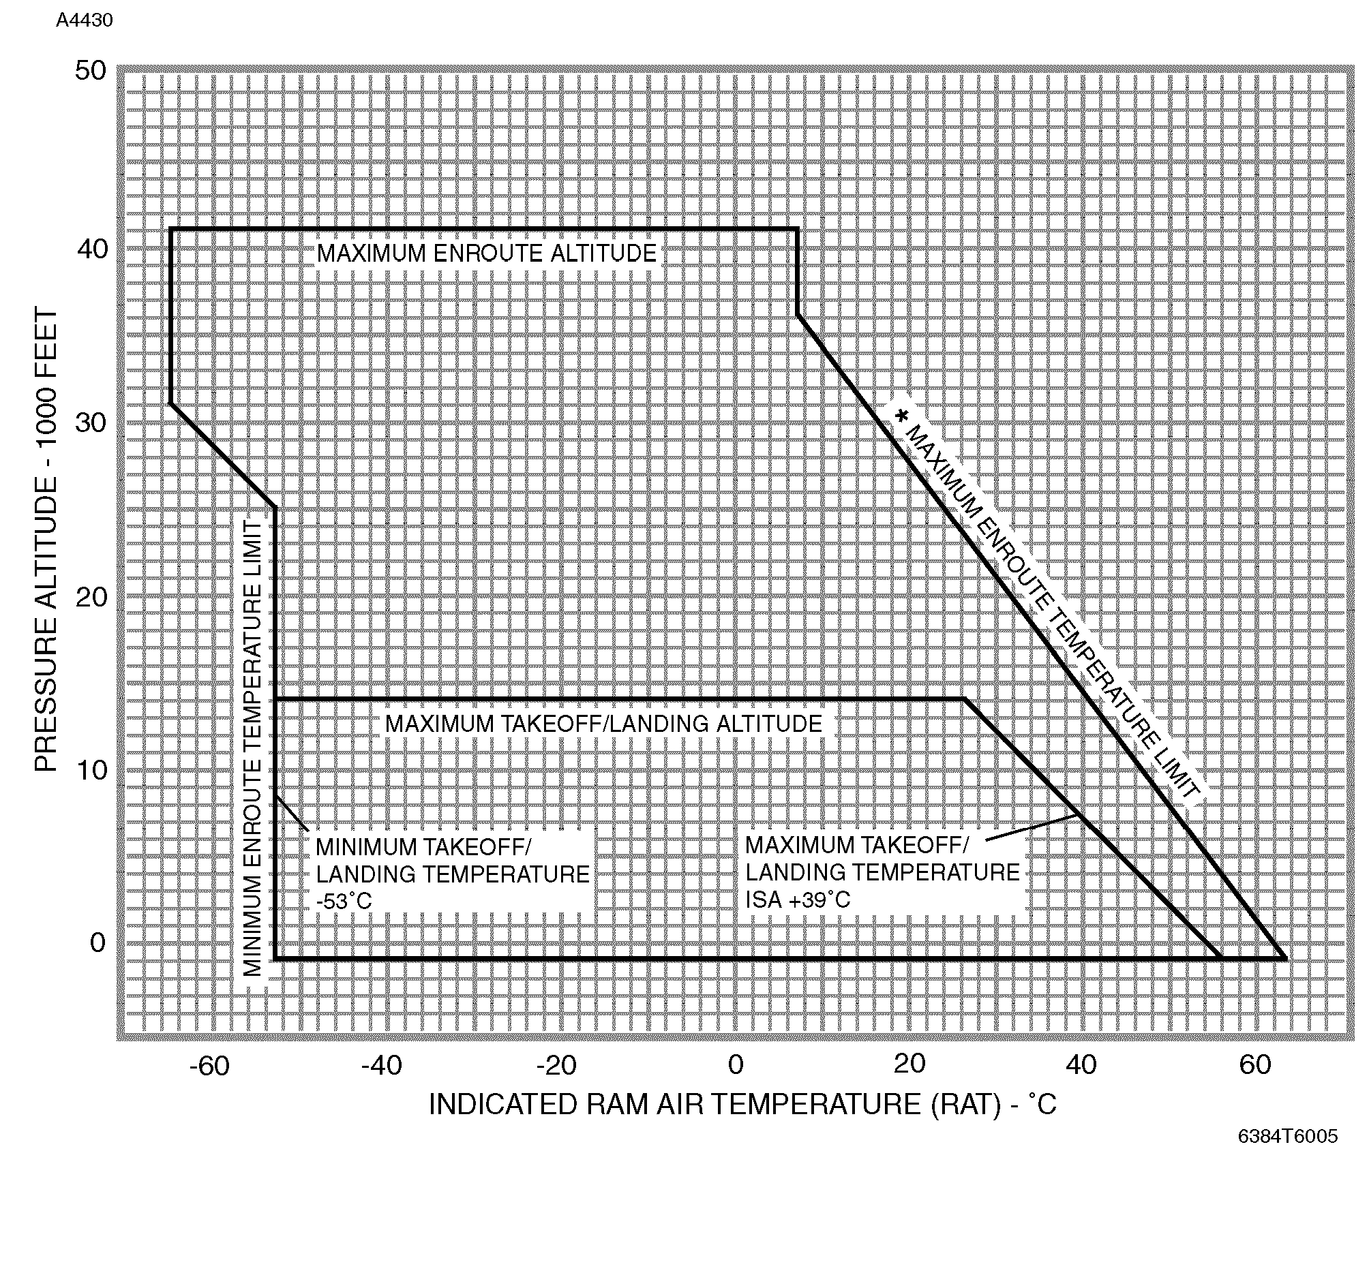

Figure 2-9 

**\*** Maximum Enroute Operating Temperature Limit is ISA +39°C ambient temperature adjusted for Ram Rise (Refer to Figure 4-3) or

the Indicated RAM Air Temperature (RAT) from Figure 2-9, whichever is less.

## PASSENGER SEATING

For all takeoffs and landings, adjustable seats must be fully upright and outboard.

Maximum passenger seating, not including 2 crew seats, is five (six with optional belted toilet installed).

## AUDIO CONTROL PANEL

Operation of the audio panel in the passenger speaker (PASS SPKR) mode is limited to required passenger briefings or emergencies.

### NOTE

* + - The same side cockpit speaker is muted when PASS SPKR is selected with the audio control panel rotary switch. All incoming transmissions and auxiliary warnings (GPWS and TCAS, if installed) will be received only through the opposite side speaker. If both audio control switches are selected to PASS SPKR, both cockpit speakers become muted. Avoid selecting both switches to PASS SPKR at the same time.
    - With passenger speaker mode selected and microphone selector switch selected to oxygen mask, the cockpit speaker will not receive voice interphone communications from the oxygen mask microphone of the opposite side pilot.
    - Headset audio is not affected when PASS SPKR mode is selected.

FAA APPROVED

**I**

525FM-15 Configuration BK U.S. 2-17

Airspeed Indicator . . . . . . . . . . . . . . . . . . . . . . . . . . . . . . . . . . . . Red Line - 263 KIAS

0.71 Mach

Left and Right Inter-Turbine Temperature

Indicators . . . . . . . . . . . . . . . . . . . . . . . . . . . . . . . . . . . . . Red Triangle - 1000°C

Red Line - 820°C Yellow Band - 796 to 820°C Green Band - 200 to 796°C

Left and Right Fan RPM Indicators . . . . . . . . . . . . . . . . . . . . Red Line - 104.4% RPM (Refer to Section IV for thrust setting limits) Green Band - 20 to 104.4% RPM

Left and Right Ammeter Indicators . . . . . . . . . . . . . . . . . . . . . . . . Red Line - 300 Amps

Cabin Differential Pressure Indicator . . . . . . . . . . . . . . . . . . . . . . . . Red Line - 8.6 PSI

Green Arc - 0.0 to 8.6 PSI

Oxygen Pressure Indicator . . . . . . . . . . . . . . . . . . . . . . . . . . . . . . Red Line - 2000 PSI

Yellow Arc - 0.0 to 400 PSI Green Arc - 1600 to 1800 PSI

Brake and Gear Pneumatic Pressure Indicator

(In Nose Compartment) . . . . . . . . . . . . . . . . . . . Wide Red Arc - Above 2050 PSI

Narrow Red Arc - 0.0 to 1600 PSI Wide Yellow Arc - 1600 to 1800 PSI Wide Green Arc - 1800 to 2050 PSI

Brake Hydraulic Accumulator Pressure

Indicator (In Nose Compartment) . . . . . . . . . . . Narrow Red Arc - Underpressure

Light Green Arc - Precharge Pressure

Yellow Arc - Caution Wide Green Arc - Normal Operating Range

Wide Red Arc - Overpressure

**PASSENGER SEATING**

For all takeoffs and landings, adjustable seats must be fully upright and outboard.

Maximum passenger seating, not including 2 crew seats, is five (six with optional belted toilet installed).

**AUDIO CONTROL PANEL**

Operation of the audio panel in the passenger speaker (PASS SPKR) mode is limited to required passenger briefings or emergencies.

### NOTE

* + - Depending on the modification level of the audio panel installed, all incoming transmissions and audio warnings to one or both cockpit speakers may be lost if either audio panel has passenger speaker mode selected.
    - With passenger speaker mode selected and microphone selector switch selected to oxygen mask, the cockpit speaker will not receive voice interphone communications from the oxygen mask microphone of the opposite side pilot.
    - Headset audio is not affected when PASS SPKR mode is selected.

FAA APPROVED

**I**

525FM-15 Configuration BL U.S. 2-17.1

Airspeed Indicator . . . . . . . . . . . . . . . . . . . . . . . . . . . . . . . . . . . . Red Line - 263 KIAS

0.71 Mach

Left and Right Inter-Turbine Temperature

Indicators . . . . . . . . . . . . . . . . . . . . . . . . . . . . . . . . . . . . . Red Triangle - 1000°C

Red Line - 820°C Yellow Band - 796 to 820°C Green Band - 200 to 796°C

Left and Right Fan RPM Indicators . . . . . . . . . . . . . . . . . . . . Red Line - 104.4% RPM (Refer to Section IV for thrust setting limits) Green Band - 20 to 104.4% RPM

Left and Right Ammeter Indicators . . . . . . . . . . . . . . . . . . . . . . . . Red Line - 300 Amps

Cabin Differential Pressure Indicator . . . . . . . . . . . . . . . . . . . . . . . . Red Line - 8.6 PSI

Green Arc - 0.0 to 8.6 PSI

Oxygen Pressure Indicator . . . . . . . . . . . . . . . . . . . . . . . . . . . . . . Red Line - 2000 PSI

Yellow Arc - 0.0 to 400 PSI Green Arc - 1600 to 1800 PSI

Brake and Gear Pneumatic Pressure Indicator

(In Nose Compartment) . . . . . . . . . . . . . . . . . . . Wide Red Arc - Above 2050 PSI

Narrow Red Arc - 0.0 to 1600 PSI Wide Yellow Arc - 1600 to 1800 PSI Wide Green Arc - 1800 to 2050 PSI

Brake Hydraulic Accumulator Pressure

Indicator (In Nose Compartment) . . . . . . . . . . . Narrow Red Arc - Underpressure

Light Green Arc - Precharge Pressure

Yellow Arc - Caution Wide Green Arc - Normal Operating Range

Wide Red Arc - Overpressure

## HONEYWELL SPZ 5000 INTEGRATED FLIGHT CONTROL SYSTEM

1. The Honeywell SPZ 5000 Integrated Flight Control System Pilot’s Manual for Cessna CitationJet Publication Number: A28-1146-089-00, dated 15 October 1992 or later revision must be immediately available to the flight crew.

### NOTE

The Honeywell pilot’s manual is published by Honeywell and, while written specifically for the CitationJet, is written generically. Some SPC 5000 capabilities in the Honeywell pilot’s manual are not available in the CitationJet installation.

1. One pilot must remain in his/her seat with the seat belt fastened during all autopilot operations.
2. Operating in the composite mode is limited to training and display tube failure conditions. The flight director must be utilized when operating in composite mode in IMC and in the event of display tube failure.
3. EFIS ground operation with the IC FAN message or the DISPLAY FAN FAIL caution light illuminated is limited to 10 minutes or until the IC HOT message illuminates, whichever occurs first.
4. Dispatch is prohibited if IC HOT message is displayed or following a flight where the IC HOT message was displayed, until the condition is identified and corrected.
5. Dispatch in instrument meteorological conditions is prohibited with the IC FAN message displayed or the DISPLAY FAN FAIL caution light illuminated.
6. The pilot’s EADI and EHSI must be installed and operational in the normal (non- composite) mode for takeoff.
7. The SPZ 5000 system must be verified to be operational by a satisfactory automatic preflight test (no messages on power up).
8. The minimum autopilot engage height is 110 feet AGL.

## STANDBY GYRO HORIZON

A satisfactory preflight test must be accomplished on the standby gyro system.

FAA APPROVED

## OXYGEN MASK

1. The crew oxygen mask(s) must be used in accordance with applicable operating rules when flying above FL 350.

### NOTE

* + Headsets, eyeglasses or hats worn by the crew may interfere with the quick-donning capabilities of the oxygen masks.
  + For two pilot operations, the standard crew oxygen mask must be worn around the neck by both pilots, or the optional sweep-on oxygen mask must be properly stowed to qualify as a quick donning mask for operations above FL 350.

1. For single pilot operations, a crew oxygen mask must be available for a passenger occupying the right crew seat. The mask must be checked during preflight and passenger briefed on its use.

## ICING LIMITATIONS

### NOTE

* + Icing conditions exist when the indicated RAT in flight is +10°C or below, and visible moisture in any form is present.
  + Icing conditions on the ground exist when the OAT or indicated RAT is

+10°C or below and, where surface snow, slush, ice or standing water may be ingested by the engines or freeze on engine nacelles, or engine sensor probes.

1. Minimum engine N2 speed for effective anti-icing . . . . . . . . . . . . . . . . . . . 70% N2
2. Minimum temperature for operation of tail deicing boots (Indicated RAT) . . -35°C
3. Engine anti-ice shall be ENG ON, (or ENG/WING) for operations with indicated RAT of +10°C or below when flight free of visible moisture cannot be assured.
4. After an icing encounter with inoperative tail deice boots, maximum flap deflection is

15 degrees. Refer to the Flaps Inoperative Approach and Landing Abnormal Procedure for landing with flaps 15 degrees.

## OPERATIONS IN SEVERE ICING CONDITIONS

**WARNING**

### SEVERE ICING MAY RESULT FROM ENVIRONMENTAL CONDITIONS OUTSIDE OF THOSE FOR WHICH THE AIRPLANE IS CERTIFIED. FLIGHT IN FREEZING RAIN, FREEZING DRIZZLE, OR MIXED ICING CONDITIONS (SUPERCOOLED LIQUID WATER AND ICE CRYSTALS) MAY RESULT IN ICE BUILD-UP ON PROTECTED SURFACES EXCEEDING THE CAPABILITY OF THE ICE PROTECTION SYSTEM, OR MAY RESULT IN ICE FORMING AFT OF THE PROTECTED SURFACES. THIS ICE MAY NOT SHED WHEN THE ICE PROTECTION SYSTEMS ARE USED, AND MAY SERIOUSLY DEGRADE THE PERFORMANCE AND CONTROLLABILITY OF THE AIRPLANE.

All wing icing inspection lights must be operative prior to flight into known or forecast icing conditions at night.

(Continued Next Page)

**OPERATIONS IN SEVERE ICING CONDITIONS**(Continued)

### NOTE

This supersedes relief provided by the Master Minimum Equipment List.

Severe icing conditions that exceed those for which the airplane is certificated shall be determined by the following visual cues:

1. Unusually extensive ice accumulation on the airframe and windshield in areas not normally observed to collect ice.
2. Accumulation of ice on the upper surface of the wing aft of the protected area.

If one or more of these visual cues exist:

1. Use of the autopilot is prohibited.
2. Immediately request priority handling from Air Traffic Control to facilitate a route or altitude change to exit the icing conditions.
3. Leave flaps in current position, do not extend or retract.
4. Avoid abrupt and excessive maneuvering that may exacerbate control difficulties.
5. If unusual or uncommanded roll control movement is observed, reduce angle-of-attack.

Since the autopilot, when installed and operating , may mask tactile cues that indicate adverse changes in handling characteristics, use of the autopilot is prohibited when:

1. Unusual lateral trim is required while the airplane is in icing conditions.
2. Autopilot trim warnings are encountered while the airplane is in icing conditions.

## KINDS OF OPERATIONS EQUIPMENT LIST

This airplane may be operated in day or night VFR or IFR and flight into known icing conditions when the appropriate equipment is installed.

The following equipment list identifies the systems and equipment upon which type certification for each kind of operation was predicated. The systems and items of equipment listed must be installed and operable unless:

1. The airplane is approved to be operated in accordance with a current Minimum Equipment List (MEL) issued by the FAA.

Or;

(Continued Next Page)

**KINDS OF OPERATIONS EQUIPMENT LIST** (Continued)

1. An alternate procedure is provided in the FAA Approved Airplane Flight Manual for the inoperative state of the listed equipment and all limitations are complied with.

### NOTE

The following systems and equipment list does not include all equipment required by the FAR Parts 91 and 135 Operating Requirements. It also does not include components obviously required for the airplane to be airworthy such as wings, primary flight controls, empennage, engine, etc.

|  |  |  |  |  |  |  |  |
| --- | --- | --- | --- | --- | --- | --- | --- |
| SYSTEM and/or COMPONENT | KIND OF | | | OPERATION | | | COMMENTS |
| V F R  D A Y | | V F R  N I G H T | I F R  D A Y | I F R  N I G H T | I C I N G |
| AVIONICS |  | |  |  |  |  |  |
| 1) VHF Transceiver | **\*** | | **\*** | 1**\*** | 1**\*** | 1**\*** | **\*** or as required by operating regulation |
| 2) Static Wicks | 15 | | 15 | 15 | 15 | 15 |  |
| 3) Transponder | **\*** | | **\*** | 1**\*** | 1**\*** | 1**\*** | **\*** or as required by operating regulation |
| 4) EFIS Display Cooling Fan | 1 | | 1 | 1 | 1 | 1 |  |
| 5) VHF NAV Receiver | **\*** | | **\*** | 1**\*** | 1**\*** | 1**\*** | **\*** or as required by operating regulation |
| 6) Cockpit Voice Recorder | **\*** | | **\*** | **\*** | **\*** | **\*** | **\*** required for two pilot operations |
|  |  | |  |  |  |  | with six passenger seats installed |
| ELECTRICAL |  | |  |  |  |  |  |
| 1) Battery | 1 | | 1 | 1 | 1 | 1 |
| 2) Battery Overheat Annunciator | 1 | | 1 | 1 | 1 | 1 |
| 3) DC Generator | 2 | | 2 | 2 | 2 | 2 |
| 4) DC Generator Annunciator | 2 | | 2 | 2 | 2 | 2 |
| 5) DC Loadmeter | 2 | | 2 | 2 | 2 | 2 |
| 6) DC Voltmeter and Select Switch | 1 | | 1 | 1 | 1 | 1 |
| 7) AC Inverter | 1 | | 1 | 1 | 1 | 1 |
| 8) Inverter Annunciator | 2 | | 2 | 2 | 2 | 2 |
| ENVIRONMENTAL/PRESSURIZATIO   1. Bleed Air Shutoff Valve 2. Cabin Bleed Air Flow Control Valve 3. Outflow Valve/Safety Valve 4. Primary Door Seal 5. Secondary Door Seal 6. Pressurization Controller 7. Emergency Press Dump Valve 8. Fresh Air Fan   (Continued Next Page) | N |  |  |  |  |  |  |
|  | 2 | 2 | 2 | 2 | 2 |  |
|  | 1 | 1 | 1 | 1 | 1 |  |
|  | 2 | 2 | 2 | 2 | 2 |  |
|  | 1 | 1 | 1 | 1 | 1 |  |
|  | 1 | 1 | 1 | 1 | 1 | required above FL310 |
|  | 1 | 1 | 1 | 1 | 1 |  |
|  | 1 | 1 | 1 | 1 | 1 |  |
|  | 1 | 1 | 1 | 1 | 1 |  |

**I** FAA APPROVED

|  |  |  |  |  |  |  |  |
| --- | --- | --- | --- | --- | --- | --- | --- |
| SYSTEM and/or COMPONENT | KIND OF | | | OPERATION | | | COMMENTS |
| V F R  D A Y | | V F R  N I G H T | I F R  D A Y | I F R  N I G H T | I C I N G |
| ENVIRONMENTAL/PRESSURIZATIO  (Continued)   1. Defog Fan 2. Differential Press/Cabin Altitude Gage 3. Cabin Temperature Control System (except air conditioner) 4. Duct Over Temperature Annunciator 5. Cabin Altitude Warning System | N |  |  |  |  |  |  |
|  | 1 | 1 | 1 | 1 | 1 |  |
|  | 1 | 1 | 1 | 1 | 1 |  |
|  | 1 | 1 | 1 | 1 | 1 |  |
|  | 1 | 1 | 1 | 1 | 1 |  |
|  | 1 | 1 | 1 | 1 | 1 |  |
|  |  |  |  |  |  | required above FL240 |
| EQUIPMENT AND FURNISHINGS   1. Exit Sign (lighted) 2. Seat Belt 3. Shoulder Harness | 2  **\***  **\*** | | 2  **\***  **\*** | 2  **\***  **\*** | 2  **\***  **\*** | 2  **\***  **\*** | * one per occupied seat * crew seats and all occupied passenger seats |
| FIRE PROTECTION   1. Engine Fire Detection System 2. Engine Fire Extinguisher System 3. Portable Fire Extinguisher | 2 | | 2 | 2 | 2 | 2 |  |
| 2 | | 2 | 2 | 2 | 2 |
| 1 | | 1 | 1 | 1 | 1 |
| FLIGHT CONTROLS   1. Flap Position Indicator 2. Flap System (including annunciators) 3. Trim Tab Position Indicator (rudder, aileron, and elevator) 4. Trim Systems (rudder, aileron, and elevator) 5. Stick Shaker System 6. Speed Brake System (both sides) | 1 | | 1 | 1 | 1 | 1 |  |
| 1 | | 1 | 1 | 1 | 1 |
| 3 | | 3 | 3 | 3 | 3 |
| 3 | | 3 | 3 | 3 | 3 |
| 1 | | 1 | 1 | 1 | 1 |
| 1 | | 1 | 1 | 1 | 1 |

|  |  |  |  |  |  |  |
| --- | --- | --- | --- | --- | --- | --- |
| SYSTEM and/or COMPONENT | KIND OF | | OPERATION | | | COMMENTS |
| V F R  D A Y | V F R  N I G H T | I F R  D A Y | I F R  N I G H T | I C I N G |
| FLIGHT/NAVIGATION INSTRUMENTS   1. Airspeed Indicator 2. Sensitive Altimeter 3. EADI (including VG-14A gyro) 4. EHSI (including C-14D gyro) 5. Vertical Speed Indicator 6. Pilot’s RMI 7. Pilot’s NAV 1 OBS 8. Standby Attitude Indicator 9. Copilot’s Attitude Indicator 10. Copilot’s HSI/Directional Gyro 11. Clock 12. Magnetic Compass | 2 | 2 | 2 | 2 | 2 |  |
| 2 | 2 | 2 | 2 | 2 |
| 1 | 1 | 1 | 1 | 1 |
| 1 | 1 | 1 | 1 | 1 |
| 0 | 0 | 2 | 2 | 2 |
| 0 | 0 | 1 | 1 | 1 |
| 0 | 0 | 1 | 1 | 1 |
| 1 | 1 | 1 | 1 | 1 |
| 1 | 1 | 1 | 1 | 1 |
| 1 | 1 | 1 | 1 | 1 |
| 0 | 0 | 1 | 1 | 1 |
| 1 | 1 | 1 | 1 | 1 |
| FUEL/ENGINE   1. Fuel Boost Pumps (including annunciators) 2. Fuel Flow Indicator System 3. Fuel Quantity System 4. Fuel Crossfeed/Transfer System (with annunciator) 5. Firewall Shutoff System 6. Fuel Low Level Annunciators 7. Fuel Low Pressure Annunciators 8. Engine Driven Fuel Pump 9. Dual Igniter System, Each Engine (including indicator lights) 10. Engine Indicators, N1, ITT, N2, Oil Pressure, and Oil Temperature 11. Engine Oil Pressure Annunciators 12. Hydraulic Pressure On Annunciator 13. Hydraulic Flow Low Annunciators 14. Thrust Attenuators | 2 | 2 | 2 | 2 | 2 |  |
| 2 | 2 | 2 | 2 | 2 |  |
| 2 | 2 | 2 | 2 | 2 |  |
| 1 | 1 | 1 | 1 | 1 |  |
| 2 | 2 | 2 | 2 | 2 |  |
| 2 | 2 | 2 | 2 | 2 |  |
| 2 | 2 | 2 | 2 | 2 |  |
| 2 | 2 | 2 | 2 | 2 |  |
| 2 | 2 | 2 | 2 | 2 |  |
| 2 | 2 | 2 | 2 | 2 | N1 required for emergency bus operations |
| 2 | 2 | 2 | 2 | 2 |  |
| 1 | 1 | 1 | 1 | 1 |  |
| 2 | 2 | 2 | 2 | 2 |  |
| 2**\*** | 2**\*** | 2**\*** | 2**\*** | 2**\*** | **\*** For thrust attenuators stowed, multiply flaps 15° takeoff field length and landing |
|  |  |  |  |  | distance by 1.05. Takeoff prohibited for |
|  |  |  |  |  | flaps 0° and flaps 15° corrected field |
|  |  |  |  |  | lengths greater than 4500 feet. |

FAA APPROVED

2-24 U.S. Configuration AZ 525FM-15

|  |  |  |  |  |  |  |  |
| --- | --- | --- | --- | --- | --- | --- | --- |
| SYSTEM and/or COMPONENT | KIND OF | | | OPERATION | | | COMMENTS |
| V F R  D A Y | | V F R  N I G H T | I F R  D A Y | I F R  N I G H T | I C I N G |
| ENVIRONMENTAL/PRESSURIZATIO  (Continued)   1. Defog Fan 2. Differential Press/Cabin Altitude Gage 3. Cabin Temperature Control System (except air conditioner) 4. Duct Over Temperature Annunciator 5. Cabin Altitude Warning System | N |  |  |  |  |  |  |
|  | 1 | 1 | 1 | 1 | 1 |  |
|  | 1 | 1 | 1 | 1 | 1 |  |
|  | 1 | 1 | 1 | 1 | 1 |  |
|  | 1 | 1 | 1 | 1 | 1 |  |
|  | 1 | 1 | 1 | 1 | 1 |  |
|  |  |  |  |  |  | required above FL240 |
| EQUIPMENT AND FURNISHINGS   1. Exit Sign (lighted) 2. Seat Belt 3. Shoulder Harness | 2  **\***  **\*** | | 2  **\***  **\*** | 2  **\***  **\*** | 2  **\***  **\*** | 2  **\***  **\*** | * one per occupied seat * crew seats and all occupied passenger seats |
| FIRE PROTECTION   1. Engine Fire Detection System 2. Engine Fire Extinguisher System 3. Portable Fire Extinguisher | 2 | | 2 | 2 | 2 | 2 |  |
| 2 | | 2 | 2 | 2 | 2 |
| 1 | | 1 | 1 | 1 | 1 |
| FLIGHT CONTROLS   1. Flap Position Indicator 2. Flap System (including annunciators) 3. Trim Tab Position Indicator (rudder, aileron, and elevator) 4. Trim Systems (rudder, aileron, and elevator) 5. Stick Shaker System 6. Speed Brake System (both sides) | 1 | | 1 | 1 | 1 | 1 |  |
| 1 | | 1 | 1 | 1 | 1 |
| 3 | | 3 | 3 | 3 | 3 |
| 3 | | 3 | 3 | 3 | 3 |
| 1 | | 1 | 1 | 1 | 1 |
| 1 | | 1 | 1 | 1 | 1 |

|  |  |  |  |  |  |  |
| --- | --- | --- | --- | --- | --- | --- |
| SYSTEM and/or COMPONENT | KIND OF | | OPERATION | | | COMMENTS |
| V F R  D A Y | V F R  N I G H T | I F R  D A Y | I F R  N I G H T | I C I N G |
| FLIGHT/NAVIGATION INSTRUMENTS   1. Airspeed Indicator 2. Sensitive Altimeter 3. EADI (including VG-14A gyro) 4. EHSI (including C-14D gyro) 5. Pilot's Standby HSI 6. Vertical Speed Indicator 7. Standby Attitude Indicator 8. Copilot’s Attitude Indicator 9. Copilot’s HSI/Directional Gyro 10. Clock 11. Magnetic Compass | 2 | 2 | 2 | 2 | 2 |  |
| 2 | 2 | 2 | 2 | 2 |
| 1 | 1 | 1 | 1 | 1 |
| 1 | 1 | 1 | 1 | 1 |
| 0 | 0 | 1 | 1 | 1 |
| 0 | 0 | 2 | 2 | 2 |
| 1 | 1 | 1 | 1 | 1 |
| 1 | 1 | 1 | 1 | 1 |
| 1 | 1 | 1 | 1 | 1 |
| 0 | 0 | 1 | 1 | 1 |
| 1 | 1 | 1 | 1 | 1 |
| FUEL/ENGINE   1. Fuel Boost Pumps (including annunciators) 2. Fuel Flow Indicator System 3. Fuel Quantity System 4. Fuel Crossfeed/Transfer System (with annunciator) 5. Firewall Shutoff System 6. Fuel Low Level Annunciators 7. Fuel Low Pressure Annunciators 8. Engine Driven Fuel Pump 9. Dual Igniter System, Each Engine (including indicator lights) 10. Engine Indicators, N1, ITT, N2, Oil Pressure, and Oil Temperature 11. Engine Oil Pressure Annunciators 12. Hydraulic Pressure On Annunciator 13. Hydraulic Flow Low Annunciators 14. Thrust Attenuators | 2 | 2 | 2 | 2 | 2 |  |
| 2 | 2 | 2 | 2 | 2 |  |
| 2 | 2 | 2 | 2 | 2 |  |
| 1 | 1 | 1 | 1 | 1 |  |
| 2 | 2 | 2 | 2 | 2 |  |
| 2 | 2 | 2 | 2 | 2 |  |
| 2 | 2 | 2 | 2 | 2 |  |
| 2 | 2 | 2 | 2 | 2 |  |
| 2 | 2 | 2 | 2 | 2 |  |
| 2 | 2 | 2 | 2 | 2 | N1 required for emergency bus operations |
| 2 | 2 | 2 | 2 | 2 |  |
| 1 | 1 | 1 | 1 | 1 |  |
| 2 | 2 | 2 | 2 | 2 |  |
| 2**\*** | 2**\*** | 2**\*** | 2**\*** | 2**\*** | **\*** For thrust attenuators stowed, multiply |
|  |  |  |  |  | flaps 15° takeoff field length and landing |
|  |  |  |  |  | distance by 1.05. Takeoff prohibited for |
|  |  |  |  |  | flaps 0° and flaps 15° corrected field |
|  |  |  |  |  | lengths greater than 4500 feet. |

FAA APPROVED

2-24.1 U.S. Configuration AY 525FM-15

|  |  |  |  |  |  |  |
| --- | --- | --- | --- | --- | --- | --- |
| SYSTEM and/or COMPONENT | KIND OF | | OPERATION | | | COMMENTS |
| V F R  D A Y | V F R  N I G H T | I F R  D A Y | I F R  N I G H T | I C I N G |
| ICE AND RAIN PROTECTION   1. Engine Anti-Ice System (including annunciators) 2. Wing Anti-Ice System (including annunciators) 3. Windshield Anti-Ice System (including annunciators and including rain removal doors) 4. Pitot-Static and AOA Heat (including annunciators) 5. Tail Deice System (including annunciators) 6. Glareshield Ice Detect Lights | 2 | 2 | 2 | 2 | 2 |  |
| 0 | 0 | 0 | 0 | 2 |  |
| 1**\*** | 1**\*** | 1**\*** | 1**\*** | 2 | * pilot’s required for ground defog and rain |
|  |  |  |  |  | removal |
| 2**\*** | 2**\*** | 2**\*** | 2**\*** | 2**\*** | **\*** single AOA system |
| 0 | 0 | 0 | 0 | 1 |  |
| 0 | 0 | 0 | 2**\*** | 2**\*** | **\*** required for night ice detection |
| LANDING GEAR/BRAKES   1. Landing Gear Position Indicator 2. Unsafe Indicator 3. Landing Gear Aural Warning System 4. Emergency Extension System 5. Power Brake System 6. Antiskid System (including annunciator) 7. Emergency Brake System | 3 | 3 | 3 | 3 | 3 | **\***For inoperative antiskid, multiply takeoff field length and landing distance by 1.4. |
| 1 | 1 | 1 | 1 | 1 |
| 1 | 1 | 1 | 1 | 1 |
| 1 | 1 | 1 | 1 | 1 |
| 1 | 1 | 1 | 1 | 1 |
| 1**\*** | 1**\*** | 1**\*** | 1**\*** | 1**\*** |
| 1 | 1 | 1 | 1 | 1 |
| LIGHTING   1. Cockpit and Instrument Light System 2. Landing Lights 3. Navigation Light 4. Anti-collision Light (Wing Tip Strobe) 5. Wing Inspection Light 6. Passenger Safety System | 0 | 1 | 0 | 1 | 0 |  |
| 0 | 2 | 0 | 2 | 0 |  |
| 0 | 3 | 0 | 3 | 0 |  |
| 0 | 2 | 0 | 2 | 0 |  |
| 0 | 0 | 0 | 1**\*** | 1**\*** | **\*** required for night ice detection |
| 1 | 1 | 1 | 1 | 1 |  |
| OXYGEN   1. Oxygen System Including Pressure Gage 2. Passenger Masks 3. Crew Oxygen Mask | 1 | 1 | 1 | 1 | 1 | required if unpressurized or if flight is above |
|  |  |  |  |  | FL240 |
| **\*** | **\*** | **\*** | **\*** | **\*** | **\*** one for each occupied seat |
| 2**\*** | 2**\*** | 2**\*** | 2**\*** | 2**\*** | **\*** one for each occupied crew seat |

|  |  |  |  |  |  |  |
| --- | --- | --- | --- | --- | --- | --- |
| SYSTEM and/or COMPONENT | KIND OF | | OPERATION | | | COMMENTS |
| V F R  D A Y | V F R  N I G H T | I F R  D A Y | I F R  N I G H T | I C I N G |
| WARNING/CAUTION   1. Annunciator Panel 2. Master Caution 3. Master Warning 4. Audio Warnings (red annunciators, engine fire, dual generator fail, autopilot, minimums, altitude, and landing gear)   or   1. Tone Warnings (autopilot, minimums, altitude, and landing gear) 2. Overspeed Warning System 3. Miscellaneous Annunciators, (DME, display fan, nose avionics fan, thrust attenuator stow) | 1 | 1 | 1 | 1 | 1 | pilot’s is required pilot’s is required   * all audio warnings are required (Verbal Warning System) * all audio warnings are required (Tone Warning System) * all are required |
| 1 | 1 | 1 | 1 | 1 |
| 1 | 1 | 1 | 1 | 1 |
| * | * | * | * | * |
| * | * | * | * | * |
| 1 | 1 | 1 | 1 | 1 |
| * | * | * | * | * |
| MISCELLANEOUS EQUIPMENT   1. FAA Approved Airplane Flight Manual 2. Honeywell SPZ 5000 IFCS Pilot’s Manual 3. Approved FMS Pilot’s Manual 4. Hand Microphones 5. Passenger Briefing Cards | 1 | 1 | 1 | 1 | 1 |  |
| 1 | 1 | 1 | 1 | 1 |  |
| 1 | 1 | 1 | 1 | 1 |  |
| 2 | 2 | 2 | 2 | 2 |  |
| * | * | * | * | * | * one required for each occupied seat |
| SINGLE PILOT  The following are required when the airplane is operated with a crew of one pilot; per applicable operating rules:   1. Operable SPZ 5000 IFCS/Autopilot. 2. Headset with microphone (must be worn). 3. FAA Approved Pilots’ Abbreviated Checklist, Cessna PN 525CL-07 or later approved revision. 4. 4-bug reference ring on the pilot’s airspeed indicator. 5. Provisions for storage and retention of navigation charts, accessible to the pilot from the pilot station. | | | | | | |

FAA APPROVED

**I**

2-26 U.S. Configuration AA 525FM-14