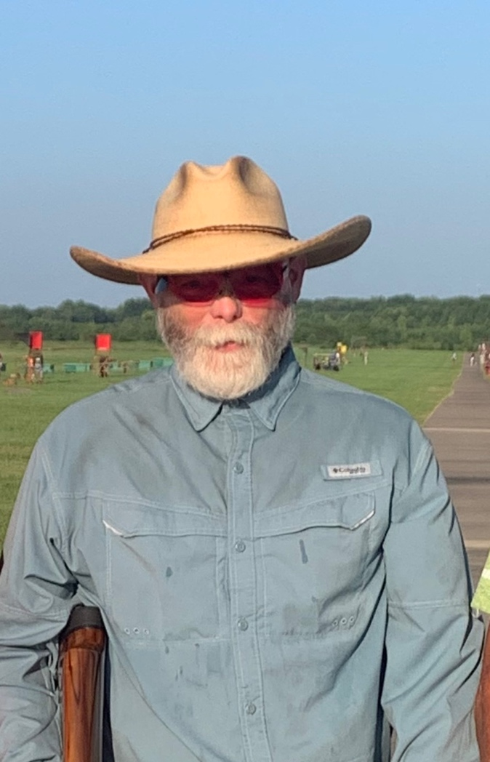
Robert E. Pennock Jr. “Robby”

Robert Pennock Jr. was introduced to trap shooting by his Uncle Gerald Pennock. Gerald put two traps in his back yard and Robby was put to work right away loading and pulling for shooters. He was hooked. A few years later, Gerald sold his traps and began shooting at the Remington Gun Club. This is where Robby and Gerald would spend most of their time. Robby shot his first ATA targets in 1985 as a sub-junior.
As with a lot of young shooters, Robby stopped shooting not long after he graduated high school due to getting married, establishing a home, and taking care of bills. Robby would shoot every once in a while during this time but really got back into it in 2006. This is when he also started traveling outside the state to shoot. Robby reached the 27-yard line in 2007. In 2009, Robby talked his wife (Wendy) into shooting and learned that there was “crying in trapshooting”. He has also helped coach a few teams of young shooters. Robby has always been willing to help out anyone who asks and has encouraged the youth shooters to listen to the older generation -you can hear some amazing stories. Robby has always been interested in what was best for the shooters as a whole. He decided to help out by running for Arkansas ATA Delegate, which he has been for several years. Robby has helped out at several of the gun clubs with running shoots or teaching how to run shoots. He is always putting others first when it comes to shooting. Who else would work the whole Grand American so their wife could shoot! (He did but only one time).
Robby has won several trophies at the Grand American, SW Zone, Arkansas State shoot, Louisiana, Missouri, Texas, Kansas, Mississippi and Oklahoma. During these shoots, Robby has made some lifelong friends and is always excited to see them. When asked what his favorite memory in trapshooting is; he replied, sitting out under that huge tree at Remington during any of the state shoots and visiting with Steve Mathis, Devon Melbourne & family, Andy Waldo, Jimmy Self & family, Roger Finkle, Bronson Castleberry, Arlie Griffin, Ray Bearden, Jim Clifton and the list goes on and on and on. Robby has never met a stranger and will always seek them out at the next shoot.

