Arkansas State Trapshooting Federation

Constitution and Bylaws

Article I

Name and Purpose

This organization is an Arkansas based, non-profit organization, officially known as the Arkansas State Trapshooting Federation or the ASTF, and hereafter shall be referred to as the "Federation."

The purpose of this Federation shall be to encourage and promote the sport of trapshooting, to govern the Federation's annual trapshooting championships and the sport of trapshooting in general within the state of Arkansas, and to promote good fellowship and sportsmanship by all members.

Article II
Membership

Section 1 - Classes
There shall be one (1) class of membership: life. No membership shall be transferable or assignable. All memberships shall terminate upon the death of said member. The annual target year for the ASTF will always be the same as the ATA's target year.

Section 2 - Residency
All members of the Federation shall be residents of the state of Arkansas. Residency requirements are defined as having established a residence in Arkansas at least six (6) months prior to the state shoot. The only exception to this shall be those serving on active military duty.

Section 3 - Cost

Life memberships, 18 and over, shall cost $35.00. Life memberships for shooters 17 and under on September 1 shall be $20.00. All dues shall be paid to the Federation Treasurer, who shall deposit said funds into the appropriate Federation accounts. The Treasurer shall maintain a current list of all paid members for inspection by the general membership.

Section 4 - Suspension/Expulsion
The Board of Directors (the Board) may impose sanctions, suspend, or terminate the membership of any member for just cause. The Board shall have the authority to conduct investigations into alleged misconduct and/or violations of the rules of the Amateur Trapshooting Association (ATA), the rules of the ASTF, state criminal law, and/or federal criminal law. All complaints shall be submitted in writing to the Zone Director of the zone in which the alleged misconduct and/or violation occurred. The complaint must be filed within fifteen (15) calendar days of the discovery of the offense.

1

The Zone Director and the Vice President from that Zone shall then investigate the complaint; and upon finding just cause, forward the complaint to the entire Board of Directors, along with their findings. The Board shall then notify the accused member of the time and place where the Board shall meet to hear, consider, and render a decision. The accused member shall be given a minimum of fifteen (15) calendar days' notice and shall have the right to present witnesses and testimony in his or her defense. The decision of the Board shall be final. If misconduct and/or violations were found not to exist after an investigation by the Zone Vice President and Director, the member who made the allegation shall be notified by the investigators as to their decision.

Article Ill
Board of Directors, Officers, and Delegates

Section 1 - Board of Directors
The Board of Directors, hereafter referred to as the "Board," shall consist of the following twelve (12) people:
1 - President
3 -Vice Presidents
1 - Secretary
1 - Treasurer
4 - Zone Directors
1 -ATA Delegate
1 - ATA Alternate Delegate

Section 2 - Elected Officers
The following State and ATA officers shall be elected by the Statewide Membership and Zone­ wide Membership at the Annual Meeting of the Federation: At the business meeting all current members of the ATA residing in the State of Arkansas, who are present in person at the meeting and are also current members of the ASTF, who have been active members shall be entitled to vote for the following State and ATA Offices:

President
Secretary
Treasurer
Director-At-Large
ATA Delegate
ATA Alternate Delegate

The following state officers shall be elected by the Zone-wide Membership prior to the Annual Meeting of the Federation:
Northern Director
Central Director
Southern Director

2

In order to afford the greatest number of Zone members the chance to vote, Zone elections shall be held during the Arkansas State Shoot on the Saturday of the Singles Championships, with the specific time of the meeting to be posted ahead of time at the clubhouse. The results of these Zone elections will be announced at the Annual Meeting of the Federation on Sunday.

After verbal nominations have been made and seconded, all voting for Officers and Delegates shall be by show of hands, written ballot, or by acclamation. The “Term of Office” for all Officers shall be for one (1) Target Year beginning at the start of the New Target Year after their election, with the exception of the ATA Delegate and the ATA Alternate Delegate, whose terms begin immediately after the annual meeting of the Federation and will extend to the following years Annual Meeting. Individuals may serve in only one elected state office at a time. However, nothing shall prohibit them from serving in a local zone, or national office at the same time as well.

Section 3 - Appointed Officers
Three (3) Vice Presidents, one (1) from each Zone, shall be appointed by the newly elected President. The “Term of Office” for each Vice President shall be for one (1) “Target Year” beginning at the start of the New Target Year after the election of the President.

Section 4 - ATA Delegate and Alternate ATA Delegate
An ATA Delegate and Alternate ATA Delegate shall be elected by the statewide membership at the Annual Meeting of the Federation each year. After verbal nominations have been made and seconded, all voting for Delegates shall be by show of hands, written ballot, or by acclamation. The Delegate and Alternate Delegate shall serve for one (1) calendar year or until the next election. Individuals may serve in only one elected state office at a time; however, nothing shall prohibit them from serving in a local, zone, or national office at the same time as well.

Section 5 - Voting
A minimum of seven (7) of the twelve (12) Officers and Delegates shall be required to conduct Federation business. A simple majority vote shall be required on all items for consideration. The President shall have voting power only in the event of tie votes. Should the President be absent, the ATA Delegate shall have voting power and cast the deciding vote. Should both the President and the ATA Delegate be absent, the Alternate ATA Delegate shall have voting power and cast the deciding vote.

Section 6 - Meetings
This body will follow Roberts Rules of Order when conducting meetings. The ASTF will have 2 types of Meetings. “Annual Meetings” will be conducted at the State Shoot, with the Board of Directors and general members of the Federation in attendance. “Board of Director Meetings” will be conducted at various times throughout the year as needed, with only board members present and any other members who wish to attend. Other than the Annual Meeting of the Federation, all other special meetings shall be called for by no less than three (3) officers, who in turn shall notify the remaining Officers at least twenty (20) calendar days in advance. At all Federation meetings, the order of business will be as follows:

3

Roll Call
Reading of the Minutes
Treasurer’s Report
Report of Committee
Old Business
Elections (Annual Meeting only)
New Business
Any other business or reports deemed necessary by the President
Adjournment

Section 7 – Replacement of Director or VP Due to Relocation or Resignation.
From time to time a zone officer (VP or Director) may relocate from one part of the state to another. If this relocation happens to move them into a different zone then they will be forced to resign their representation of the former zone. If the officer in question is a Vice President then the President shall appoint another VP from the zone in question to fill out the term. If the officer in question is a Director then the existing VP for that zone will be moved into the vacated Director’s spot and the President will appoint a new VP to fill his/her vacancy. The replacement guidelines in this section will be the same if a Director or VP resigns during his/her term.

Section 8 – Selection of Officers for spots not filled during Annual Meeting.
If an elected officer position is not filled during the Annual Meeting (i.e. nobody runs for that spot) then the task of filling that position will be handled by the officers that were elected at the Meeting and will follow these guidelines (Note…if the President’s spot is not filled then only subsection 3 will be used to fill that office):
1. Find a suitable volunteer: The elected officers will get together and try to find a suitable person to fill the vacancy. If a person is found then a simple majority vote of affirmation of the elected officials (President, Directors, Secretary, Treasurer, and Delegate) will be required to install this person to the vacant office.
2. Other Officers taking over duties: With the exception of the office of President, if no person can be found to fill the vacancy then the duties of this office can fall to another officer and they will be able to hold both offices at the same time (i.e. Secretary/Treasurer, or Treasurer/North Director). In no case shall the President hold more than 1 position.
3: If the President’s position is not filled: If the President’s position is not filled during the General Meeting then this position will be filled by one of the Zone Director’s moving up into the President’s spot and then that person will appoint their replacement to the Zone Director’s spot they vacated. The method that the 3 Zone Directors use to determine which will move to President is up to them. Once a President is determined he will then appoint the VP’s from each respective zone as called out in Section 3.

4

Article IV
Zones

There shall be three (3) Zones for the purpose of the election of Directors and the appointment of the Vice Presidents: the Northern Zone; the Central Zone; and the Southern Zone. See Addendum #1 (one) - Map of the Counties of Arkansas.

The Northern Zone shall consist of the following counties: Mississippi, Poinsett, Jackson, Independence, Cleburne, Van Buren, Pope, Johnson, Crawford, and all counties north thereof.

The Central Zone shall consist of the following counties: White, Faulkner, Lonoke, and Pulaski.

The Southern Zone shall consist of the following counties: Crittenden, Cross, Woodruff, Prairie, Jefferson, Saline, Conway, Yell, Logan, Sebastian, and all counties south thereof.

Article V
Hall of Fame and State Team

Section 1 - Hall of Fame Purpose and Selection Committee
The purpose of the Hall of Fame (HOF) is to recognize outstanding Federation contributors and shooters.

The HOF Selection Committee shall consist of the eight (8) elected Officers: President, Secretary, Treasurer, Northern Director, Central Director, Southern Director, ATA Delegate, and the At-Large Director. The HOF Selection Committee’s "Term of Office" shall be for one (1) "Target Year" beginning at the start of the "New Target Year" after their election.

Section 2 - Hall of Fame Selection Process
Any member of the Federation may nominate a person or persons for induction into the HOF. The nomination shall be made to their Zone Director or Vice President by March 15th and shall include a summary of shooting achievements which supports their choice for nominee. The Zone Director or Vice President will, in turn, present this information to the HOF Selection Committee, along with their recommendation. A three-fourths majority vote of the HOF Selection Committee is necessary to induct an individual into the HOF. The inductee must be a resident of the state of Arkansas or a former resident with strong ties to Arkansas. Inductees will be considered on the basis of being a contributor to the ASTF, an outstanding shooter, or a combination of both attributes. A contributor is an individual (shooter or non-shooter) or group of individuals (shooters or non-shooters) who has significantly enhanced trapshooting in Arkansas. Selection guidelines include:

5

1. Service to the ASTF or the ATA.
2. Offices held in the ASTF or the ATA.
3. Donation of time, manpower, equipment, financial aid, etc. to the ASTF or the ATA.

A shooter is an individual who has enhanced trapshooting in Arkansas and who has significant shooting achievements. Selection guidelines include:

1. Lengthy history of shooting (preferably 10 years).
2. Wins - local, state, zone, national, world.
3. Accomplishments - records set, honors, high averages, state teams, etc.
4. Is an outstanding role model for the sport of trapshooting-Demonstrates good sportsmanship and has the highest of character and integrity.

Section 3 - Arkansas State Trapshooting Team (State Team)
Members of the Arkansas State Trapshooting Team will be chosen based on high averages from the preceding year. The shooter must compete in a championship event during the ASTF State Shoot. Target requirements shall be posted in the state shoot program book annually. The State Team will be comprised of the top ten (10)Men, the top two (2) Ladies, the top five (5) Juniors , the top five (5) Sub-Juniors, the top (l )Veteran, and the top (1) Senior Veteran shooters. Age requirements for Special Category shooters are and will be the same as those listed in the ATA Rule Book. In addition, any Special Category shooter who is not the top shooter in their Special Category will still be eligible for the State Team in their Special Category if their average falls within or above the averages of the top ten Men shooters.

State Team Requirements (2012 target year and foreword)

 | Singles | Handicap | Doubles
Men | 1500 | 1500 | 1000
Ladies, Vet., Jr. | 1500 | 1000 | 500
Sr. Vet. | 1000 | 1000 | 500
Sub Jr. | 1000 | 500 | 500

Article VI
Duties of the Officers and Delegates

It shall be the duty of the President to preside at all meetings of the Board of Directors, to call for meetings of the Board when deemed necessary, to appoint such committees as may be deemed necessary for the good of the Federation, and to oversee that all rules and regulations of the Board are carried into effect.

6
It shall be the duty of the Vice Presidents to perform the duties of the President in his/her absence, to investigate complaints, to chair committees, and to perform any other duties that may be required.

It shall be the duty of the Secretary to keep accurate written accounts, including minutes, of all proceedings of the Federation, to receive and notify all members of information pertaining to meetings or elections, and to issue notices of such to the membership. The Secretary shall also assist the Treasurer in the collection of state dues. The Secretary will coordinate with the gun clubs on requested shoot dates, review documents and submittals to the ATA for approval. They will also follow up with gun club payment requirements per ATA rules.

It shall be the duty of the Treasurer to receive and hold all funds of the Federation and disburse the same as authorized to do by vote of the Board of Directors or by executive order. The Treasurer shall give a full financial report of the year's receipts and disbursements at the Annual Meeting of the Federation.

It shall be the duty of the Directors to assist in the day-to-day operation of the Federation and to represent the membership at Board meetings. They shall also: assist the Vice Presidents in the discharge of their duties; investigate complaints; chair committees; and perform any other duties that may be required.

The ATA Delegates (or in their absence the Alternate ATA Delegates) in a properly called meeting, constitute the Board of Directors of the ATA, and as such have the responsibility of overseeing the operation of the Association. It shall be the duty of the ATA Delegate (and the Alternate ATA Delegate in the absence of the ATA Delegate) to outline and put in force the general policy of the Amateur Trapshooting Association, designating the time, place, and rules of all registered tournaments and registered club shoots, prescribing all championship requirements , allotting, donating, and distributing all trophies, cash contributions for competitive trapshooting under such conditions and at such times and places as it in its judgment may deem best for the sport. It shall have the duty, specifically, to see that the property, business, and assets of the Amateur Trapshooting

Association are efficiently managed to the best interest of this corporation. (Note: these duties are taken directly from: "ATA BYLAWS; ARTICLE I; BOARD OF DIRECTORS; DUTIES”- Amateur Trapshooting Association.)

Article VII
State Shoot History

In addition to the information that is required by the ATA Bylaws and the ATA Official Rule Book, each year the ASTF State Shoot Program Book shall include a complete listing of the state's Past Champions (Singles, Doubles, Handicap, HAA, Lady, Junior, Sub-Junior, Veteran, and Senior Veteran) as a necessary means of preserving the history of trapshooting in Arkansas.

In an effort to preserve more trapshooting records, a more detailed "History of Arkansas Trapshooting" will be created and maintained, and a copy of this document will be kept with the ASTF Bylaws and the ASTF Policy Manual.
7

Article VIII
State and Southwestern Zone Shoot Requirements

Section 1 - General

The date and location for the Arkansas State Trapshooting Championships (State Shoot) will be determined at the preceding Annual Meeting by the Membership. Should a gun club wish to host a State Shoot, they must first meet the requirements listed in Sections B, C, D, E,H below.

Section 2 - Readiness of Location
Any gun club requesting to host the State Shoot must certify in writing to the Board of Directors of the Arkansas Trapshooting Federation (ASTF) that all facilities as set out in the below requirements are installed and ready for use prior to requesting and accepting the responsibility of holding the State. Inspection of the proposed gun club by at least two (2) ASTF Officers (President, VP's, Secretary, and Treasurer) or Directors (Northern, Central, Southern, At-Large) as to this readiness must be done prior to voting. After being voted as a host gun club, should the host gun club then encounter circumstances that would prevent them from hosting their particular State or SW Zone Shoot; the Board of Directors of the ASTF will then convene for the purpose of selecting an alternate site.

Section 3- Financial Solvency
Any club wishing to host the State Shoot must submit to the Board of Directors of the ASTF the following proof of financial solvency six (6) months prior to the State Shoot and again thirty (30) days prior to the State Shoot:
1. A Financial Statement for the previous twelve (12) months.
2. An affidavit by a club officer listing the major suppliers of targets, ammo, etc.
3. A statement of the financial condition of the club, stating that there are no outstanding liens, judgments, or financial contingencies, which could adversely affect the ASTF.
The Board may decide to waive this requirement if in its opinion there is no present risk of financial failure that would jeopardize the hosting of the State Shoot.

Section 4 - Facilities of Hosting Club - STATE SHOOT ONLY
Any club wishing to host the State Shoot must have the following facilities:
1. A minimum of five (5) program fields and one (1) practice field, with all six (6) trap machines in excellent working order.
2. A minimum of one (1) extra trap machine in excellent working order on hand as a standby.
3. A building or shelter adequate for one hundred and fifty (150) shooters.
Solid structures must be available for cashiering, squadding, and handicapping. If these structures must be rented it will be at the expense of the hosting club and not the ASTF.
4. Restroom facilities at a minimum of two (2) stalls for each one hundred (100) shooters.

8
5. Parking area available at a minimum of seventy-five (75) spaces for each one hundred (100) shooters.
6. Electrical and water hookups for recreational vehicles at a minimum of ten
(10) hook-ups for each one hundred (100) shooters. Each spot must be outlined so that the boundary for each camper is clearly identified.
7. Drinking water coolers with sufficient cups at each trap, with each cooler to be serviced and filled regularly during the day.
8. Hosting club must have an operational and extensive PA System for announcements, National
Anthem, shoot-offs and emergency notifications.
9. The Gun Club Facilities will be ADA Compliant.

Section 5 - Other Requirements - STATE SHOOT ONLY
Any club wishing to host the State Shoot must provide the targets and all personnel necessary for the above-mentioned facilities in Section D, namely:
1. Food Service Personnel - Full food service must be provided from 10:00 a.m. until 3:00 p.m. for the anticipated number of shooters in attendance.
2. Trap Personnel - Trained, experienced setters and scorers, with adequate relief personnel available as well.
3. Trap Mechanic - Experienced Trap Mechanic and assistants as needed.

NOTE: At all State Shoots, the following will be provided by the ASTF:

1. Cashiers – At least one (1) experienced cashier who will calculate the options and make the payouts to the shooters. All payouts must be completed within two (2) weeks after the competition of the State Shoot.
2. Handicapping Committee - Experienced Chairman and assistants (Note: per the ATA OFFICIAL RULES; SECTION VJ, · the ATA Delegate is the Chairman of the Handicap Committee. Other handicapping assistants must be known, experienced ATA members).
3. Squadding Committee - Experienced Chairman and assistants.
4. Any computer personnel as needed.
5. All trophies not provided by the ATA (Note: the ATA Rule Book lists the ATA trophies
that will be provided to all states for their respective State Shoots).

Section 6 - Facilities of Hosting Club - SW ZONE SHOOT ONLY

The Date and Location to hold the SW Zone Shoot will be the sole discretion of the Delegate per the bylaws of the ATA Southwestern Zone Trapshooting Association.

Below is a suggested guideline for any club interested in hosting a SW Zone Shoot:
- A minimum of five (5) program fields and one (1) practice field, with all five (5)
trap machines in excellent working order.
2. A minimum of one (1) extra trap machine in excellent working order on hand as a standby.
3. A building or shelter adequate for fifty (50) shooters. Solid structures must be available for cashiering, squadding, and handicapping.
9
4. Restroom facilities at a minimum of one (1) stall for each fifty (50) shooters.
5. Parking area available at a minimum of thirty (30) spaces for each fifty (50) shooters.
6. Electrical and water hookups for RV's at a minimum of four (4) hookups.
7. Drinking water coolers with sufficient cups at each trap, with each cooler to be serviced and filled regularly during the day.

Section 7 - Other Requirements - SW ZONE SHOOT ONLY
Any club wishing to host the SW Zone Shoot must provide the targets and all personnel necessary for the above-mentioned facilities in Section E, namely:
1. Food Service Personnel - Full food service shall be provided from 10:00 a.m. until 3:00 p.m. for the anticipated number of shooters in attendance.
2. Trap Personnel - Trained, experienced setters and pullers, with adequate relief personnel.
3. Trap Mechanic - Experienced Trap Mechanic and assistants as needed.
4. Cashiers - At least one (1) experienced cashier who will calculate the options and make payouts to the shooters. All club payouts must be completed within two (2) weeks after the completion of the SW Zone Shoot (Note: Zone added money will be mailed to Zone winners at a later date by ATA Zone Officials).
5. Handicapping Committee - Experienced Chairman and assistants (Note: per the
ATA OFFICIAL RULES, SECTION VJ; the ATA Delegate is the Chairman of the Handicap Committee. Other handicapping assistants must be known, experienced ATA members).
6. Squadding Committee - Experienced Chairman and Assistants.
7. Any computer personnel as needed.
8. All club trophies (Note: Zone trophies will be mailed to Zone winners at a later date from ATA Zone Officials. The ATA Rule Book lists the Zone trophies that will be provided to all Zones for their respective Zone Shoots.).
9. In general the SW Zone shoot will follow the schedule dictated by the SW Zone Association.
The hosting club can if desired run separate events concurrently and offer local trophies for these events as long as they don’t interfere with the SW Zone Shoot Schedule.

Section 8 - Other Required Shoots
Any gun club that is eligible to host a State Shoot must hold at least three (3) registered trapshoots per year, not counting the State or SW Zone Shoot.

Section 9 - Profit and Loss Statement
After the completion of the State Shoot, the ASTF Treasurer shall file a complete Profit and Loss Statement of the State Shoot with the ASTF within forty-five (45) days following the last day of the Shoot. These Financial Statements may be viewed at any time by any ASTF Officer or Delegate.

10

Article IX

Fiduciary Duty

Because the ASTF is an Arkansas-based, non-profit organization, the Board of Directors shall endeavor to see that the ASTF remains financially solvent. Specifically, the Board of Directors shall make every effort to see that the yearly expenses of the ASTF not exceed the yearly income of the organization; the expenses of the State Shoot not exceed the income of the State Shoot; and lastly, the expenses of the Arkansas rotation of the SW Zone Shoot not exceed the income of the Arkansas rotation of the SW Zone Shoot.

Article X
ASTF Official Logo
See Addendum Two (#2)

Article XI

State Shoot Logo
See Addendum Three (#3)

Article XII
ASTF Target Year

The annual target year for the ASTF will always be the same as the ATA's target year.

Article XIII
Amending the ASTF Bylaws

Section 1 - Amending Bylaws
The Bylaws of the Arkansas State Trapshooting Federation may be adopted, modified, changed, enlarged, amplified, or amended by a majority vote of the ASTF Board of Directors per June 2016 Annual meeting.

11

Article XIV

Policy and Procedures Manual

The ASTF will maintain a Policy and Procedures Manual which will contain details about items of business or policy that the Board of Directors enters into from time to time. An example would be details on a loan to a gun club or setting Pre-Squad fees. These Policies and Procedures will be listed numerically in the manual as they are enacted and will from time to time be “retired” as they are deemed by the Board to no longer be applicable. The “retired” items will be listed in the back of the manual for future reference. The maintenance of the manual will be at the sole discretion of the Board at their periodic meetings.

Article XV
Website/Social Media

Section 1. Website: The website of the ASTF shall be informative to the membership and contain information that benefits the ASTF and/or the Amateur Trapshooting Association (ATA). The content of the website shall be managed by a company or person in which the ASTF Board of Directors deems fit. This person/company may also be appointed by the Board of Directors to manage all ASTF social media accounts.

Section 2. Social Media: All social media accounts shall be used as an informational tool as well. These platforms may be used to direct the membership to the ASTF website for more detailed information or in any other way the Board deems necessary. These platforms will also have only ASTF content or content from the Amateur Trapshooting Association. The person/company who manages these accounts may be appointed by the Board of Directors.

12

Addendum #1 (one) – Article I V Arkansas Zones
Map of the Counties of Arkansas

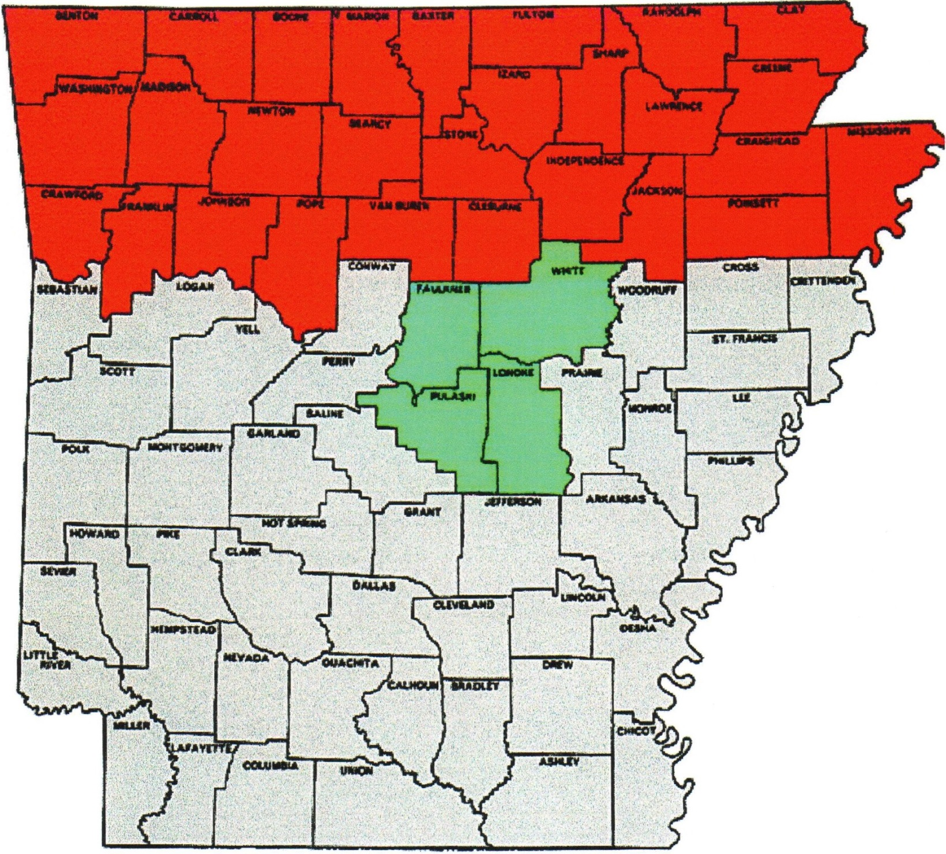
Red Counties - North Zone
Green Counties - Central Zone
Gray Counties - Southern one

13
Addendum #2 (two) - Article VIII
Arkansas State Trapshooting Federation Official Logo

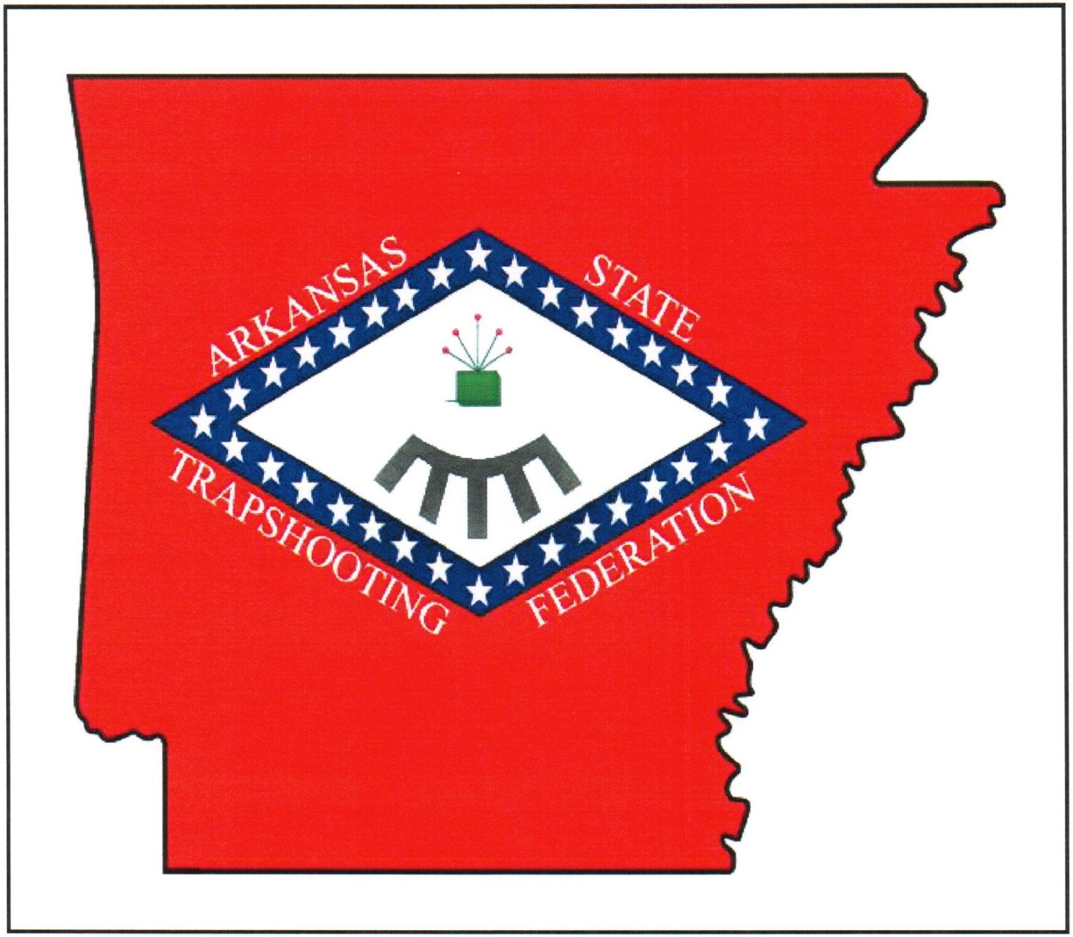

14

Addendum #3 (three) - Article XI
Arkansas State Shoot Logo

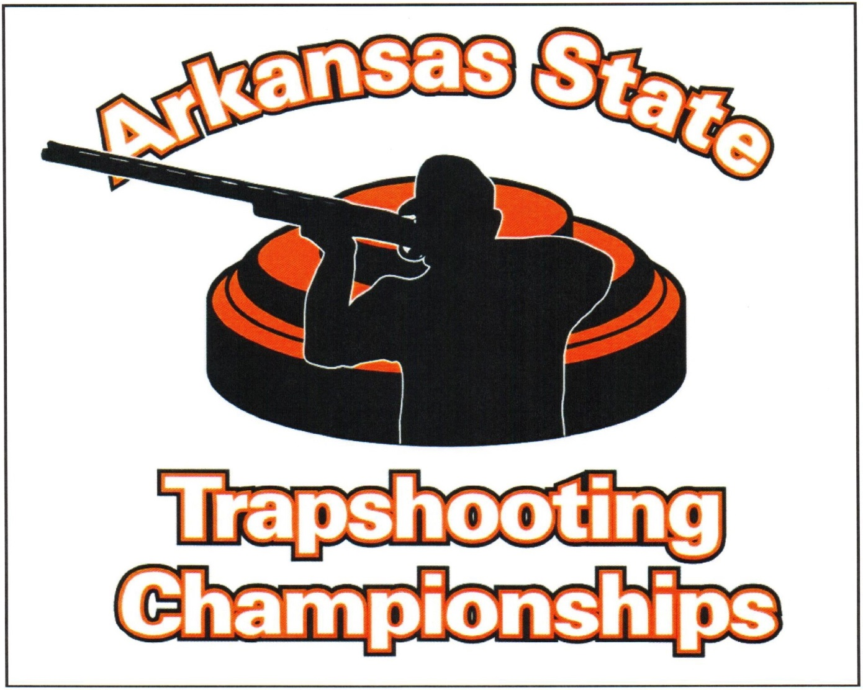

Bylaws Revised 2022

15

