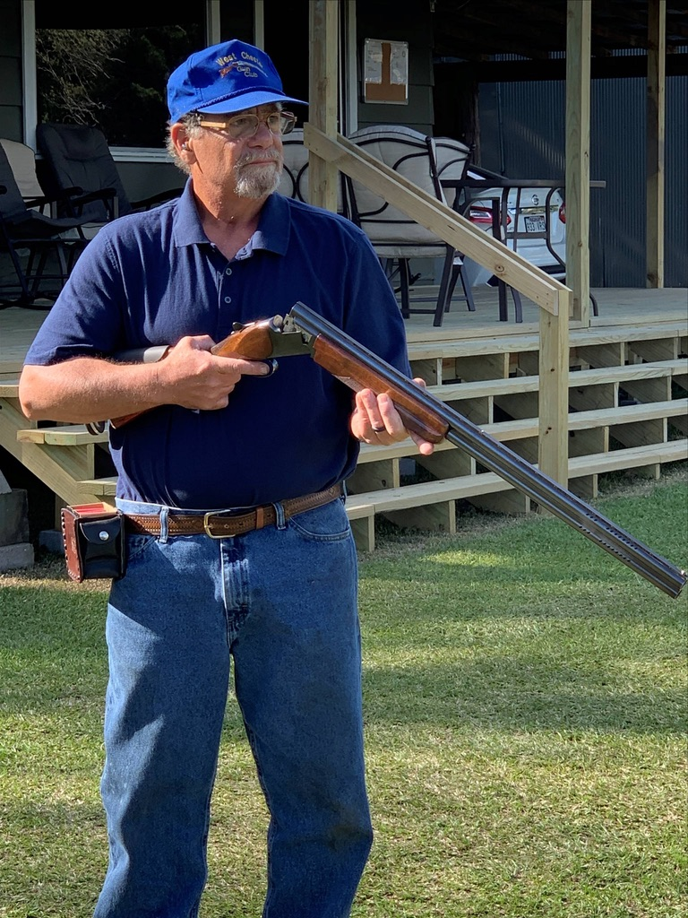
Ben Forte
2019

Ben started shooting in 1966, at the West Chester Gun Club in Pennsylvania, with his father Giuseppi. His father and family friend Frank Little, helped him get a good foundation in shooting and coaching. Ben won his first trophy at the Coral Reef Preliminary Handicap at the Delaware State Shoot, in 1970. He started to work at West Chester Gun Club as a trap loader, in 1966. Ben held every position at one time or another, at the club, with a membership of 450 shooters. During this period, Ben also went out to shoot in a lot of the clubs in the Northeast. He won trophies at the Pennsylvania, Delaware, and Maryland state shoots. He won awards at the Pennsylvania Grand, the Westey Hogan, and Spring Grand in Litchfield, AZ.
Back surgeries slowed Ben down in 1995 through 1998, but he continued to shoot and work at the West Chester gun club until the year 2000. After 35 years at the club as a shooter and worker, Ben moved to Camden, Arkansas.
After Ben’s move to Camden in 2000, he made friends with Tony Pass. Tony then asked Ben to manage and run the club, using all the knowledge he had gained working at West Chester. Ben helped Camden through some troubling times during this period. He also started to shoot all over the State of Arkansas. In 2007, Ben won the Remington Handicap with the lone 98. The same year he had 200 straight at the Southwest Zone in Lonoke, losing in a shoot-off but still winning his class. He won the Sub-Vet Handicap Championship in 2012 with a 95 and tying for high the next two years. Ben had another injury in 2009, rupturing a disc in his neck requiring metal support. He was unable to get back to his best level of shooting after the injury, but he still helps others.
He started coaching the AYSSP with the Camden/Fairview team, both Junior High and Seniors, when the program began8 years ago, at Camden/Fairview. The last few years he has worked with shooters from Smackover, Columbia Christian, Harmony Grove/Camden, Magnolia and other AYSSP Shooters who come to Camden to practice. Ben has given countless hours of instruction to young shooters in South Arkansas who ask for his help.
Ben has been a Board member for the ASTF for about 5 years. He started helping with the State Shoot Program book in 2011. He helped grow the ad revenue to a new level of $11,500 in 2018. In 2013, he helped with the state trophy awards and greatly improved them. He accepted and completed the task of helping Rick Evans Grandview Wildlife Center, Warren, Delta, and Mountain get ATA certified and was on call to answer questions during the shoots. Ben is currently consulting for Southern Arkansas University concerning a new trap and skeet facility which will be used by SAU, AYSSP teams, as well as the general public. The facility plans to hold monthly ATA shoots.
Ben has been active in the sport for over 50 years, he has shot 112,850 registered targets to date. He has won awards all over the country. He has been blessed to receive help from many people. He has been able to pass this knowledge on to many young shooters. You can find Ben now, at the Camden Gun Club, managing the club, cutting the grass, working on trap machines and whatever else needs to be done. He runs an ATA shoot every Saturday from March until the first week in October, his greatest love now is to help kids get started and reach their potential.

