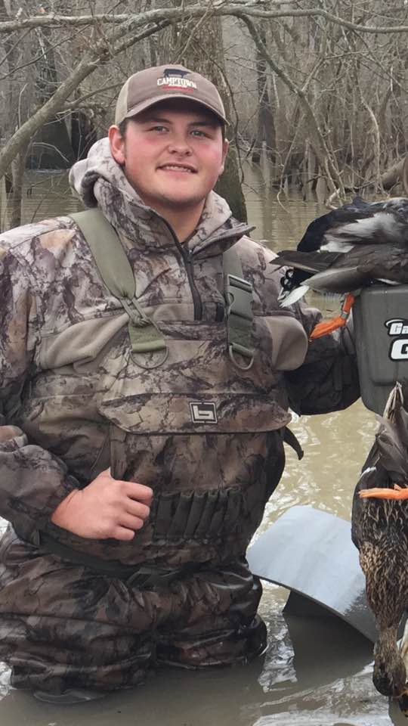

Daniel Griffin
2021

Daniel Griffin was a true example of a passionate and dedicated trap shooter. He began trap shooting in 2009 with the first Greene County 4-H team and the Greene County Tech school shooting team before joining the Harrisburg Trap Club where he began competing in ATA competitions. Trap shooting quickly became the foundation upon which Daniel would build his hobbies, plans, and goals.

Daniel was honored to make the ATA All-American team and then won the Arkansas State Doubles Championship in 2015. Daniel also won the Sub-Junior Clay Target Champion and High Overall Sub-Junior at the Grand American which was one of his favorite accomplishments. At the Fall Diamond Classic in Missouri, Daniel was the Super 400 Handicap Champion and won a diamond necklace on his mother’s birthday which he proudly gave to her as a gift. At the 2014 Grand American, Daniel and his squad were the first junior squad in history to break 500/500, an accomplishment for which he was so proud. Daniel earned many more shooting awards in the years to follow.

One win that Daniel would never forget was when he defeated Harlan Campbell in a carryover win at the Grand American. Mr. Campbell, one of the most skilled shooters in ATA, was also Daniel’s idol and the person he most admired and respected in the shooting sports family. After that accomplishment, Daniel always carried the shooting bag he won for the event because it reminded him to stay focused and be confident when he competed.
On a more personal level, Daniel loved traveling to different states to compete with his squad. He traveled and competed in Texas, Kansas, Nebraska, Missouri, Illinois, and all over Arkansas. Daniel was working toward an Agri-Business Degree from Arkansas State University in Jonesboro and his plans were to join his father on the family farm. Daniel was a loving and giving person, and was always willing to help others improve their shooting skills and learn about shooting sports. Unfortunately, Daniel passed away before realizing his goal of becoming a trap shooting instructor. He was passionate about sharing his love for shooting sports with others.

