INCOME INEQUALITY AND CONCENTRATION OF WEALTH

I could never have imagined that a protest speech, no matter how strong the message, would lead to a crowd of people marching to the capital building where people would break through doors and expect that no one would get shot. It is hard to believe.

Before that, how could George Floyd's death, as horrific as it was, trigger such widespread protest to the point of attacking police, burning buildings, toppling statues, and looting?

There are many factors involved especially the Covid lock-down factor but I would like to point out another important factor for your consideration, the economic squeeze that has been building up for the past 50 years. Most people have no understanding of the intricate mechanisms involved but younger generations know intuitively that something is definitely wrong. They are not getting ahead and at the same time they are told that this is the richest country in the world. The incredible advances in technology should have resulted in younger generations having a higher standard of living than their parents but now, the opposite is true. On top of that, technology has gotten to the point that college education is almost essential but at the same time it has been made unaffordable. I think that a big part of what we are seeing is the venting of this frustration.

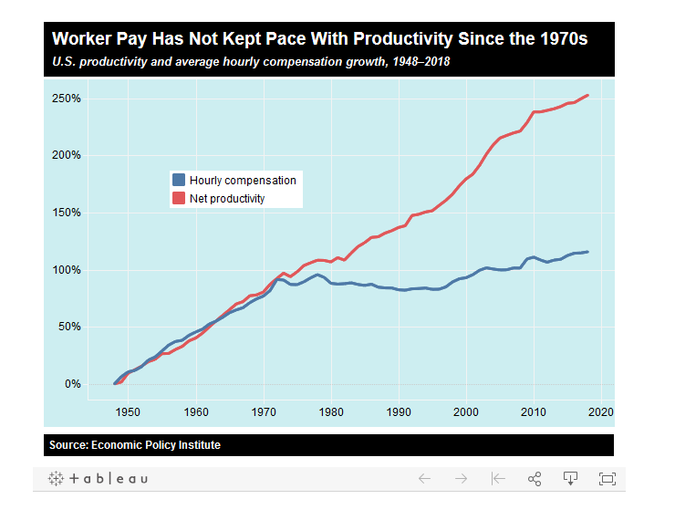
(5)

Income inequality was not always such a problem. This chart is the key. It shows hourly productivity steadily increasing at the same rate as hourly compensation for the average worker from 1946 until about 1971 which is how a natural economy functions, fair and balanced. Actually, real family income roughly doubled from the late 1940s to the early 1970s for all income levels, rich, middle class, and poor.(35)

"In the 1950s and 1960s homelessness declined to the point that researchers were predicting its virtual disappearance in the 1970s.” Since then homelessness has grown to crisis levels. Why? (38)

The Civil Rights Act, the Voting Rights Act, and the Fair Housing Act were passed in the 60s.
With all of that progress toward racial equality, in the 70s “blacks, as well as whites, improved their socioeconomic status. Among both races, educational attainment increased, the occupational distribution was upgraded, and real purchasing power rose markedly. In almost every comparison, the gains were somewhat greater among blacks than among whites and thus most indicators of racial differentiation declined.” (34)

In the 1960s letters were written with typewriters, copies were done with carbon paper, corrections were done with whiteout, and mechanical drawings were done with pencil on vellum paper. The most popular electronic device at that time was a 6 transistor AM radio. Of course, since then advanced technology has resulted in sophisticated tools with a huge increase in productivity and the corresponding wealth produced.

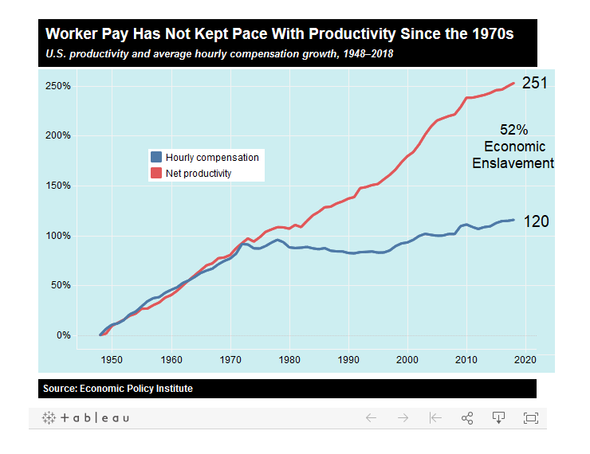

But after 1971 something dramatically changed. Advancing technology resulted in productivity increasing 150% but wages, adjusted for inflation, only increased 50%. The increased wealth in that was produced after 1971 did not result in a proportional increase in average worker compensation.

The average workers are getting paid half of what they would be getting if a natural economy had continued from 1970. With a perverted economy instead, what evolved was economic enslavement at a level of at least 50%.

Do not complain to your boss, with unfair foreign competition he is in the same boat. The economic enslavement is systemic and sophisticated, no physical chains required. Instead we are told that we live in a free country.

If you are not getting ahead and you are white you are told that it is your fault. Work harder! If you are not white, then the problem is systemic racism and white privilege. What is systemic is the economic squeeze.

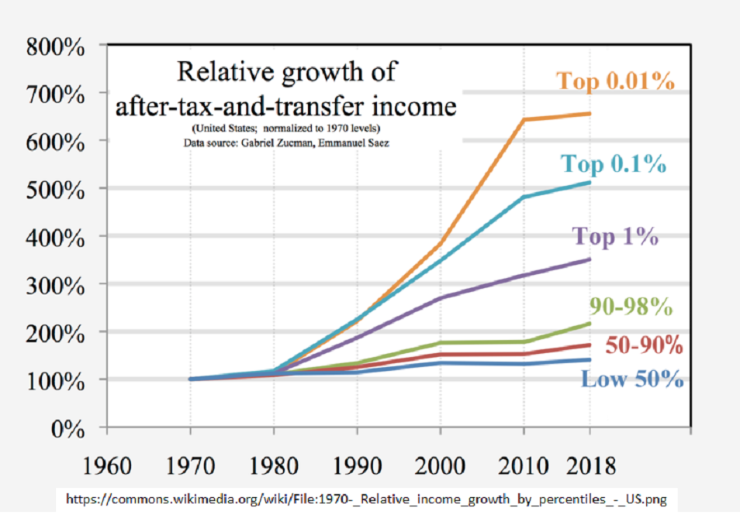
(4)

This chart shows where a lot of the wealth from economic oppression has gone. The rich have had dramatic growth in income and wealth. This chart does not show that all incomes were equal in 1970, they were not, but whatever level that was for each group was used as a reference. This chart shows the dramatic increase in income growth for the top 1% even after the 2008 crash.

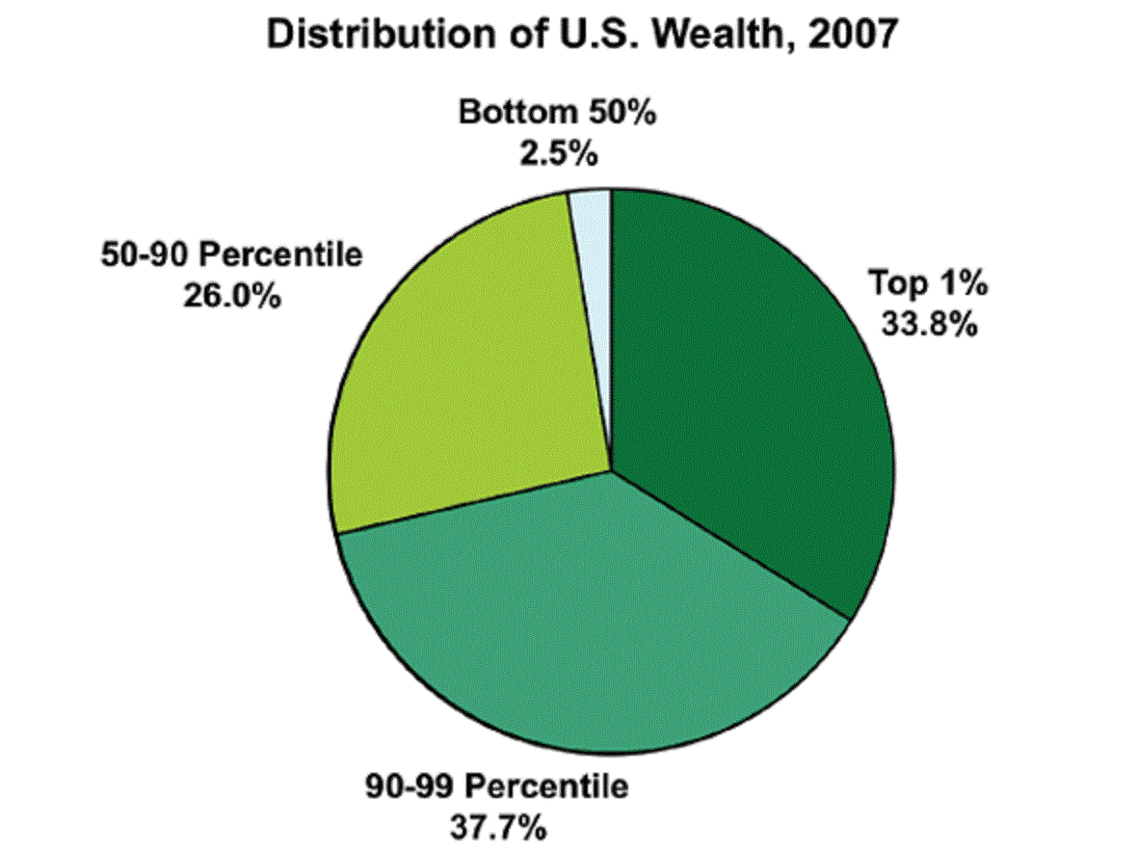
(2)

This chart is from 2007 concerning wealth inequality. It shows that the bottom 50% had 2.5% of the wealth. The top 10% of families (the portion on the right plus the portion at the bottom) had over 70% of the wealth. This was before the 2008 crash, it has gotten even worse. In 2019 the bottom 50% had less than 1% of the wealth! (3)

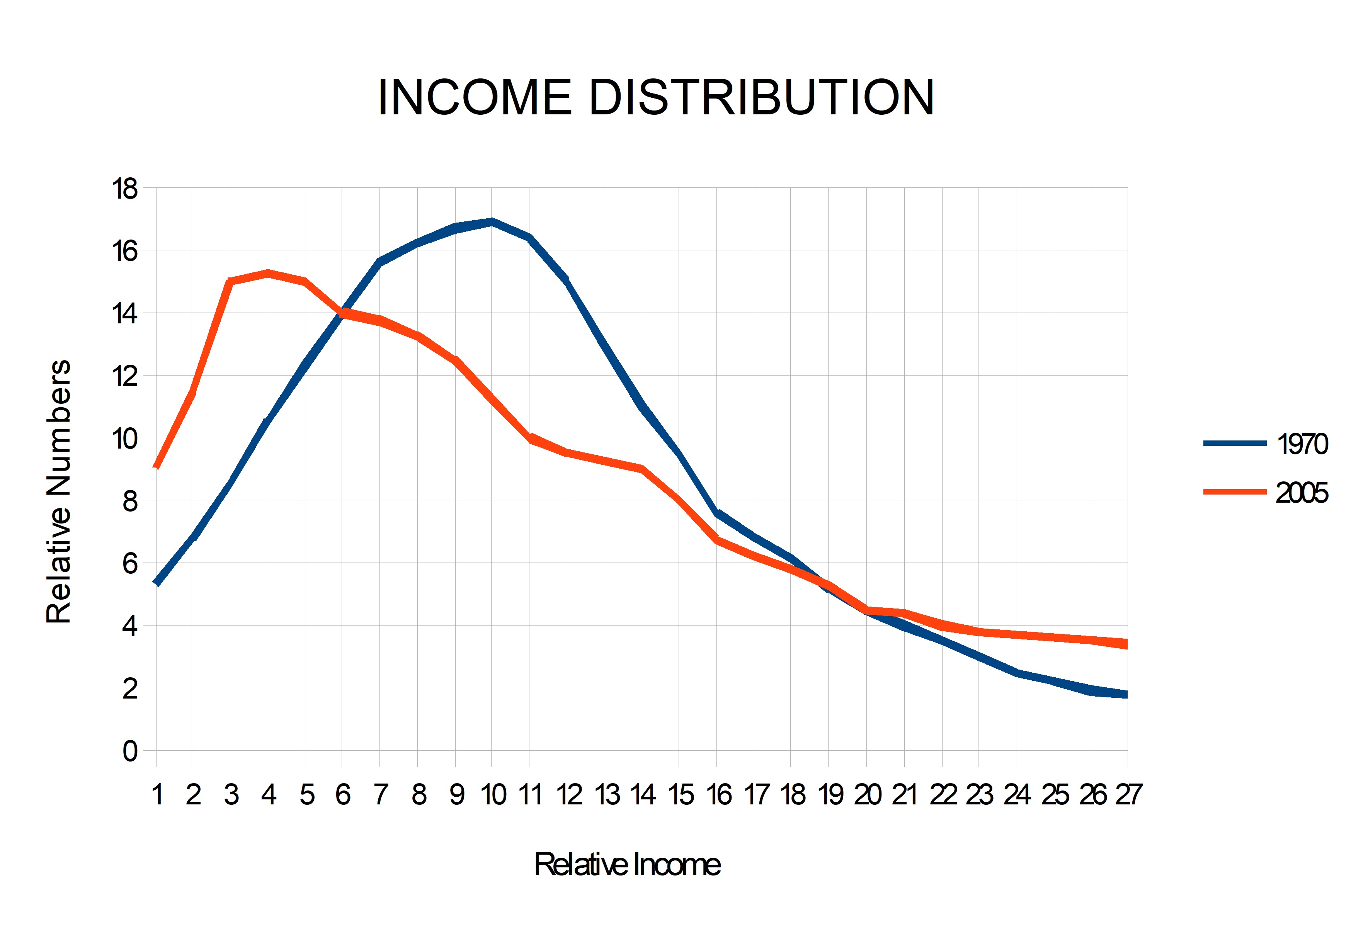
(6)

This chart is from the Statistical Abstracts of the United States income tax data. I plotted the income distribution for years 1970 and 2005. In 1970 we see a bell curve showing a normal, natural, distribution. It shows a majority in the middle class with fewer and fewer as incomes increase and fewer and fewer as incomes decrease. But in the year 2005 we see a distorted, unnatural distribution, the middle class has completely disappeared and the peak income is near the poverty level. This was the case even before the 2008 crash! For 2016 the distortion was even worse.

Since 1971, the perverted economy pushed the middle class toward the poverty level while the poor minorities at the poverty level were made even poorer requiring more government assistance. Even though economic enslavement has been a slow process taking over 50 years, people intuitively know that something is very wrong and feel that they deserve more. This produced an entitlement mentality that has resulted in the dramatic growth in Welfare, Medicare, Social Security and other entitlement programs which have already made this country a semi-socialist country. Social programs are a method for politicians to buy votes from the struggling masses. The bigger the struggle, the more votes.

Credit cards have an appeal to the entitlement mentality created by economic enslavement, a way to get ahead and worry about the consequences later. Credit card debt has also grown exponentially and greatly increases the level of economic struggle.

Crime is another way poor minorities adapt to the economic squeeze which results in racial disparities in policing, incarceration, and the lack of employment opportunities when released. That made it easy for some to gather statistics from poor minority areas and claim “Systemic Racism.” This recent media narrative has been very successful in inciting violent riots and promoting the “defund the police” insanity.

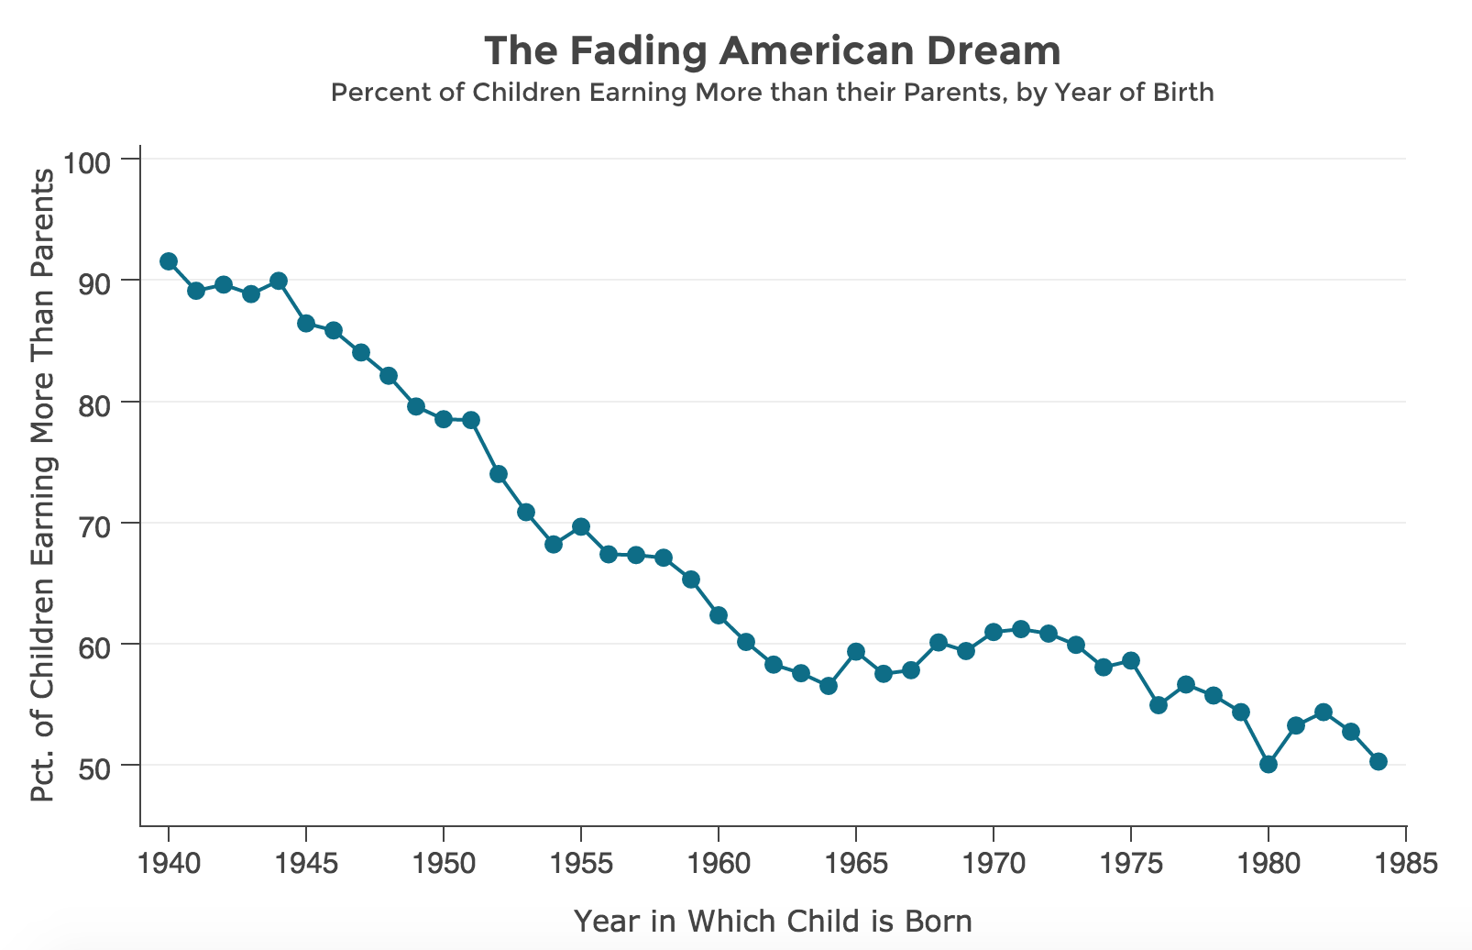
Without economic oppression, income levels would have increased and crime would have decreased especially in minority neighborhoods. During the Trump economic boom from 2018 to 2019, which resulted in the lowest black unemployment level in history but only a 10% increase in average household income, 29% fewer black persons and 22% fewer white persons were victims of serious crimes. (43,52) Imagine what 100% increase in average income would have done.

(11)

One would expect, as technology advances the result is increased worker productivity and a steadily increasing standard of living. Until recently each generation did have a higher standard of living than their parents. However, it has now gotten to the point that most children will actually have a lower standard of living than their parents.

The establishment has such control of the economy that they can determine what level of standard of living they will allow the average person to have. I think that they went way too far.

You can see that this is a very serious problem. “Tax the rich” is a common response. Unfortunately that would not address the cause at all. There will always be rich people due to a combination of skill and luck or quite often being able to take advantage of the power of government to take money away from us and give it to them. (Hence the term “lucrative government contract.”)

Over the years politicians have offered many social programs to reduce the level of enslavement in exchange for votes, Social Security, Welfare, Food Stamps, School Lunch, etc. Present Democratic proposals are free college, medicare for all, and universal child care (free babysitting). This does nothing to solve the fundamental problem. It will actually increase government's power and control over all of us.
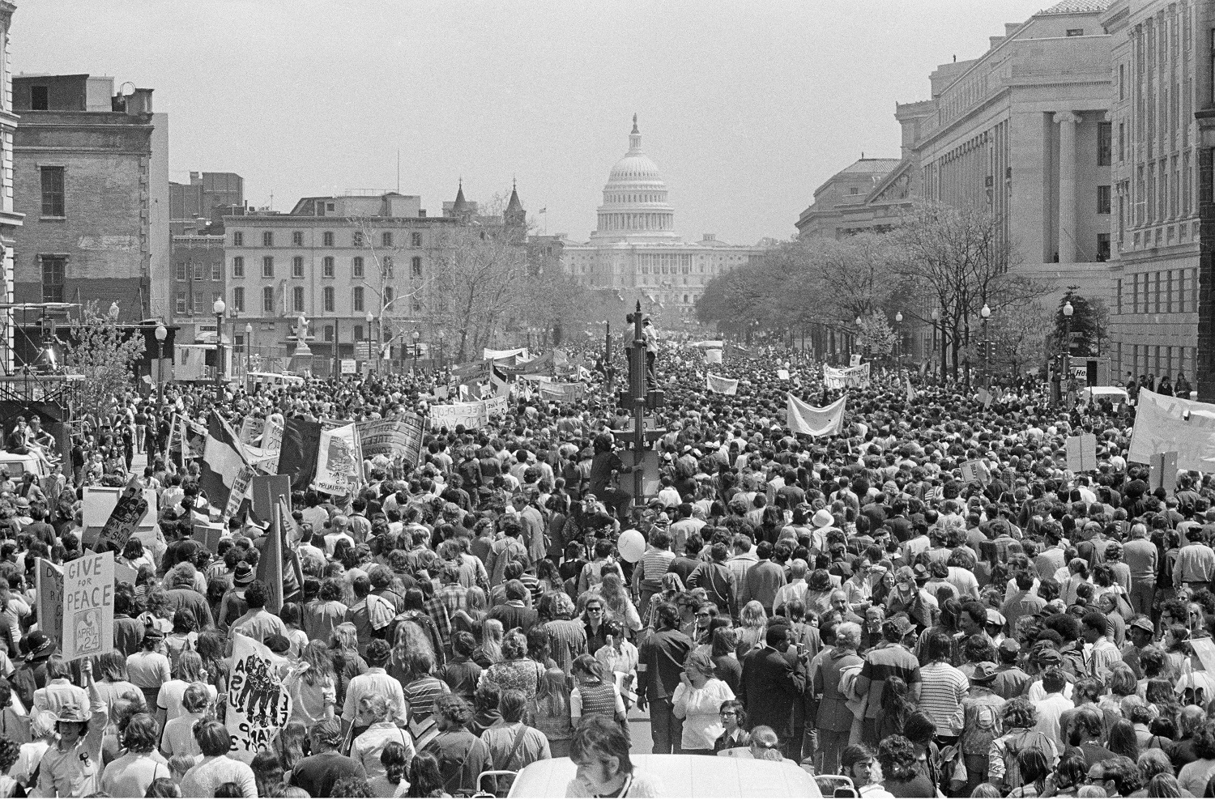
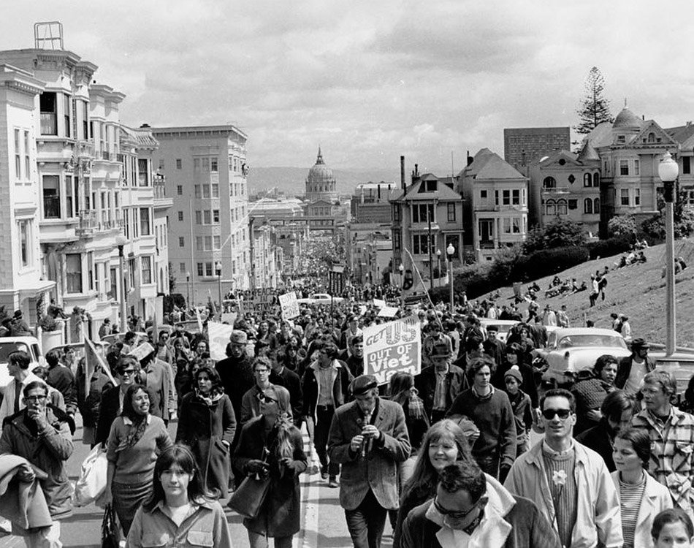
(37)

The late 60s and early 70s anti-establishment revolution had everything to do with it. There were many demonstrations but on November 15, 1969, over 500,000 people marched through Washington, D.C. protesting the Vietnam War and the draft.(7) That accomplishment was beyond incredible, it was a miracle considering that there was no internet and no cell phones at that time. The establishment took notice and took swift action against the young and arrogant that had way too much free time and had the audacity to protest the war and the draft. The Aerospace Cutback in 1971 provided the loss hundreds of thousands of jobs which resulted in reduced wages in order to increase the level of struggle that has been the case sense. Mass protests against the war gradually disappeared.

The establishment also easily eliminated the draft as military service then became the best option for employment for many young people.

I was 25 years old at that time and remember how the Aerospace Cutback caused a sudden and drastic change in the economy. Before the cutback jobs were plentiful and wages were great. I could work for 4 or 5 months, quit my job, have plenty of money to take off a month or two and not worry about being able to find another job. After the cutback I felt lucky to get a job and I kept it despite the lower wages. It is now labeled the Aerospace Recession to give the illusion that it was a natural economic event. It definitely was not.

Another thing that I remember in the 1970s was the massive imports of Japanese cars that were actually higher quality than American cars. My first Honda Civic went 167,000 miles, which was much more than the average American car at that time.

With low tariffs and high corporate taxes, domestic automobile production could not compete resulting in bankruptcy and government bailouts starting in 2008.

The change to a perverted and unethical economy has mainly involved the following:

- THE AEROSPACE CUTBACK provided a sudden loss of jobs.

- INFLATION which causes prices to steadily rise relative to wages,

- ANTI-AMERICAN GLOBALIZATION by increasing personal and corporate taxes
and lowering tariffs,

- REGULATIONS which are an additional burdensome increase the cost of doing business.

- FOREIGN AID which directly benefits foreign countries and has a negative effect
on our economy.

A thorough understanding of the above problems will result in effective SOLUTIONS.

FIRST, INFLATION:

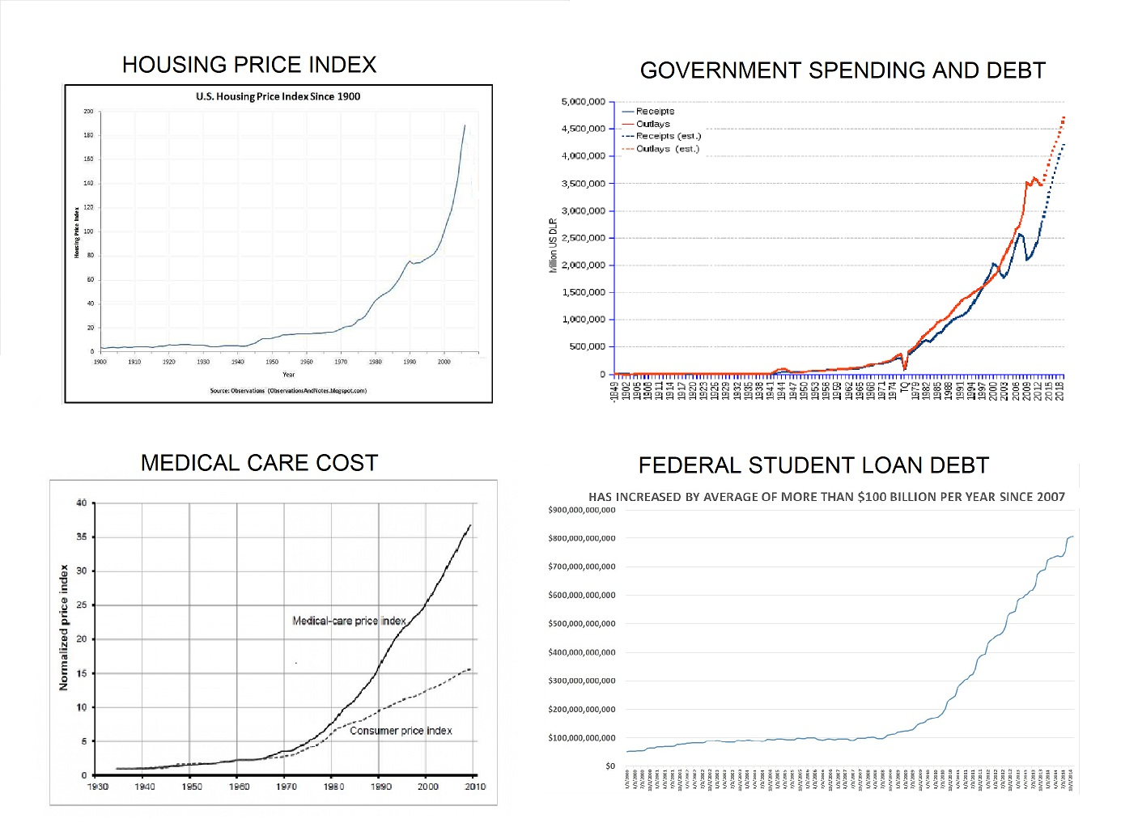
(9, 10)

Inflation is mainly the result of the expansion of currency in circulation in excess of demand. This is what inflation looks like. Housing cost, Government Spending, Medical Care Cost, and Student Loan Debt, all rising exponentially. This cannot continue without eventual economic disaster.

MEDICAL CARE COST CRISIS

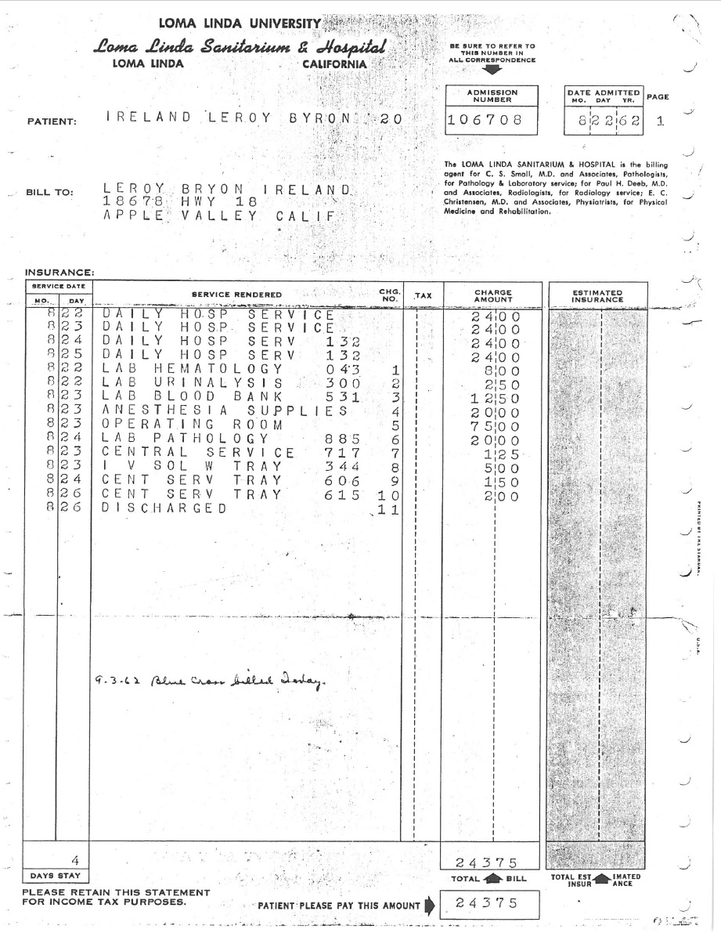

Medical care cost, which has outpaced inflation by more than double, is especially insidious. People die and/or go bankrupt as a result. This is due to the over-regulation of medical care industry and insurance companies in particular.(20) My dad had major cancer surgery in 1962 requiring 4 days at Loma Linda University Medical Center and the total billed to Blue Cross was $243.75. At $24 per day room rate and $60 per day for the total service, health care was once affordable. Adjusting for inflation, the present room rate should be about $240 per day and total service about $600 per day.

The FDA drives up the prices by 1) delaying the introduction of life-saving therapies, 2) suppressing safe methods of preventing disease, causing the price of drugs to be so high that some do without, 4) denying access to effective drugs approved in other countries, 5) intimidating those who develop innovative methods to treat disease, 6) approving lethal prescription drugs that kill, 7) censoring medical information that would let consumers protect their own health, 8) censoring medical information that would better educate doctors, 9) misleading the public about scientific methods to increase longevity, and 10) failing to protect the safety of our food. For an example of this, Monsanto genetically engineered BT Toxin into corn without any FDA approval required. (21, 26, 27)

On the street where I do my workout, I met Rita, a nurse who impressed me with her knowledge of Quercetin, Ivermectin, and Zinc for preventing and treating Covid-19. I told her about BHT (32) and she told me about Bangladesh. She met a doctor from Bangladesh that told her about the low number of deaths in his country from Covid-19 because Ivermectin is widely used there. I looked up the statistics in February 2021 and the deaths per capita in the US was 30 times higher than in Bangladesh. (53) Bangladesh, with half the population of the US, had 8,400 casualties, the US 500,000!

Why would health agencies completely ignore this information? The earliest report on the effectiveness of Ivermectin that I could find was at msn.com on May 19, 2020. (54) Youtube removed Dr. Pierre Kory's Senate testimony about the success of Ivermectin February 9, 2021. (56) Why would the media censor this information? An NIH update on February 11, 2021, reported, “Ivermectin is not approved by the FDA for the treatment of any viral infection.”(58) However, a WHO-sponsored review of Ivermectin trials published December 31, 2020, indicates an 83% reduction in Covid mortality.(57) The FDA and NIH with the cooperation of the media are guilty of large scale death and destruction of the economy for the purpose of maximizing drug company profits from immunizations (and also getting rid of Trump).

A defective study was done early on that concluded that Hydroxychloroquine was ineffective and potentially dangerous. It was a lie, the opposite is true. (50) Two studies on Ivermectin just started Feb 27, 2021 in the United States. Why so late? Why wait 9 months? (55) Why do studies from other countries not count, even during a pandemic?

Favipiravir (46), Hydroxychloroquine (45), and especially Ivermectin (over 90% effective with Doxycycline) (44), have been proven safe and effective especially when given with vitamin D3, C, Quercitin, Melatonin, and Zinc. (44 page 9) They are a broad spectrum inexpensive solutions to prevent Coronavirus infections unlike vaccines which are expensive and target a narrow genetic code spectrum. As the virus mutates eventually a new vaccine will be required, likely every year, just like the regular flu shot, making millions of dollars for the drug companies.

Hydroxychloroquine is an antimalerial drug and Ivermectin is an antiparasitic drug. I have wondered what they have to do with viruses. They both improve the effectiveness of Zinc and Zinc is toxic to both parasites and viruses. (48)

Presisdent Trump was taking Hydroxychloroquine but got Covid-19 in October 2020. Why? Because he quit taking it in May. He caved to the hype that concluded that there was no benefit and it may cause more harm than good. In those studies Hydroxychloroquine was given after a Covid infection had progressed and the patients were in ICU. (49) It is much more effective when given earlier. (45)

Since the FDA has made the above three all but impossible to acquire, here is an alternative. Dr. Kelly Victory claimed that Hydroxychloroquine and Ivermectin have a beneficial effect on Zinc and that is why, when taken together, they prevent one from getting Coronavirus. She said that Quercetin also has a beneficial effect on Zinc and could be just as effective in preventing Coronavirus infections.

Also BHT has clinically been studied and found effective against lipid coated viruses as reported at nih.gov in 1985! It has been documented to cure shingles, genetal herpes, epstein barr, and many other viruses. (32) Coronavirus is a lipid coated virus yet BHT has never been considered for study. Why? The fact that it is available and cheap could have everything to do with that.

I have been taking BHT as a supplement for over 30 years as recommended by the book, “Life Extension: A Practical Scientific Approach” by Durk Pearson and Sandy Shaw. I know that it is safe.

For Covid prevention I recommend, in order of importance: (Minimum mg per day) (47)

Ivermectin (if you can get it) an oral monthly dose of 12mg for 4 months.(59)

BHT 500mg (See roysrant.com)
Quercetin 250 mg
Zinc 30–50 mg
Vitamin C 1000 mg
Vitamin D3 1000 IU summer, 3000 IU winter (51)
Melatonin 2 mg at night
Vitamin K2 75 to 125 micro-grams
Magnesium Glycinate 300 mg
B Complex Vitamins 2 times Recommended Daily Allowance

The FDA testing requirements add millions of dollars to the cost of drug approval making cheap and available solutions unprofitable. Only patentable profitable drugs are considered. The FDA policies maximize drug companies profits.

Also, consider this, since placebo effect has been proven safe and effective, why eliminate it as a factor in clinical studies? Even with very serious diseases, the FDA requires giving one group the drug and the other group doesn't get the drug and the data of how many in each group die determines the effectiveness of the drug. That is just immoral and disgusting. It would be better to have two or more drugs with potential to be given to different groups and compare the results. At least everyone would have a better chance of survival. If only one drug is available, then give it to everyone and compare the data before the drug was available with the data after.

But here is the most significant factor with regard to medical care cost. Insurance company profits are regulated by an insurance commissioner in every state plus federal laws to a maximum of about 10%. With that restriction, if the profit is at its maximum, profit can only be increased if expenses could somehow be increased which would justify increasing premiums and 10% of those increased premiums would be an increased profit. Insurance companies simply enabled medical care cost and malpractice claims to increase. (22) This perverted profit motive has been in operation for over 50 years. Now the hospital bill for one night can cost over $10,000. Why else would any insurance company agree to pay that much?

Insurance companies, if deregulated and allowed to increase their profit by decreasing expenses, could offer free market services that government now provides. If they provide product liability insurance for a drug company, they could establish an organization that would set reasonable testing standards and oversee and approve the results. The emphasis would be on he best solution not the most expensive.

REAL ESTATE PRICE INFLATION (8)

YEAR APPRAISED VALUE MONTHLY RENT YEARLY SALARY

1975 $34,000 $100 $17,000

2019 $600,000 $2,000 NOT $300,000

PROFIT: $566,000

In the mid 1970s I purchased my first house in Los Angeles for $34,000. The payment was less than $200 per month, a big step from the $100 per month I paid for renting a house. I made $17,000 per year at that time as an engineering lab supervisor.

That same house today in 2019 would rent for at least $2,000 per month and be valued at over $600,000 but my income is not anywhere near $300,000 per year. That is what I would be making if wages kept up with the cost of housing. If I still owned that house and sold it today, the $566,000 profit would come from younger generations having to accept a lower standard of living. The profit comes from our children.

Bureaucratic over-regulation, fees, and permits can add over $100,000 to the cost of a house before construction starts.(19) The property tax alone in California would add about $600 per month to the mortgage payment and continues even after the mortgage is paid off. It is, in effect, a rent payment that increases every year. Real estate is the only property that you can never actually own.

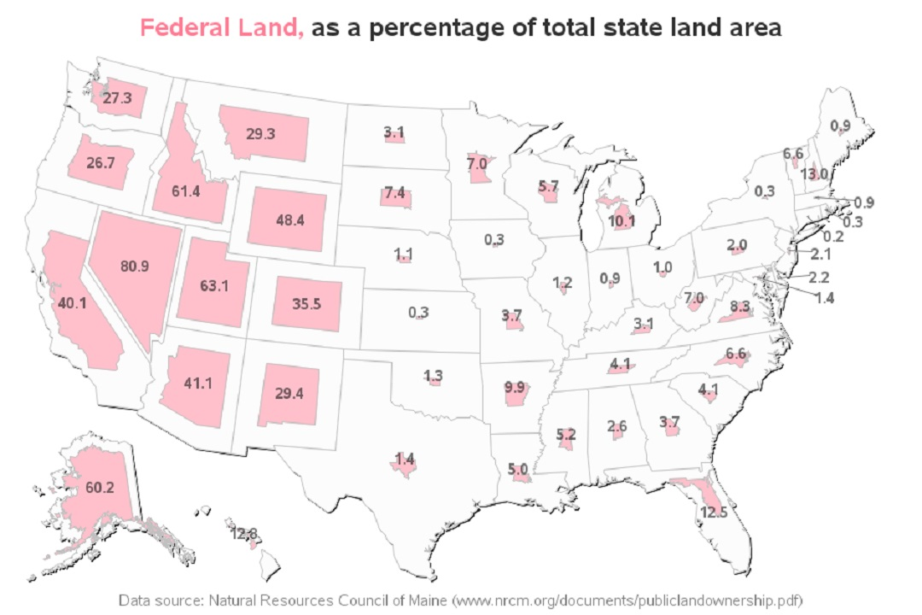

Adding to the cost of real-estate is the artificial shortage of land. The federal government claims 58% of the land west of the Mississippi River.(18)

When I was young, in the 60's, I assumed that I would eventually buy a house. Young people now question if they will ever be able to afford the rent let alone buy a house. This is an unnatural decline after over 200 years of economic progress and technological advancement.

Inflation is the result of an unethical banking system. The Federal Reserve is able to create money out of nothing and lend the currency into circulation through various means at a huge profit. This is the original cyber currency. If the central bank increases the money supply by One Trillion Dollars, usually by financing government debt, that money is spent and as it works its way through the banking system, the banks can use 10% of that as reserves and lend another One Trillion Dollars also at a huge profit. The bottom line, if a banking system profits from inflation, it will generate constant inflation.

It used to be that if one wanted to borrow money, the lender would have to find people that had accumulated extra money that they were willing to lend. The interest rate paid to them and the interest rate of the loan were subject to the balance of supply and demand.

The present system, however, offers an unlimited supply of money to lend at arbitrarily low interest rates. With an unlimited supply of cheap money, saving is punished and borrowing is usually the only choice for big ticket items, especially real estate. With fewer and fewer middle income people able to qualify for the loan on a house, the rich can still buy the house, charge rent, and make money on inflation. With this process, the rich get richer and accumulate more and more property and at the same time the middle and lower class suffer with the higher cost of housing.

The same effect of inflation is true for commercial and industrial property. Few business owners can afford to purchase the property where their business is located. The vast majority pay rent and the rent goes up every year and never goes down, not even during the Great Recession. That cost is past on to their customers adding to inflation.

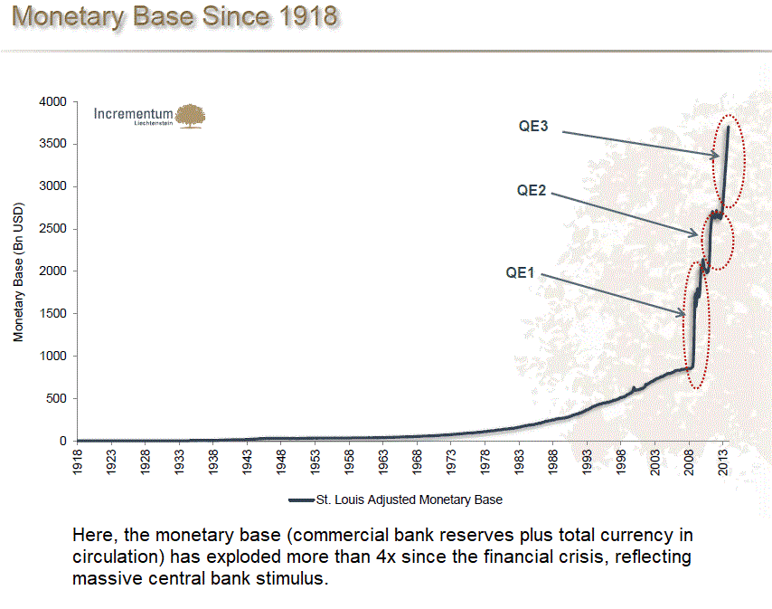
(12)

The reason why interest rates are so low is because of the Federal Reserve's Quantitative Easing programs. Because the Great Recession almost destroyed the economy, something dramatic had to be done. By increasing bank reserves, banks have much more lending capacity than the demand for loans. Interest rates are lowered in order to increase the demand for loans. A simple case of supply and demand.

The typical bureaucratic solutions like minimum wage, rent controls, price controls, welfare, medicare, and Social Security programs do nothing to solve the problem.

Borrowing money and raising taxes to finance entitlements to buy votes causes more inflation which makes people worse off and they feel they deserve more entitlements. It is a vicious cycle.
The major problem with inflation is the inability to save for retirement. When I first started working in the early 70s I made less than $3 per hour. Money saved then would not contribute significantly to my retirement now. The Social Security system now requires present taxes on people working to pay benefits for the retired. That Ponzi Scheme is yet another burden on younger generations.

It used to be that adults would take care of their parents. In fact the need for eldercare is increasing. But with the economic enslavement, this has become more and more difficult placing an additional burden on younger generations. (29)

However, that presents yet another problem because of the baby boom demographic. When I was young, there were about 10 people working for every one retired. When all of the baby boomers retire, the ratio is predicted to be 2 to 1. How can that possibly work? Higher taxes and higher government debt of course.

Or plan B, cause a Great Recession that destroys retirement accounts and reduces home equity to the point of massive foreclosures and bankruptcies. The Great Recession was designed and implemented by the establishment, especially the Federal Reserve. They took the Great Depression as a template and substituted a real estate boom for a stock market boom. The law was changed to allow banks to make risky investments and then banks were required to make subprime loans or risk being charged with discrimination at a federal level. The real estate boom was huge. There is a fundamental principle of intentional boom and bust cycles and that is, the bigger the boom, the bigger the bust. (28)

The establishment took an extreme measure to save Social Security from bankruptcy. According to the Bureau of Labor Statistics, among 65- to 74-year-olds, labor force participation is predicted to hit 32 percent by 2022, up from 20 percent in 2002. At age 75 and up, the rate will jump from 5 percent in 2002 to 11 percent in 2022. If enough people can't afford to retire then the problem is solved. (13)

SECOND FACTOR ANTI-AMERICAN GLOBALIZATION:

If you are member of an international organization that has established a “service” that creates money out of nothing, makes loans, and charges interest on those loans, you would want to establish that banking racket world wide.

However, with poor undeveloped countries, like China used to be and Afghanistan is now, there is no profit potential. But if money could somehow be diverted from rich countries and used to industrialize poor countries along with establishing an international banking system, then the profit potential is huge.

Afghanistan has taken so long, over 17 years, because of the Koran. Most Muslims believe that it prohibits collecting any interest on a loan or savings account. That makes establishing a banking system very difficult and credit cards, well, impossible. (25)

From Reuters in 2018: “Afghanistan’s banking sector is small, but Islamic finance is seen as an important feature that could help attract more people into the financial system. The Islamic Bank of Afghanistan estimates that only 5.7 percent of the population has dealings with the banking sector.” (23)

“Since 2001, Washington has spent more on nation-building in Afghanistan than in any country ever, allocating $133 billion for reconstruction, aid programs and the Afghan security forces.” (24) And you better believe that there were plenty of the well connected rich establishment that took their cut. But that achieved only a 5.7% bank participation rate after over 17 years of nation building! Even if that was up from zero, the international banking cartel has to be very disappointed.

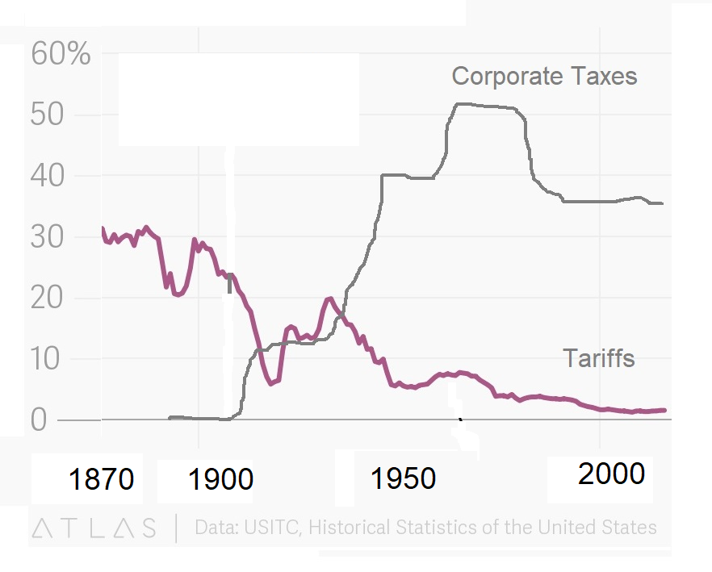
(14)

Before the Federal Reserve act and the 16th amendment in 1913, federal personal and corporate taxes were zero and tariffs averaged about 20% giving domestic production a considerable advantage over foreign production of goods sold in the US. These protectionist policies were admittedly unfair. However, by 1952 corporate taxes had gone up dramatically to above 50% and tariffs, the tax on foreign production, went down to 5%. The addition of personal income taxes increased the cost of labor. This punished domestic production and gave a huge advantage to foreign production. This was totally unfair in the opposite direction. Why would any president or congress go along with that for over 60 years? This was the case even for past Republican administrations.

Anti-American Globalization actually started taking effect in the 1960s especially with Japanese imports. This was offset by government spending on the space race which made the Aerospace Cutback so dramatic. (33)

The result is a trade deficit with China of $420 billion in 2018. Paul Krugman and other mainstream trade experts are now admitting that they were wrong about globalization: It hurt American workers far more than they thought it would. (36)

Actually the goal of he Globalists seems to be worldwide economic enslavement. I suspect that the same Hourly Compensation vs Worker Productivity graph in many other countries would look just like ours.

I offer as evidence the fact that homelessness has become a world wide problem. Even Australia, Canada, France, Germany, Greece, Ireland, New Zealand, and the United Kingdom have a higher homeless rate than the United States! (42)

Again, a fundamental principle of a natural economy is: Advancing technology results in increased worker productivity which produces more wealth and results in a higher average standard of living.

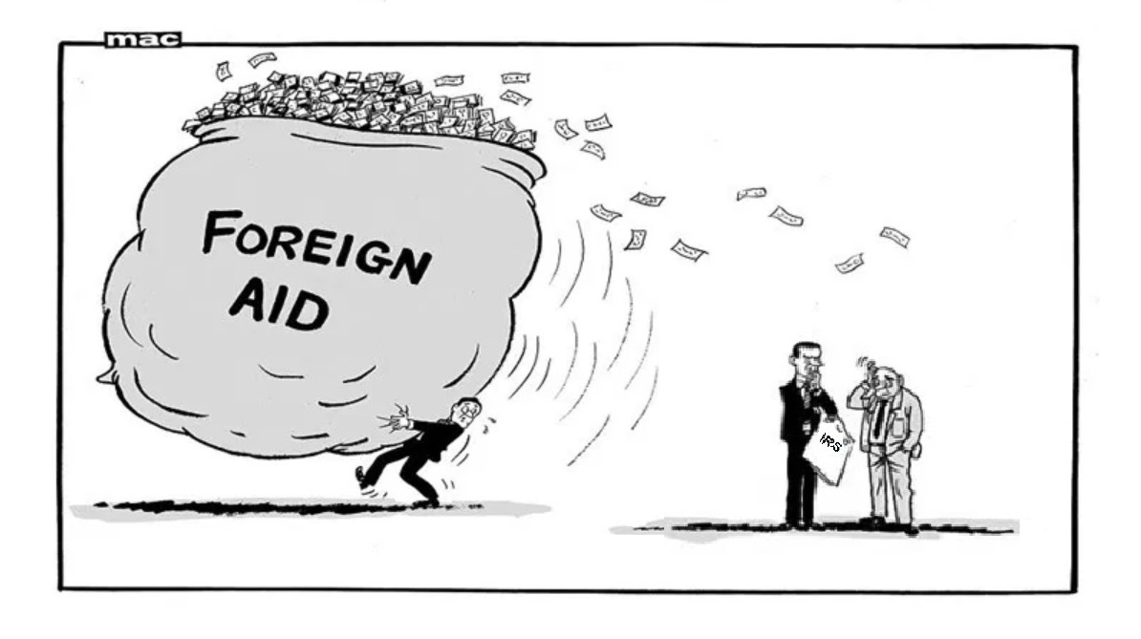
FOREIGN AID

Foreign countries, especially China, have benefited from Anti-American Globalization in another way, foreign aid. For example, the US and other countries have given billions of dollars to China. Japan gave 32 billion dollars to China from 1984 to 2016. Why would Japan do that? Japan and China have had mutual animosity for thousands of years.

Also, from 2001 to 2003 the US gave over 5 billion dollars to China. Why would our government do that? That did lead to a Congressional hearing titled "Feeding the Dragon" but in spite of that, foreign aid to China continues to this day! Evidently we have the best government that money can buy, politicians can't all be that stupid. There has to be some organized clandestine activity behind these aid programs, corporate tax increases, and tariff decreases.

REGULATIONS

Like high corporate taxes, regulations add to the cost of doing business in the United States.

In the early 1990s, thousands of printed circuit board manufactures were put out of business by environmental regulations. I had to order printed circuit boards from a company in Alberta Canada. An employee there said that their environmental agencies work with businesses to solve problems. In the US environmental agencies are predatory.

The compliance costs associated with EPA regulations under Obama numbered in the hundreds of billions and have grown by more than $50 billion in annual costs. Such high costs, especially those related to the energy sector, ripple throughout the economy, impacting GDP, killing thousands of jobs, and increasing the cost of consumer goods. (39)

SOLUTIONS

The solution is smaller government, lower taxes, less regulations, less social programs, and more freedom. Rush Limbaugh once said, “It's hard to sell freedom to people that think they are free.”

The solution to Anti-American Globalization was being addressed by President Trump. He realized that the existing trade deals were not fair. In 2018 he lowered corporate tax rates and raised tariffs. He is the only president in over 60 years to see the obvious problem and take action.

In 2016 he also lowered personal income taxes and the success was dramatic. In the two years before the pandemic, the average household income increased $5805 per year. (43) With 128.58 million households, that totals over $1.5 trillion less profit for the three years before the pandemic that would normally go to the well connected establishment rich. That is a huge loss for a very small number of people.

The establishment rich have always owned and controlled the mass media and media bias is not a new concept. But the lies and bias against Trump has been intense and relentless because he has reduced their profits from anti-American globalization, foreign aid, nation-building, and war. (40, 41)

Trump is not prejudiced against Mexicans or Muslims. He took the steps that he was able to take to prevent terrorists, criminals, and drugs from freely entering the country. He is not anti gay. A federal judge ruled that the Trump administration could not stop funding sex-reassignment surgeries for military members.(14) But he could ban gays from serving in the military. He just did not want taxpayers to be required to pay for hormone therapy, counseling, and sex reassignment surgery just as an owner of a private company should not be required to bake a cake for a gay wedding. Hormone therapy is $1500 per year, sex reassignment surgery is $30,000 minimum, and counseling, who knows? Give me a break.

That being said, if trade is to be accomplished fairly, for each competitive imported product domestic corporate taxes should be no more than taxes on foreign corporations making those similar products. Import tariffs should be no less than foreign tariffs on our exports.

However, realize that corporations get the money to pay the taxes from their customers and tariffs add to the price of the products we buy. They are hidden taxes on all of us. The ideal would be for both to be zero worldwide.

Insurance companies, if deregulated, could offer free market services that government now provides. If they provide product liability insurance for a drug company, they could establish an organization that would set reasonable testing standards and oversee and approve the results. The emphasis would be on he best solution not the most expensive. If insurance companies provide fire insurance, they could efficiently establish and run fire departments. The business liability insurance mechanism could provide reasonable environmental protection. Requirements would replace regulations and would not be excessive, arbitrary, or predatory. They would not try to put their customers out of business. Insurance companies are a free market alternative to government.

The solution to the inflation problem is implementing a policy of zero inflation. Achieving zero inflation with a paper currency cannot easily be done. I have thought about this for a long time. How does one challenge the Federal Reserve, the most powerful corporation in the world with all of the power of the Federal Reserve Act protecting it from Federal, State, and Local taxes and protecting it from AUDIT!! Only the insiders can find out exactly how much money is created, how much profit as a result and where all of that money goes.

However something incredible happened recently that started in Switzerland. It was called the “Sovereign Money Movement” and was the first attempt at reducing inflation. An article on this movement stated that “Contrary to popular opinion, most of the increase in money in circulation occurs with the local bank and not the central bank.” and “The greater part of the banks' deposits consists, not of cash paid in, but of credits borrowed. For every loan makes a deposit.” Money borrowed is spent and ends up back in the banking system and that money is used as reserves that allow for more loans.

The Sovereign Money Movement was not successful because they wanted to change the 10% reserve requirement to 100% in one jump. But increasing the reserve requirement slowly, over 5 years or so from the present 10% to 100% would reduce the inflation rate by at least 50%. The goal of course is zero but that would be a huge first step. (30)

The second step would be a law requiring the Federal Reserve (or preferably the United States Treasury Department) to implement a policy of zero inflation. The currency in circulation should be expanded with increased domestic demand, mainly population growth, plus foreign demand. This increase would add to government income and be spent into circulation.

In order to accomplish this, government borrowing would have to end and the budget would have to be balanced. With cheap and easy money corrupting the government budgeting attitude for so long, this would not be easy in spite of the fact that there is no national emergency like a declared war that requires high government spending.

Foreign Aid should be entirely voluntary, typically run by private charities. Instead of a bribe to foreign leaders, the money would get to the people who really need it. Foreign Aid is a method to take money away from the poor people in the rich country and give it to the rich people in the poor country. (16)

FEDERAL GOVERNMENT EXPENDITURES AND DEBT

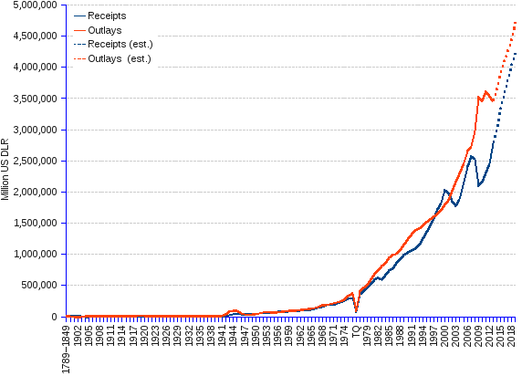
(14)

Congress along with the entire government bureaucracy is addicted to cheap and easy money that finances spending without limit and obligates younger generations to ever increasing interest payments. A major intervention will be required to prevent inevitable disaster. Like any drug addict, there will be withdrawal pains by being required to operate within a rational budget.

Until then the Federal Reserve could negate the effect of the 100% reserve requirement and zero inflation mandate by lending banks money, that they create out of nothing, that banks could use to lend at a higher interest rate. But hopefully media attention would be generated and maybe enough people would figure out the scam. “AUDIT THE FED” might be a new protest chant. That would be great but “ELIMINATE THE FED” would be incredible!

With free market capitalism, if someone has money and values the product more than the money and someone who has the product values the money more than the product, when the exchange is made the result is a win-win situation.

Go to theethicaleconomy.com and join the movement.

