Performance Training for Middle School Athletes

The transition to High School level performance requires a base of correct Alignment, Balance and Coordination
Take yourself to the next level of success this spring!

What is FAST’s Focus?
Each participant will come away with enhanced strength to body weight; joint stability, balance and coordination. As a result they will experience less injury and the ability to train at the highest level without peaking.

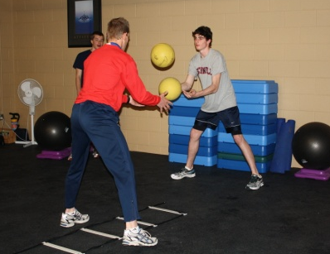
Programs designed by Dwight Sandvold: an Athletic Trainer as well as a Certified Strength and Conditioning Specialist

Dates: April 6th – May 20: M and W 4:15- 5:15 p.m.
Fee: $150 – 5 weeks at two times a week.
Venmo @Dwight-Sandvold or Check to FAST
Questions? dwightsandvold@yahoo.com

