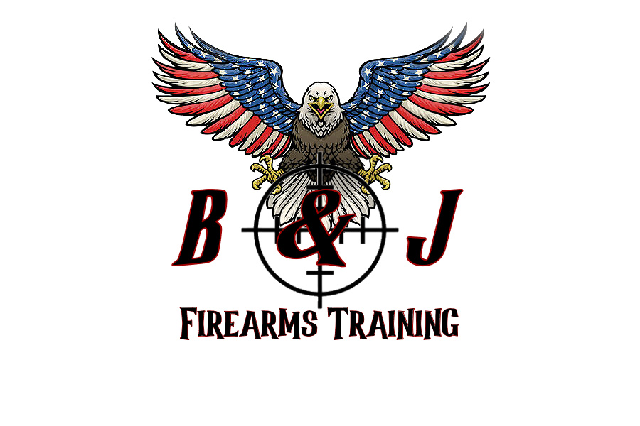

**B & J FIREARMS TRAINING LLC**

946 Liberty Street, Belvidere, NJ 07823

(908) 339-1013 / (908) 246-9853

***Release of Liability and Waiver, Assumption of*** ***Risk and Indemnification***

I, ______________________________________ (print name) acknowledge that I wish to participate in firearms training, at the following location, Belvidere Range on ______________ (date), and attest that I have read, fully understand, and agree with the following representations and conditions:

I am aware of the risk that comes with participating in the following program/activities, and assume all risks foreseeable and unforeseeable, in any way connected with my participation herein. I am aware that ***B&J Firearms Training LLC*** is not responsible for any lost, stolen, damaged valuables, property or any personal injury sustained while in the performance of my training.

I agree not to institute any claims or legal actions against ***B&J Firearms Training LLC,*** and any of its employees or owners regarding any claim or expenses (including attorney’s fees, claims by a third party or otherwise that might be made on my behalf) in any way connected with the claim related to my participation in the program/activities. I have read and fully understand, agree and accept voluntarily all provisions of this Release of Liability and Waiver, Assumption of Risk and Indemnification.

This release will be governed by and construed in accordance with the laws of the State of New Jersey and the venue for all challenges of this waiver shall be restricted to the federal or state courts located within Warren County, New Jersey.

I am signing this agreement freely, voluntarily, competently and I am at least twenty-one (21) years of age.

______________________________________ _________________________________ ____________

Signature of Participant Print Name Date