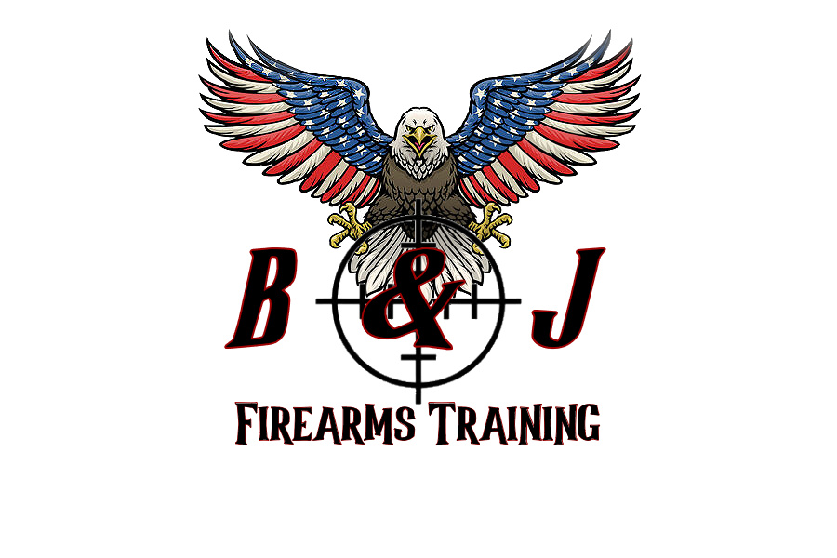

**B & J FIREARMS TRAINING LLC**

946 Liberty Street, Belvidere, NJ 07823

(908) 339-1013 / (908) 246-9853

***Photograph Release Form***

I, ________________________________________________ grant B&J Firearms Training LLC my permission to use the photographs or videos taken on _______________________ (date of class) for any legal use, including but not limited to: publicity purposes, illustration, advertising and web content.

Furthermore, I understand that no royalty, fee or other compensation shall become payable to me by reason of such use.

____________________________________________ ______________________

Signature of Participant Date