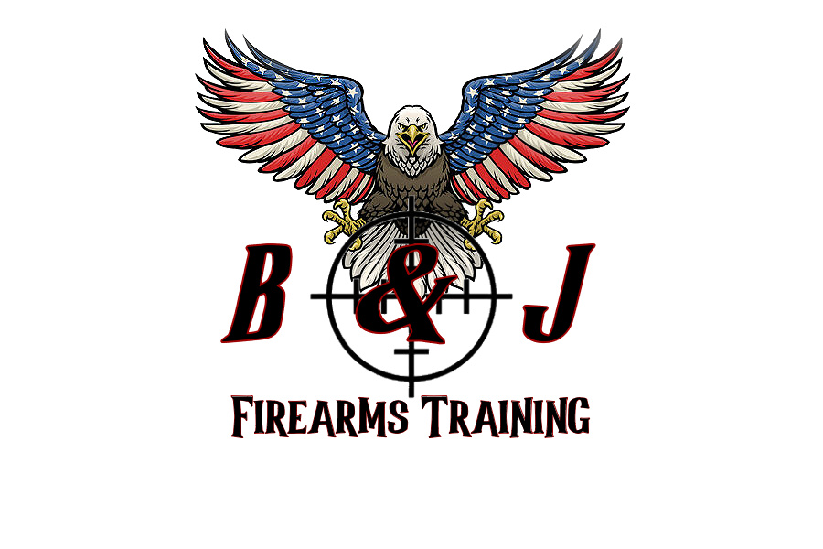

**B & J FIREARMS TRAINING LLC**

946 Liberty Street, Belvidere, NJ 07823

(908) 339-1013 / (908) 246-9853

***Range Safety Mitigation Plan***

***Range Safety Rules:***

* TREAT EVERY WEAPON AS IF IT WAS LOADED
* NEVER POINT A WEAPON AT ANYTHING YOU DO NOT INTEND TO SHOOT
* KEEP YOUR FINGER STRAIGHT AND OFF THE TRIGGER UNTIL YOU ARE READY TO FIRE
* KEEP YOUR WEAPON ON SAFE UNTIL YOU ARE READY TO FIRE
* KNOW YOUR TARGET AND BEYOND
  + All safety violators will be removed from the range immediately with NO refund.
  + Hearing and eye protection will be worn at all times during live fire training.
  + Listen to all commands provided by the instructors.
  + Anyone on the range can call a “cease fire” if an unsafe condition or safety violation occurs.
  + First aid and safety kit(s) will be kept on the range; all shooters will be advised of its location prior to training.
  + In the event of an accident the situation will be assessed by the instructors, if needed someone will be designated to contact 911 while aid is rendered appropriately.

Signature: _________________________________________

Print Name: ________________________________________

Date/Time: _____________________________