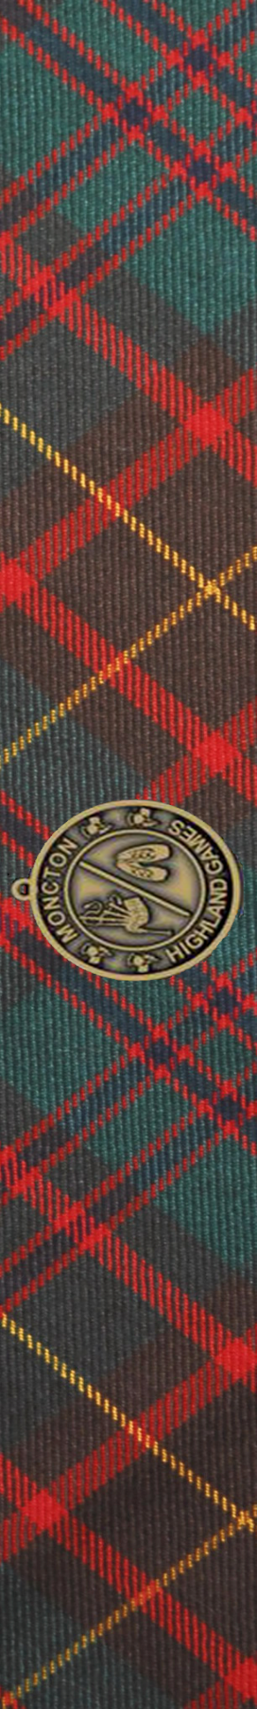
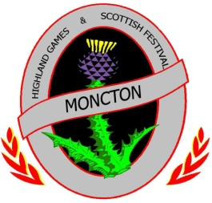
Hal Betts Sportsplex
Assomption Blvd.
June 17, 2023

June 22 2013
Greater Moncton
Highland Games
& Scottish Festival

CLAN REGISTRATION FORM 2023

Show your Clan pride at our Games!
We welcome Clan Associations to join us on Saturday, June 17 at the Hal Betts Sportsplex.
To register, please complete this form and contact our Clan Coordinator, Murray MacLean at 506-856-5819 or macleanm@rogers.com

We are able rent 10'x10' tents, 6' tables, and folding chairs for your use;
please see the rates below for prices.
In order to rent via our organization,
your registration and payment must be received by May 19, 2023.

CLAN NAME _____________________________________________

CONTACT PERSON ___________________________________________

ADDRESS ____________________________________________________

PHONE _________________________FAX _________________________

E-MAIL ______________________________________________________

DESCRIPTION OF RENTAL EQUIPMENT (Enter number of items required):
10’ x 10’ Tent - $150 each _____
6’ Table - $25 each _____
Folding chairs - $5 each _____

HOURS:
Clan Alley will be open from 8:30 AM to 5:30 PM on Saturday June 17. Clan members may set up Friday after 2:00 PM. Vehicles must be off the grounds by 8:00 AM and will not be permitted on site until after 6:00 PM.

Make cheque payable to:
Greater Moncton Scottish Association or e-transfer greatermonctonscots@gmail.com
Mail registration form to: greatermonctonscots@gmail.com or
Greater Moncton Scottish Association, Inc.
PO Box 26004
RPO West Moncton
Moncton, NB
E1E 4H9

Direct any questions to: Murray MacLean at 506-856-5819 or macleanm@rogers.com

