**Capture the Flag with Petoi Robots: A Beginner guide V8.0**

**May 14, 2025**

Author:Sebastien Simon

Assistants :Gemini ,Deep seek

This document outlines the rules and considerations for playing **Capture the Flag with Petoi Robots** on a small field, building upon the classic capture the flag game and flag football.

### **Objective:**

Be the first team to reach the opponent's home zone.

### **Players roles:**

Here you can assign your own names to the roles.The following are examples

* **Coordinator : (e.g., Simon**)
  + Ensure safety of the games and players
  + Provide pre-programmed commands for forward movement, turning left, turning right, and backward movement using Mind+ and coding block.
  + Position the robots on the board following the games rules and instructions of Large Language Model (Gemini and Deep Seek V3)
  + Downloads pre-programmed commands to robots according to chat with Gemini and Deep Seek V3
  + Position flags and token on the field
  + Make video
* **LLM Controller 1 : (e.g., Deep Seek V3,e.g., Me ):**
  + Manages two robots (here labeled 45 and 46)
* **LLM Controller 2 : (e.g., Gemini ,e.g.,You ):**
  + Manages two robots (here labeled 47 and 48)
* **Robots** :**Four Petoi Bittle Robots without sensors**

Robot numbers and nicknames are examples only.

* + 45:Vector
  + 46:Kinetic
  + 47:Logic
  + 48:Adapt

#### 

#### **Field Size and Token Ratio:**

* Consider adding a recommended robots-to-field size ratio for different player counts. For example:
  + 2 robots per team: 4x4 grid.
  + 3 robots per team: 6x6 grid.
  + 4 robots per team: 8x8 grid.

### **Playing Area:**

* A square grid board with clearly marked starting zones (home zones) for each team at opposite ends.
* The playing area is divided into **4 columns and 4 rows** for a 2-token game.
* Each square measures **288 mm x 288 mm**, separated by lines of **10 mm**.
* The total field size is **1220 mm x 1220 mm**.
* Flags are placed in opposing corners of the board, in starting zones

### **Equipment:**

* **Two flags** ( orange and blue ) of **25 x 20 mm**  on a pole of height :**75 mm**
* Token diameter **32 mm** and a height of **10 mm**.
* Petoi robots for **Gemini** are labeled **47** and **48**.
* Petoi robots for **Deep Seek V3** are labeled **45** and **46**.
* Computer to run **Mind+ , Gemini, Deep Seek V3** equipped with at least four bluetooth ports to downloads programs to robots
* Use letters to label columns (A, B, C, D) and numbers to label rows (1, 2, 3, 4) for easier reference during gameplay.

### **Gameplay:**

#### Setup:

1. Toss a coin to determine which team places their players first.
2. Robots must be placed within the home zone, at least one square apart.
3. Players can choose any unoccupied squares within their home zone for their robot.
4. The game begins once all robots are in position.

#### Turn Structure:

* Each turn (attempt ) has a **time limit** of **2 min max** (adjustable based on player preference) starting when the opponent robot is on position
* At the start of each turn, the player or game moderator starts the timer.
* Players must complete their move within the time limit. If they fail to do so, their turn is skipped, and the next player takes their turn immediately.
* Use a timer (e.g., a phone timer, sand timer, or chess clock) to track each turn.
* Players have two attempts to reach the next square (one attempt/2min)

#### Movement:

* Robots can move one square in **any cardinal direction** (Up, Down, Left, Right) during their turn.Diagonal movement is not allowed.
* Robots should have the 4 legs in the square to validate its position
* Once played a robot can be replaced correctly at the center of the square
* Robots cannot move off the grid. If a move would take a robot outside the grid, that move is not allowed.
* If a robot is blocked by another robot (friendly or opposing), it cannot move through and must choose a different direction or remain in place.

#### Zone of Control:

* Each robot has a forward-facing zone of control, which extends in a 'C' shape (three squares forward, one on each side) relative to the robot's facing direction. **See Fig. 2** for visual examples of how the zone of control rotates and is affected by the robot's position on the field.
* If an opposing robot enters a friendly robot zone of control during its turn, it is **tagged (see Fig 3 for visual example of how the Tagging mechanic Work)**
* A tagged robot cannot move on its next turn.
* A token is used to indicate the robot is tagged. After the tagged robot’s turn is skipped,the token is removed to indicate that the robot is no longer tagged.
* The zone of control tag only lasts for **one turn**. The opponent can move freely again in the subsequent turn.
* Friendly robots are allowed to move through each other zones of control without being tagged

#### Tagging:

* There is no tagging mechanic besides the zone of control. Robots cannot place flags to block squares.
* If by moving, the robot enters the zone of control of an opponent robot, then the moving robot is tagged.
* After a robot is tagged and skips its turn, it gains a temporary "cooldown" period where it cannot be tagged again for one turn.

#### Winning Condition:

* The first team to have a robot fully occupy any square of the opponent's home row, wins the game.
* If both teams enter in their opponent home zone son the same turn, the game ends in a tie,
* The team that entered the opponent's home row first wins.

#### Malfunctions

This section outlines procedures for addressing common issues that may arise during gameplay.

* **Initial Setup/Program Loading:**

If a robot exhibits strange behavior during the program loading phase, it will be replaced at the center of its starting square without penalty.

* **In-Game Malfunction**

If a robot malfunctions **during gameplay** (e.g., stops moving, moves erratically), the Coordinator will assess the situation.

If the malfunction is deemed unrecoverable within a reasonable time (e.g., 1 minute), the robot will be replaced at the center of its current square.

The opposing player has the option to either:

* Continue the game with the replacement.
* Declare a "restart" of the turn. In this case, the turn restarts with robots in their positions prior to the malfunction.
* **Battery Issues**:

If a robot's battery depletes during gameplay, it will be replaced as per the "In-Game Malfunction" procedure. Consider having spare, fully charged batteries readily available to minimize disruption.

* **LLM Availability:**

**Temporary Unavailability:**

* If an LLM Controller becomes temporarily unavailable (e.g., due to a software glitch or network issue), the Coordinator will pause the game.
* A reasonable time (e.g., 5 minutes) will be allowed to restore the LLM's functionality. If the LLM cannot be restored within this time the team passes its turn.

**Prolonged Unavailability:**

If an LLM Controller is unavailable for an extended period, the Coordinator will decide whether to:

* Continue the game with a human player controlling the LLM's robots.
* Reschedule the game.
* Declare a tie

#### **General Guidelines:**

* The Coordinator has the final say in resolving any disputes or situations not explicitly covered in these rules.

### **Glossary:**

* **Home Zone**: The starting area for each team’s robots, located at opposite ends of the grid identified with the flag.
* **Zone of Control**: The area around a robot that includes the token itself and the 5 surrounding squares.
* **Tagged**: A robot that has entered an opponent’s zone of control and is temporarily immobilized.
* **Home Row**: The row on the opponent’s side of the grid where their flag is located.

### **Quick Reference:**

1. **Movement**: 1 square per turn (up, down, left, right). No diagonals.
2. **Time Limit**: 2 minutes per turn. Skipped turns if exceeded
3. **Attempt:** A move action to enter an adjacent square
4. **Tagging**: Enter an opponent’s zone of control to tag them. Tagged robots skip their next turn and have a 1-turn tagging cooldown.
5. **Winning**: Move a robot onto the opponent’s home row .

**Annexes:**

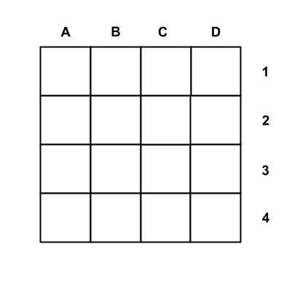

**Fig.1:**Capture the flag playing area

**Fig. 2:** Zone of Control Pattern examples.

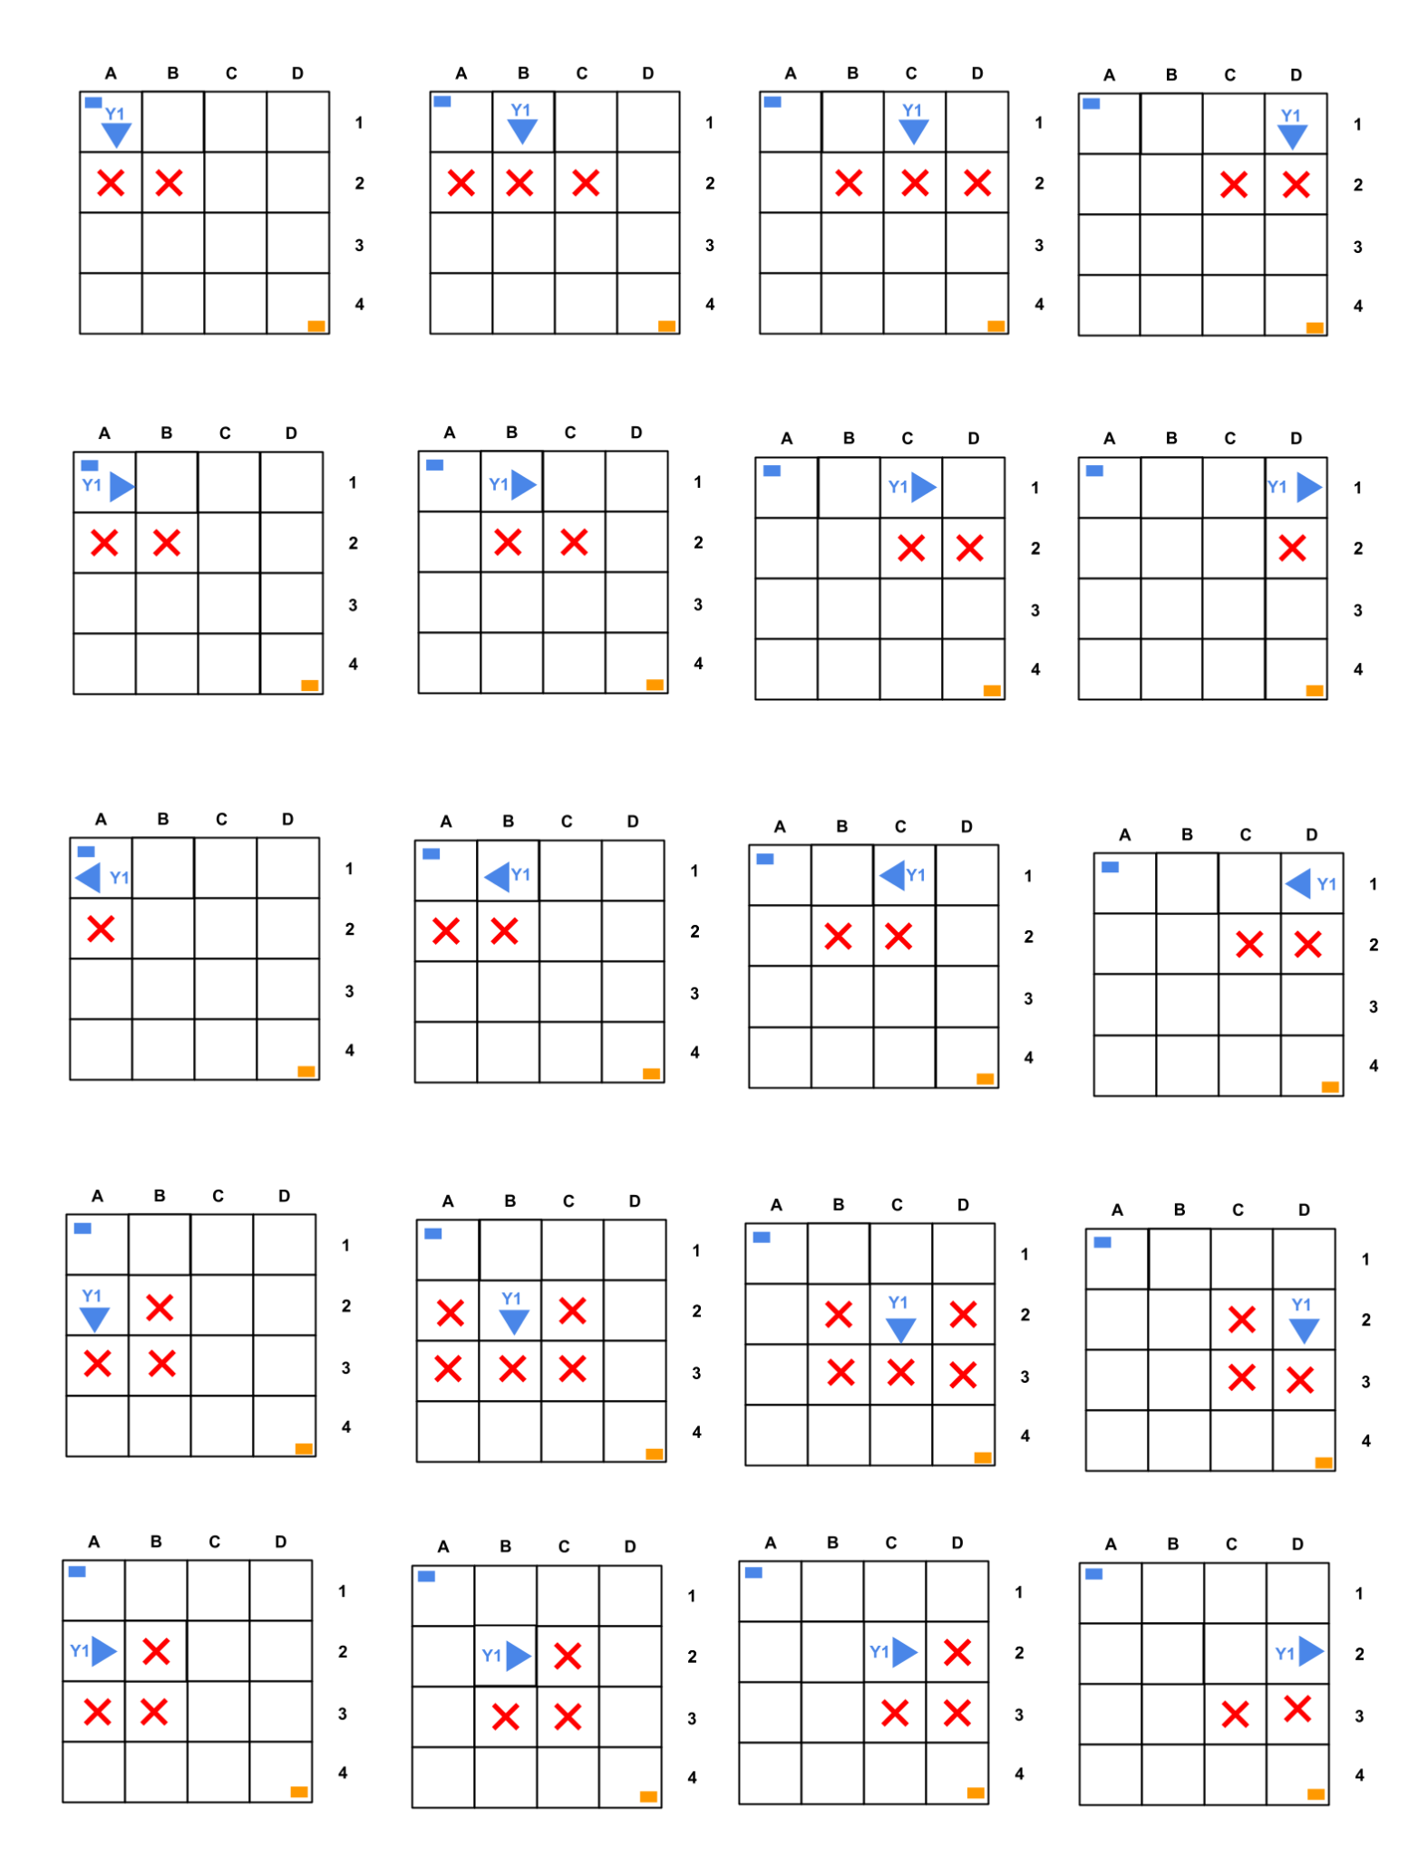

**Fig. 3:** Tagging mechanic

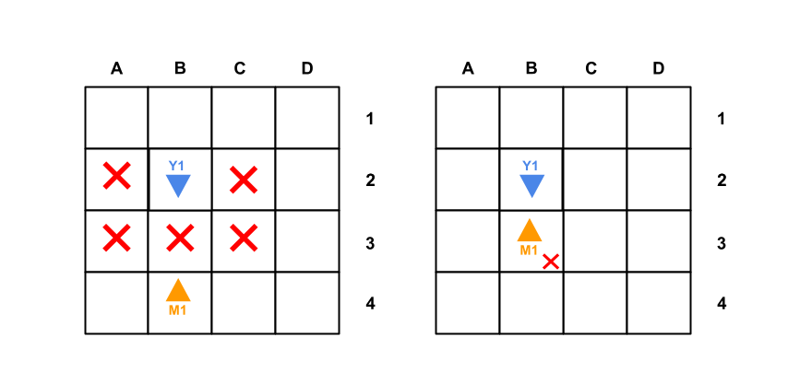

**Left picture:** M1 is outside of Y1's zone of control represented here with red crosses

**Right picture:** M1 has been tagged for one turn by entering in the Y1’s zone of control.Here the small cross represents a token.

**Fig. 4:**Winning example

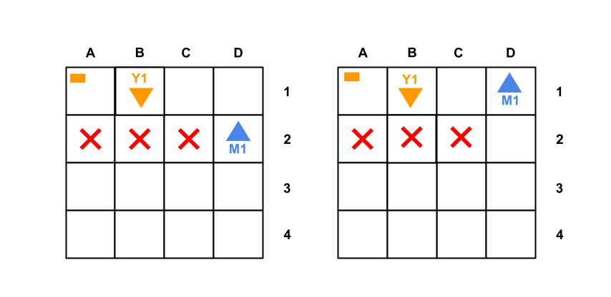

**Left Picture:** Player Y1 is positioned in their home row but cannot tag laterally.

**Right picture :** If player M1 enters Y1's home row, M1 wins the game.

**Fig.5:**Two Petois robots on a capture the flag field