STEREDLENN LLC

ROVERBALL
Rules

SEBASTIEN HENRI GUILLAUME SIMON

STEREDLENN LLC

ROVERBALL
Rules

08/18/2014

Steredlenn LLC

Roverball rules
Effective from 1 january 2015

Steredlenn.LLC
4801 Lang Avenue N.E.
Suite 110
Albuquerque,NM 87109
United States

E-mail:parisbolts@free.fr
Website:www.steredlenn.com

Copyright©steredlenn.LLC 2014

All right reserved. No part of this book may be used or reproduced in any manner whatsoever without the written permission, Except in brief quotations embodied in critical articles or reviewed.

Published 2014.

Disclaimer

Participant in roverball must be aware of the rules and of other information in this publication.They are expected to perform according to the rules.

Everyone involved in the game must act with consideration for the safety of others. Relevant national legislation must be observed. Players must ensure that their equipment does not constitute a danger to themselves or to others by virtue of its quality, material or design.

Steredlenn LLC does not accept responsibility for any defects or non compliance of facilities and is not liable for any consequences resulting from their use. Any verification, of facilities or equipment conducted before a match is limited to ensuring an overall appearance of compliance and sporting requirements.

Implementation and authority

The rules of Roverball apply to all roverball players and official’s. The date of implementation is 1 January 2015.
The rules are issued by Steredlenn LLC. Copyright is held by steredlenn LLC.

Availability of equipment

Information about the availability and the purchase of equipment on the steredlenn website (shop)

Club project

The raccoons roverball team is a club project in Turner (Michigan )
For more information: www.steredlenn.com



CONTENTS

PLAYING THE GAME

1.Field ……………….………………………………………………………………………………....8
2.Players……………………………………………………………………………………………….9
3.Teams and referees………………..…………………………………………………………..…10
4.Game………………………………..………………………………………………………………10
5.Field Schematic……………………………………………………………………………………12
6.Glossary…………………………………………………………………………………………….13
7.References…………………………………………………………………………………………14

PLAYING THE GAME

The Roverball is a space game designed to be played on the surface of a planet or on a celestial body. The Roverball is played in a rectangular field with two bowls at the ends. Players ride motorized rovers and can travel at very high speed.The objective of the game is to score point by shooting a ball through a basket located at the top of the bowl. The winner is the team with most points when the time expired.

1.Field

1.1.The field
- The field of play is rectangular with two bowls in the ends .
- Size of the field is 200 feet by 85 feet
- The bowls on each side of the flat bottom are 7 feet tall ,and 85 feet large
- Stay or ride on the bowl deck is not allowed
- The vertical basket is 7 feet high and at the top of the bowls. The basket has a diameter of 1 foot
- Middle line is marked in the middle of the field
- Face off lines are 44 feet
- Face off lines are parallel to the middle line
- All lines are 3 inches wide and are part of the field of play
- The goal is positioned outside of the field of play at the center of the deck line
- Players benches are on the same side of the side line and opposite to the penalty box and scorekeeper bench
1.2. Equipment
1.2.1.The ball
- The ball is a light coloured junior (size 4) football by a harness to which six leather handles are attached
- The ball follow criteria of the Australian horseball association.
- The ball should be able to rebound on a hard surface
- The ball could be carried by one hand
1.2.2.The bowl and the goal post
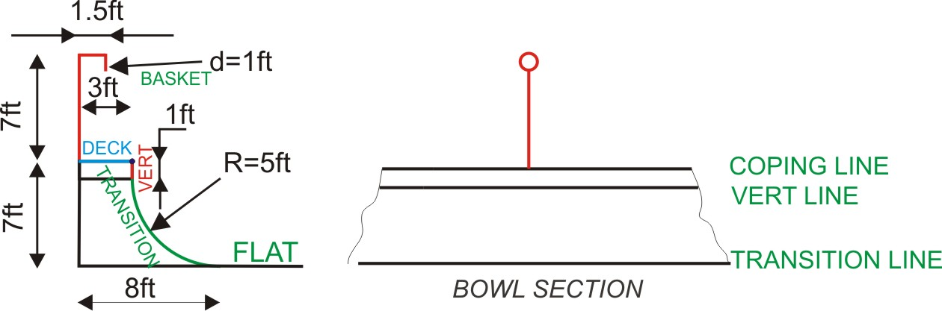

2.Players
2.1.Field players
- Players must wear protective equipment that don’t stop their freedom of movement and awareness
- Players can wear exoskeleton or prosthesis
- Basic protective equipment could be and are not limited to : helmet, ,reinforced glove, wrist protection, elbow and knee protection, back and upper body protection,hip guard
- Players are attached to their boards using rover shoes
2.2.RC and internet players (RCIP).
- RC players and network used distant control system and monitoring systems to play on the field
- RCIP used robotic rovers
2.3. Rovers
- Rovers must use the same energy and be of the same size
- Direction of rovers is electric
- Rovers are controlled with one handled equipment
- Rovers could be equipped with anti colliding electronic

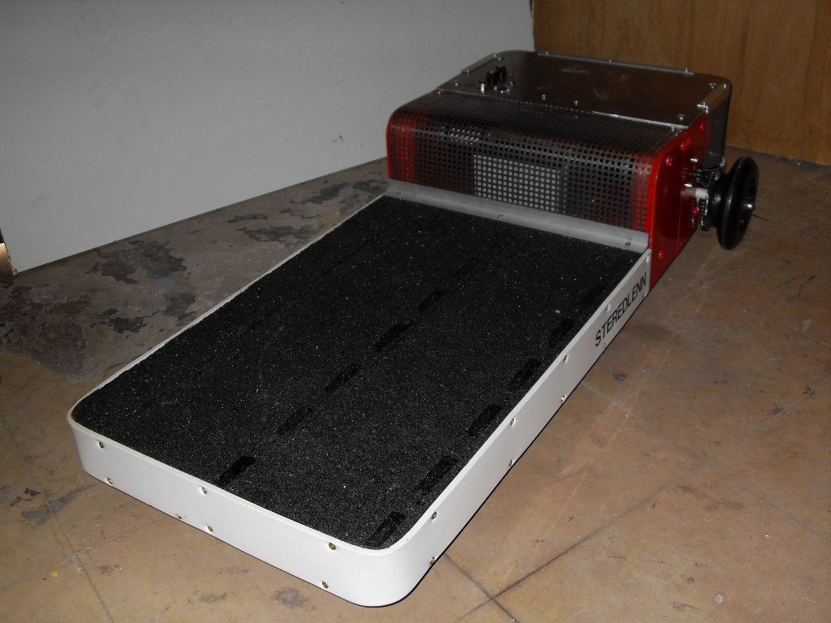
ST 811 prototype

3.Teams and referees
3.1.Teams:
- Each team is composed by up to 10 players and 2 mechanicians
- Teams can be mixed gender (human, robot ,cyborg ,computer)
- Rovers can be remotely controlled ( from or outside of the field) or programmed )
- Five players must be continuously on the field
- Players can be replaced at any time
- Mechanicians are allowed to tow rovers that are broken down to the team bench only when other rovers are not in motion
- Mechanicians are not allowed to repair rovers on the field

3.2.Referees:
- The game is controlled by two referees or a process able to do the job
- Referees use drones
- Video control is allowed
- Referees can be in remote locations
- Referees use rovers during the game

4.Game
4.1.Duration:
- Four 15 minutes period ,separated by a 5 minutes quarter- time period and 15 minutes half time
4.2.Overtime:
- If there is equality between two teams the game continues until a goal is scored
- the overtime period is 20 minutes long

4.3.Start and restart a game:
- Team who has won the advantage after a coin toss plays the ball
- Face off occurs each time there is a score
- During face off teams are in the racks
- After a score the team who was scored takes advantage.
4.4. Scoring:
- Field goal : a team score two points when the target is reached from the flat
- Air goal : A team score three point when the player was in the air above the cutting line
4.5.Advancing the ball:
- You can pass the ball in any way and any direction
- 3 passes between 3 different co-players is needed before it is allowed to score
- Giving the ball from hand to hand is not a pass
- The ball can not be hold longer than 10 seconds by a player
- Advancing the ball by foot or rover pushing is not allowed
- If the ball falls on the ground ,you must pick it up without "dismounting"
- Seizing a ball from an opponent is allowed
4.6.Penalties:
- Unacceptable faults (ex:3 fights) : the player is expelled of the rink
- Major faults (ex: voluntary colliding , bad use of throttle, fight): the player is kept out of the field 5 minutes
- Minor faults (ex: only two passes before scoring, ball outside the field): advantage is given to the no offendent team

5.Field schematic

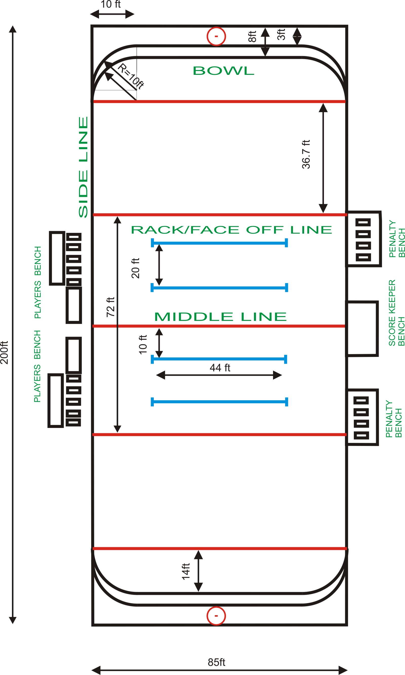
6.Glossary
B
BOWL
A bowl is a structure composed of a deck,coping,vert and transition

C
COPING
Upper edge of the ramp also called coping line

D
DECK
Flat horizontal upper portion of the ramp

F
FAULT
Action contrary to the Rules and penalized by an empire

FIELD PLAYER
One of the participants on the field

G
GOAL
Vertical post with a basket

M
MIDDLE LINE
Line in the middle of the field and parallel to the transition line

P
PLAYER:
One of the participants in a team

PLAYING THE BALL
Moving ,stopping the ball

R
RACK
U shape field marking where players are located at the start of the game.

S
SIDE LINE
Side line are the longer limit s of the field

T
TEAM
A team consists of a maximum of ten persons composed of a maximum of 5 players on the field and up to five substitute

TRANSITION
Concave part of the ramp structure

TRANSITION LINE
Horizontal line marking the start of the transition area

V
VERT
Vertical flat zone of the ramp located between the coping line and transition line
VERT LINE
Horizontal line between the transition area and the vert area

7.References

- Ontario Hockey Federation www.ohf.on.ca
- Australian Horseball Association www.australianhorseball.com
- Wikipedia http://commons.wikimedia.org/wiki/File:Half-Pipe_Vert_Ramp.svg
- Wikipedia http://en.wikipedia.org/wiki/Vert_ramp

