Proposition 1: ($45M)  Affordable Housing | Proposition 2: ($415M)  City Infrastructure | Proposition 3: ($50M)  Drainage & Stormwater
What: Authorize up to $45M in General Obligation bonds to build/repair affordable housing. Bonds repayable from property taxes; no estimated millage increase in year 1. | What: Authorize $415M in General Obligation bonds for streets, parks, public buildings, equipment, and technology. | What: Authorize $50M in General Obligation bonds to upgrade drainage systems and stormwater management.
Vote YES Argument: Creates funding to build and preserve affordable homes; more homes for lower income residents. | Vote YES Argument: Large funding for visible repairs and public services; repair roads, parks, public safety. | Vote YES Argument: Targets flooding reduction and infrastructure resilience; reduce flooding impact.
Vote NO Argument: Adds long-term debt; critics worry about oversight concern and limits on fund flexibility (BGR concern). | Vote NO Argument: Significant borrowing cost and questions about project equity/distribution; size and equity concerns. | Vote NO Argument: Amount may be insufficient given citywide needs; risk of funds not reaching most vulnerable areas; insufficient scale.
Supporters: City Council, housing advocates, developers. | Supporters: City leadership, neighborhood groups, contractors. | Supporters: Residents in flood-prone areas, resilience advocates.
Opposition: BGR (concerns on trust fund limits), fiscal watchdogs, some skeptics. | Opposition: Fiscal critics demanding oversight; residents concerned about fair distribution. | Opposition: Critics skeptical about scale and distribution.
Timeframe/Money: 30-year bonds; projects 1–5+ years. | Timeframe/Money: 30-year bonds; multi-year project delivery. | Timeframe/Money: 30-year bonds; phased projects.
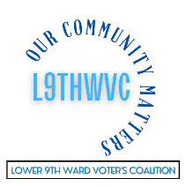

Home Rule Charter Amendment 1:  Master Plan Deadlines | Home Rule Charter Amendment 2:  City Attorney Independence
What: Extends deadlines for Planning Commission and Council action on Master Plan amendments and related actions | What: Changes charter to formalize City Attorney independence and limit mayoral removal authority in certain situations.
Vote YES Argument: Allows more time for thorough review and analysis; better review time. | Vote YES Argument: Protects impartial legal advice and reduces political interference; improves impartiality.
Vote NO Argument: May slow planning processes and delay protections. | Vote NO Argument: Could complicate executive management and legal strategy alignment; less mayoral control.
Supporters: Council, planning staff | Supporters: Many Council members, some civic groups.
Opposition: Groups wanting quicker action; those fearing delay tactics. | Opposition: Mayor (opposed), some city officials concerned about governance conflicts.
Timeframe/Money: Takes effect if approved; affects next Master Plan cycle. | Timeframe/Money: Effective if approved; may trigger legal/political debates.

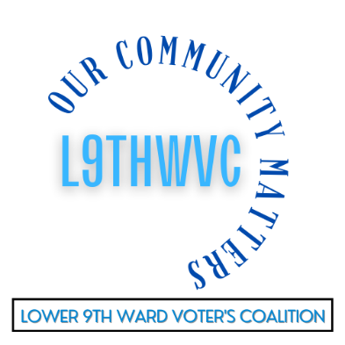
How Bonds Work: New Orleans 2025 Ballot Initiatives
• Voters are considering a $510M bond package including Infrastructure, Drainage, and Housing projects. These are typically repaid over 30 years through existing property tax collections dedicated to debt service.
• The City currently has approximately $703M in General Obligation bond debt outstanding, serviced by a 14.5 mill property tax dedicated solely to principal and interest payments.
• November 15 propositions state no estimated increase in the millage rate in the first year if the Board of Liquidation maintains the current debt service rate; long term tax impact depends on interest rates, property values, and future city borrowing decisions.
• General Obligation (GO) bonds are secured by the City’s pledge to levy property taxes. Revenue bonds are repaid by dedicated fees and charges.
• Approval of a bond proposition allows the City to borrow but does not set the exact schedule for borrowing or taxes over 30 years.
Key Factor | Effect on Taxpayers
Debt Service Millage | May remain stable short-term but continues as long as debt remains outstanding
Interest Rates & Market Timing | Higher rates can force an increase in taxes or reduce capital scope
City Budget & Property Values | Lower revenues or lower property values increase tax pressure risk
Project Delivery | Bond funds allow immediate improvements; repayment last decades
Ad-valorem (GO) Bonds | Paid by property owners while bonds outstanding; millage may be adjusted

