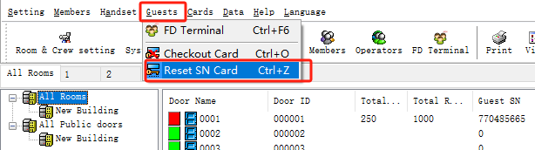

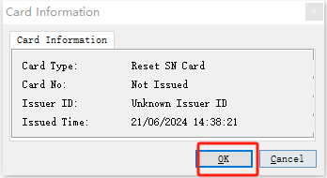

Please put one of the room card on the encoder, and press OK to issue the reset SN card, then take the Reset SN card to scan the lock, there will be one beep and green light, the lock’s SN will be reset, then try the guest card.

