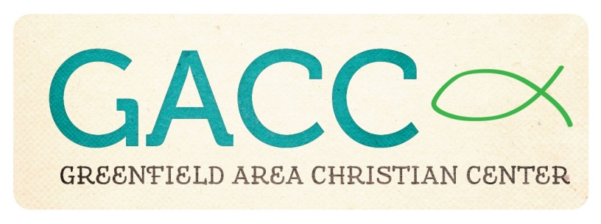

Building Usage Request Form

Name Of Individual/Group Requesting Use: _________________________________________

Contact Phone Number: ________________________________________________________

Type Of Event: _______________________________________________________________

Date And Time Of Requested Use (including set-up and clean up): _______________________

**Guidelines For Use Of Greenfield Area Christian Center Facility**

1. GACC is an alcohol/tobacco/drug free facility.
2. The availability of the GACC facility is based on a first-come-first-served basis. GACC/New Directions activities always have first priority on the calendar.
3. Individuals/groups are responsible to provide their own kitchen supplies, paper products, etc. for their event.
4. When decorating, the use of tape or thumb tacks on the walls is not permitted.
5. Any damage to GACC equipment and/or facility will be repaired or replaced at the cost of the renter.
6. Individuals/groups must maintain occupancy within safety codes. If you have questions about safety codes, please contact (937) 661-0197.
7. The GACC facility must be left in the proper condition at the end of the event. Counters, stove top, tables and chairs should be wiped down and returned to their proper place, floors should be swept and mopped (if needed), and all trash should be in garbage bags. Please turn off all lights and electrical equipment before exiting the building. All doors must be locked before the responsible adult leaves the building.
8. Full payment is due at the beginning of your event. Cost for the use of the GACC facility is as follows: (**Circle the space(s) you will be using**.)

Community Room/Kitchen: $25 per hour (up to 4 hours) $100 per day

Community Room/Kitchen & Gym: $50 per hour (up to 4 hours)

$200 per day

A $25 deposit is required upon reservation to hold your date. It will be returned to the renter if the building is in proper order. If additional cleaning is required the $25 deposit will be used to pay custodial staff.

**To schedule the GACC Facility, please contact Tonia McLanahan at 937-661-0197.**