* 1. 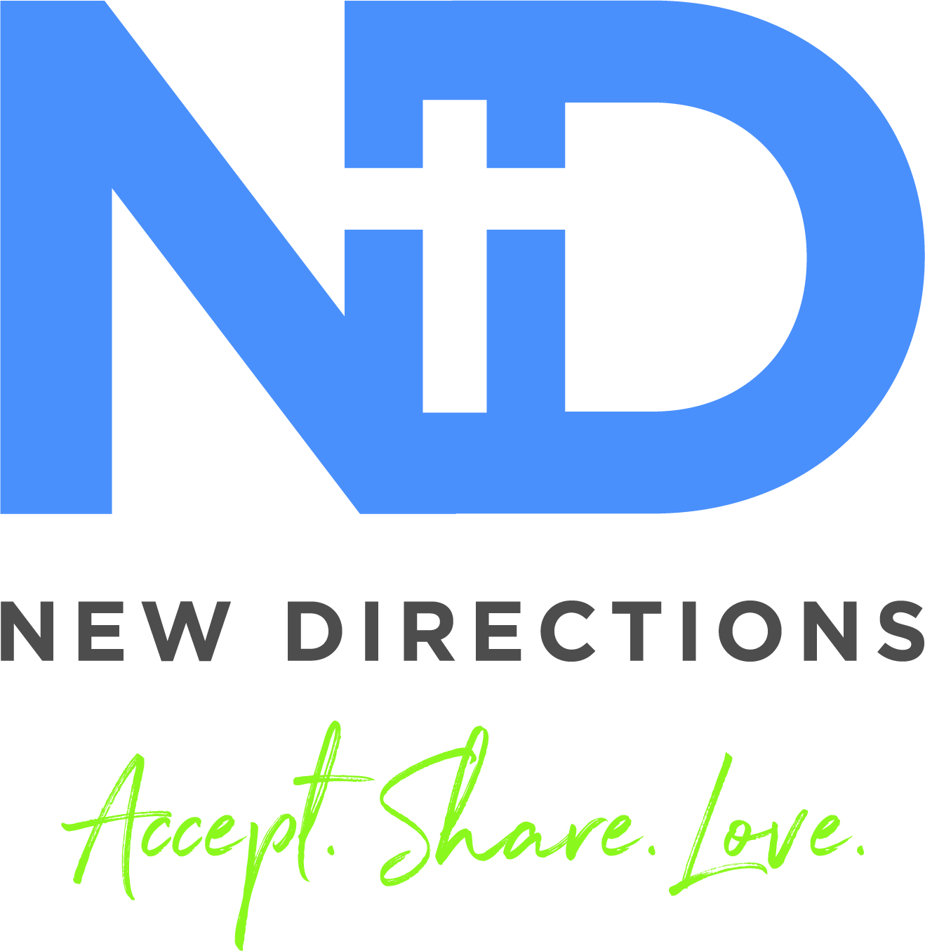**name and grade**

**Fall 2021**

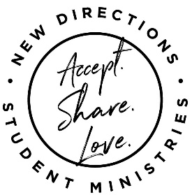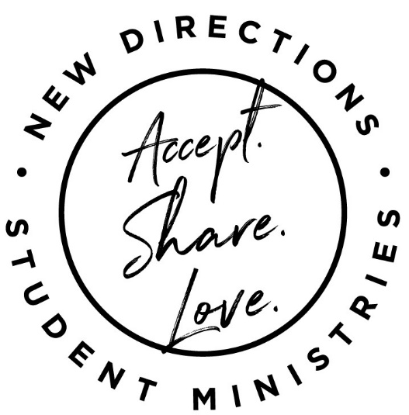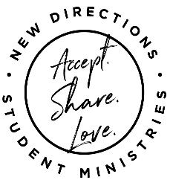

New Directions is VERY blessed to have student intern **Tori Lambert** on our staff. She joined us in June and will continue leading, learning and serving weekly on Thursdays and Fridays and for some of our special events. If you don’t already know her, here’s some info….

Hey y’all! My name is Tori Lambert. I am originally from Baton Rouge, Louisiana, but currently live in Delaware, Ohio, where I go to seminary at Methodist Theological School in Ohio. I love exploring new places and learning about different cultures-especially foods, dances and traditions and playing sports. I was on my school’s competitive jump rope team and have a rope with me almost always. My favorite color is BRIGHT!! Literally, any color that is bright is amazing to me! My favorite animal is a manatee and I love spending time with people-I am definitely an extrovert! I love random questions and facts and I am SO excited for this upcoming year! Check out these **“Tori** **Random Facts”** ⇒ **Favorite movie?** “My favorite movie of all time is Lilo and Stitch!!! Followed by Mulan probably.” **Dream vehicle?** “HOUSEBOAT♥♥♥ (does that count)” **Worst Subject in middle school?** “READING/ENGLISH – that stuff was the WORST lol.” **If you were a musical instrument?** “If I were a musical instrument, I’d be a Djembe (an African drum)” **The best book you’ve read?** “The best book I ever read, that I remember was *The Day the World Came to Town*.”

Student Intern – Tori Lambert

## **LifeGroups** are for people like YOU! **LifeGroups** usually meet weekly with 4-6 students from the same grade (boys with boys and girls with girls) and 1 or 2 Christian adult leaders. They explore topics related to their faith, pray for one another and share life together through service projects, fun outings and their weekly meetings. Tonia would love to help you form a **LifeGroup**! Contact her@ **937-661-0197** or [tmcnewdirections@gmail.com](mailto:tmcnewdirections@gmail.com) for more info.

What an AWESOME summer we had!! This is how AWESOME it was…66 adults shared their lives and skills with 80 students in grades 4-11 through a WIDE variety of DIGGs (Discover, Inspire, Grow, Groups). The most popular DIGGs involved games and creating/art.

I loved getting to learn, cook, create, pray, play, eat and serve with so many students this summer. And, I’m very excited about what’s happening next…

...**DIGGs** will continue during the school year!!! Read on for details and be sure to get the latest info @ **ndym.org** or on Facebook - **“New Directions”**

I hope to see YOU soon!

Tonia McLanahan

**From the Youth Director…**

**LifeGroups**

**ndym.org** and **“New Directions”** on **Facebook** are the two most up-to-date places to get information about what’s happening at New Directions. If you have signed up for a DIGG or a special event, you will be contacted about changes for that event. All students who have registered for an event @ ndym.org will receive a Monday email about specifics for that week. Questions? Contact Tonia @ **937-661-0197**

Need more Info??

**…And this is the secret: Christ lives in you. This gives you assurance of sharing his glory. Colossians 1:27 (NLT)**