W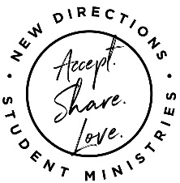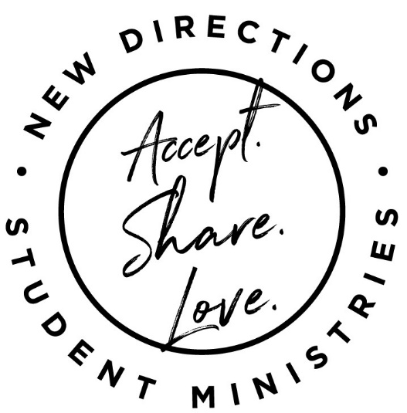

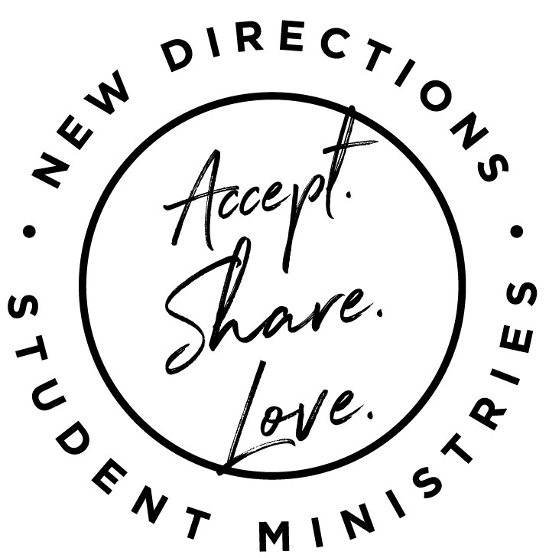

LIFEGROUPS– grades 6-12 various days, times and locations. Sign-up @ndym.org

TUESDAYS

**Grades:** 6-12 **Time:** 2:30-5:00 (after school)

**DIGG**- “Play, Play, Play” – There will be a weekly theme like “Hit it”, “Roll it”, “Deal it” “Throw it”. We’ll have a snack, devo and participate in both physically and mentally challenging activities.

WEDNESDAYS

**Grades**: 6-12 **Time:** 2:30-5:00

**DIGG** – “Wednesdays in the Woods”-bring a water bottle and explore area hiking trails.

**Grades:** 4-5 **Time:** 3:45-6 (after school)

**DIGG** - “Little Bit of EVERYTHING” – We will have a snack, devo, play games, and make something each week. “Something” could be food, play dough, a painting/craft, a friend or an improvement through service.

THURSDAYS

**Grades:** 6-12 **Time:** 2:30-5:00 (after school)

**DIGG**- “Created to Create” – music, drama, visual art, food, a better community. We’ll also feed our tummies and souls.

FRIDAYS

**Grades** 4-12 **Time:** after school till 5

**DIGG** – “Reservation for 8” – Invite friends and make a plan for your time together. Since there are only 8 Fridays available, after you’ve been to a Reservation for 8, please don’t sign-up again. Instead, sign-up on the “Reservation for 8 When Open” list; you will be contacted if there is an open Friday.

**September 13-November 19**

**FALL DETAILS**

SIGN-UP

There are 5 ways to sign up for New Directions weekly and special events:

1. **ndym.org**, choose “sign-up” from the menu, find what you want to do, fill in the info.
2. **Facebook - “New Directions”** sign-up in comments on the weekly post.
3. [tmcnewdirections@gmail.com](mailto:tmcnewdirections@gmail.com) – Include:
   1. Name and Grade
   2. Date you will participate
4. **Text or call** Tonia @ **937-661-0197**
5. Come to New Directions **910 N. 5th Street**, fill out the posted **sign-up sheet**.

MASKS

Yes, you need to bring one! The leader will determine if you will wear it.

MORE

**Special Events/Outings** will be added. Listen for school announcements, check the Facebook page and ndym.org for updates.

~~~T-SHIRTS~~~

We have New Directions t-shirts with our logo

that’s at the top of this page @ New Directions for $12.

**Sign-up ~ Masks ~ And More**

Fifth Quarter Party **-** October 8th after the game-11:30 @ Freedom Trails Campgrounds, 399 Chestnut Street, Greenfield.

Fall Retreat – October 16-17 Details when you sign-up @ ndym.org. Cost $30

**High School Special Events**

**Weekly**